Software Requirements Specification Order Room Management System

Dot Net Team



**Record of change**

*A - Added M - Modified D - Deleted

|  |  |  |  |  |
| --- | --- | --- | --- | --- |
| Effective Date | Changed Items | A* M, D | Change Description | New Version |
| July12, 2013 |  | A | Create SRS Document | 1.0 |
| August 2, 2013 |  | M | Update SRS Document | 1.1 |
| September3, 2013 |  | M | Update SRS Document | 1.2 |
|  |  |  |  |  |
|  |  |  |  |  |
|  |  |  |  |  |
|  |  |  |  |  |
|  |  |  |  |  |
|  |  |  |  |  |
|  |  |  |  |  |
|  |  |  |  |  |
|  |  |  |  |  |
|  |  |  |  |  |
|  |  |  |  |  |
|  |  |  |  |  |
|  |  |  |  |  |
|  |  |  |  |  |
|  |  |  |  |  |
|  |  |  |  |  |
|  |  |  |  |  |
|  |  |  |  |  |
|  |  |  |  |  |
|  |  |  |  |  |

**SIGNATURE PAGE**

**SIGNATURE PAGE**

**ORIGINATOR:** <Name> .Net team <Date>12th – 17th Jul, 2013

<Position> Team

**REVIEWERS:**

<Name> Võ Minh Thành <Date>17th Jul, 2013

<Position> Team Leader

<Name> Nguyễn Tấn Huy <Date>18th Jul, 2012

<Position> Project Manager

**APPROVAL:** <Name> Nguyễn Thị Hải <Date>18th Jul, 2012

<Position> Customer

Contents

**Record of change** 2

**SIGNATURE PAGE** 2

2. Introduction 4

2.1. Purpose 4

2.2. Definitions, Acronyms, and Abbreviations 4

2.3. References 4

3. High Level Requirements 4

3.1. Product Perspective 4

3.2. Actors and Use Cases Descriptions 7

3.2.1. Diagram 7

3.2.2. Actors Description 8

3.2.3. Use Cases Description 8

3.2.4. Use Case & Actor mapping 10

3.3. Operating Environment 12

3.4. Assumption and Dependencies 12

4. Functional Requirements 12

4.1. Admin 12

4.1.1. Login Page 12

4.1.2. Home Page 13

4.1.3. About Page 15

4.1.4. Account Management Page 17

4.1.5. Partner Management Page 22

4.1.6. Room Management Page 26

4.1.7. Order Management Page 31

4.1.8. Profile Page 36

4.1.9. Report Page 38

4.1.10. Create Order 47

4.1.11. Payment Management 49

4.2. User 50

4.2.1. Login Page 50

4.2.2. User Home Page 51

4.2.3. About Page 51

4.2.4. Profile Page 53

4.2.5. Order Management Page 56

4 Mockup Screens 65

4.2 SC01: Login 65

4.3 SC02: Logout 67

4.4 SC03: Admin home page 68

4.5 SC04: View image of all members 69

4.6 SC05: View information of each members 69

4.7 SC06: View all account 71

4.8 SC07: Create new account 71

4.9 SC08: Update account 75

4.10 SC09: Delete account 77

4.11 SC10: View all partner 78

4.12 SC11: Create new partner 79

4.13 SC12: Update partner 81

4.14 SC13:Delete partner 82

4.15 SC14:View all room 83

4.16 SC15:Create new room 85

4.17 SC16: Update room 86

4.18 SC17: Delete room 89

4.19 SC18: View all order 91

4.20 SC19: Create new order in Order Management Page 91

4.21 SC20: Update order 94

4.22 SC21: Delete order 97

4.23 SC22: View profile account 99

4.24 SC23: Update profile 100

4.25 SC24: Change password 102

4.26 SC25: All report ordering by all room 107

4.27 SC26: Report ordering order by room 107

4.28 SC28: Report ordering order by room and date 108

4.29 SC29: Report ordering order by room and month 109

4.30 SC30: Report ordering order by room and year 110

4.31 SC31: Report ordering order by room, date and month 111

4.32 SC32: Report ordering order by room, date and year 112

4.33 SC33: Report ordering order by room, month, year 113

4.34 SC34: Report ording order by rom , date, month, year. 114

4.35 SC35: User home page 116

4.36 SC36: User Order management page 117

4.37 SC37: Create order Management 118

4.38 SC38: Payment Management 119

# Introduction

## Purpose

This Software Requirements Specification provides a complete description of all the functions and specifications of the ORM project developing Order Room Management system. This document is intended to be used by the members of the project team that will implement and verify the correct functioning of the system.

## Definitions, Acronyms, and Abbreviations

|  |  |  |
| --- | --- | --- |
| **#** | **Abbreviations/Terms** | **Explanation** |
| 1 | SRS | Software Requirement Specification |
| 2 | BR | Business Rule |
| 3 | SC | Screen |
| 4 | UC | Use Case |

Table 1: Abbreviations & Terminologies

## References

|  |  |  |
| --- | --- | --- |
| **#** | **Name** | **Description** |
|  |  |  |

Table 2: Reference

# High Level Requirements

## Product Perspective



This application is integrated into HCD. It helps HCD to manage all rooms in the central pool, including manages people who order room, manage all information rooms, list all orders and export data to excel.

## Actors and Use Cases Descriptions



### Diagram

**Diagram 01 – Admin roles**

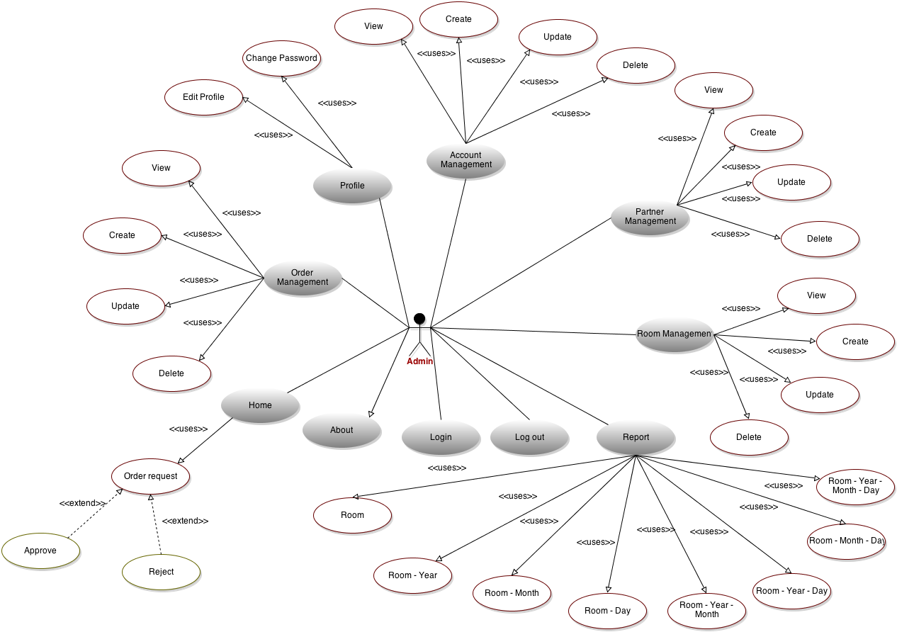

**Diagram 02 – User roles**

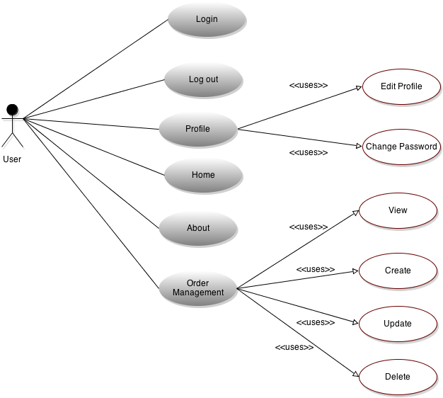

### Actors Description

|  |  |  |
| --- | --- | --- |
| **#** | **Actor Name** | **Definition & Interests** |
| **1** | Admin |  |
| **2** | User |  |

### Use Cases Description

|  |  |  |  |
| --- | --- | --- | --- |
| **#** | **Code** | **Name** | **Brief Description** |
| Login Page | | | |
| 1 | UC01 | Login | Allow admin sign in to the system. |
| 2 | UC02 | Logout | Allow user logout system. |
| Home Page | | | |
| 3 | UC03 | Admin home page | Display home page. |
| 4 | UC04 | Aprove request | Accept the request from user. |
| 5 | UC05 | Reject request | Allow admin reject request from user after admin view detail content. |
| About Page | | | |
| 6 | UC06 | Introduce project | Accept user view all information about implementation process of project. |
| 7 | UC07 | View image of all members | Accept user view image of each member and all team. |
| 8 | UC08 | View information of all members | Accept user view information of each member and all team. |
| Account Management Page | | | |
| 9 | UC09 | View all account | Allow admin view all account was created |
| 10 | UC10 | Create new account | Admin check a checkbox and create a new account for a new user. |
| 11 | UC11 | Update account | Update information for all account was created in system. |
| 12 | UC12 | Delete account | Delete an account in database. |
| 13 | UC13 | Export to excel | Accept actor export to file excel and download to computer. |
| 14 | Uc14 | Load record | Accept actor search any record and load it display in the list. |
| Partner Management Page | | | |
| 15 | UC15 | View all partner | Accept admin view all list of partners in system. |
| 16 | UC16 | Create new partner | Accept admin create all information from textboxs to system. |
| 17 | UC17 | Update partner | Accept admin update information from list of partner. |
| 18 | UC18 | Delete partner | Accept admin delete one or many rows from list of partner. |
| 19 | UC19 | Export to excel | Accept actor export to file excel and download to computer. |
| 20 | Uc20 | Load record | Accept actor search any record and load it display in the list. |
| Room Management Page | | | |
| 21 | UC21 | View all room | Allow admin view all room was created. |
| 22 | UC22 | Create new room | Admin check and create a new room. |
| 23 | UC23 | Update room | Update information for all room was created in system. |
| 24 | UC24 | Delete room | Delete a room in database. |
| 25 | UC25 | Export to excel | Accept actor export to file excel and download to computer. |
| 26 | UC26 | Load record | Accept actor search any record and load it display in the list. |
| Order Management Page | | | |
| 27 | UC27 | View all order | Allow admin view all order room was created. |
| 28 | UC28 | Create new order | Admin check and create a new order room. |
| 29 | UC29 | Update order | Update information for all order was created in system. |
| 30 | UC30 | Delete order | Delete an order in database. |
| 31 | UC31 | Export to excel | Accept actor export to file excel and download to computer. |
| 32 | Uc32 | Load record | Accept actor search any record and load it display in the list. |
| Profile Page | | | |
| 33 | UC33 | View profile account | Accept all user view information of their account. |
| 34 | UC34 | Update profile | Users can update information of their account. |
| 35 | UC35 | Change password | Users can change password of their account. |
| Report Page | | | |
| 36 | UC36 | Report ordering by all room | Display all ordering order by all room. |
| 37 | UC37 | Report ordering order by room | Allows an actor view all ordering order by any room |
| 38 | UC38 | Report ordering order by room and day | Allows an actor view all ordering order by room and date in the database |
| 39 | UC39 | Report ordering order by room and month | Allows an actor view all ordering order by room and date in the database |
| 40 | UC40 | Report ordering order by room and year | Allows an actor view all ordering order by room and year in the database |
| 41 | UC41 | Report ordering order by room, day and month | Allows an actor view all ordering order by room, date and month in the database |
| 42 | UC42 | Report ordering order by room, day and year | Allows an actor view all ordering order by room, date, year in the database |
| 43 | UC43 | Report ordering order by room, month and year | Allows an actor view all ordering order by room, month, year in the database |
| 44 | UC44 | Report ordering order by room, day, month and year | Allows an actor view all ordering order by room, date, month, year in the database |
| 45 | UC45 | Export report to ecxel file | Allow an actor can export the report which they need to excel file |
| Create Order | | | |
| 46 | UC46 | View all room | Allow an actor view information of all room |
| 47 | UC 47 | Create new order | Allow an actor create new order. |
| Payment | | | |
| 48 | UC48 | Change status of order | Allow an actor change status of order from unpaid to paid. |

Table 3: Use Case List

### Use Case & Actor mapping

|  |  |  |
| --- | --- | --- |
| **Actor**  **Use Case** | **Admin** | **User** |
| UC01: Login | **x** | **x** |
| UC02: Logout | **x** | **x** |
| UC03: Admin home page | **x** |  |
| UC04: Aprove request | **x** |  |
| UC05: Reject request | **x** |  |
| UC06: Introduce project | **x** | **x** |
| UC07: View image of all members | **x** | **x** |
| UC08: View information of all members | **x** | **x** |
| UC09: View all account | **x** |  |
| UC10: Create new account | **x** |  |
| UC11: Update account | **x** |  |
| UC12: Delete account | **x** |  |
| UC13: Export to excel | **x** |  |
| UC14: Load record | **x** |  |
| UC15: View all partner | **x** |  |
| UC16: Create new partner | **x** |  |
| UC17: Update partner | **x** |  |
| UC18: Delete partner | **x** |  |
| UC19: Export to excel | **x** |  |
| UC20: Load record | **x** |  |
| UC21: View all room | **x** |  |
| UC22: Create new room | **x** |  |
| UC23: Update room | **x** |  |
| UC24: Delete room | **x** |  |
| UC25: Export to excel | **x** |  |
| UC26: Load record | **x** |  |
| UC27: View all order | **x** | **x** |
| UC28: Create new order | **x** | **x** |
| UC29: Update order | **x** | **x** |
| UC30: Delete order | **x** | **x** |
| UC31: Export to excel | **x** | **x** |
| UC32: Load record | **x** | **x** |
| UC33: View profile account | **x** | **x** |
| UC34: Update profile | **x** | **x** |
| UC35: Change password | **x** | **x** |
| UC36:Report ordering by all room | **x** |  |
| UC37:Report ordering order by room | **x** |  |
| UC38:Report ordering order by room and day | **x** |  |
| UC39:Report ordering order by room and month | **x** |  |
| UC40:Report ordering order by room and year | **x** |  |
| UC41:Report ordering order by room, day and month | **x** |  |
| UC42:Report ordering order by room, day and year | **x** |  |
| UC43:Report ordering order by room, month and year | **x** |  |
| UC44:Report ordering order by room, day, month and year | **x** |  |
| UC45:Export report to ecxel file | **x** |  |
| UC46: User home page |  | **x** |

## Operating Environment

OE-1: The Order Room Management System shall operate with the following Web browsers: Microsoft Internet Explorer versions 6.0 and above, Netscape Communicator version 4.7, and Netscape versions 6 and 7.

OE-2: The Order Room Management System shall permit user access from the corporate Intranet and, if a user is authorized for outside access through the corporate firewall, from an Internet connection at the user’s home.

## Assumption and Dependencies

# Functional Requirements

## Admin

Login Page

##### Login

**Use Case Description**

|  |  |  |  |
| --- | --- | --- | --- |
| **Name** | Login | **Code** | UC01 |
| **Description** | Allow admin sign in to the system | | |
| **Actor** | Admin | **Trigger** | Admin click on the button **[Sign in]** |
| **Pre-condition** | Actor is not login | | |
| **Post condition** | Move from **Login Page** to the **Admin** **Home Page** with suitable role | | |

**Activities**

|  |  |  |  |
| --- | --- | --- | --- |
| **Actor** | | **System** | |
| **Main Flow: Login successfully** | | | |
| 1 | Admin input on textbox **username**, **password** then click on button  **[Sign in]**. |  |  |
|  |  | 2 | Check **username** and **password**, if **username** and **password** are correct then system will be redirect to **Admin** **Home Page** with suitable role. |

**Business Rules**

|  |  |  |
| --- | --- | --- |
| **Rule No.** | **Rule** | **Description** |
| 1 | Wrong input | Show error notification when input wrong **username** or **password** after click on the button **[Sign in]**. Text field **password** will be cleared. |
| 2 |  | If input correct **username** and **password** then system will be moved to **Admin Home Page** with suitable role. |

**System Message**

|  |  |
| --- | --- |
| MS01 | “Your login attempt was not successful. Please try again.”  Show mesage error notification when input wrong **username** or **password** after click on button **[Sign in]**. |

##### Log out

**Use Case Description**

|  |  |  |  |
| --- | --- | --- | --- |
| **Name** | Logout | **Code** | UC02 |
| **Description** | Allow user logout system | | |
| **Actor** | Admin | **Trigger** | Admin click on the button **[Logout]** |
| **Pre-condition** | Admin login into the system | | |
| **Post condition** | Return to the **Login Page** | | |

**Activities:**

|  |  |  |  |
| --- | --- | --- | --- |
| **Actor** | | **System** | |
| **Main Flow: Login successfully** | | | |
| 1 | Admin click on button **[Logout]**. |  |  |
|  |  | 2 | Return to the **Login Page** |

**Business Rules:**

|  |  |  |
| --- | --- | --- |
| **Rule No.** | **Rule** | **Description** |
| 1 |  | Admin click on button **[Logout]** then return to the **Login Page**. |

**System Message:**

|  |  |
| --- | --- |
| MS01 | “Logout successful”  Show mesage notification when click on button **[Logout]**. |

Home Page

##### Admin home page

**Use Case Description**

|  |  |  |  |
| --- | --- | --- | --- |
| **Name** | View detail request | **Code** | UC03 |
| **Description** | Allow admin view the detail of request from user. | | |
| **Actor** | Admin | **Trigger** | Click button **[Home]** |
| **Pre-condition** | Actor must login in the page with admin account. | | |
| **Post condition** | Display the detail of request from user. | | |

**Activities**

|  |  |  |  |
| --- | --- | --- | --- |
| **Actor** | | **System** | |
| **Main Flow: View the detail request is successful** | | | |
|  |  | 1 | Load **Home page admin.** |
| 2 | Chose exactly the request you want to view and click button **[Home]** below every request. |  |  |
|  |  | 3 | The system load data in database on new form and display in **Home admin page.** |

**Business Rules**

|  |  |  |
| --- | --- | --- |
| **Rule No.** | **Rule** | **Description** |
|  |  |  |
|  |  |  |
|  |  |  |
| 1 | Appear **[Approve]** and **[Reject]** button | The button **[Approve]** and **[Reject]** always appear. |
|  |  |  |

**System Message**

|  |  |
| --- | --- |
|  |  |

##### Approve request

**Use Case Description**

|  |  |  |  |
| --- | --- | --- | --- |
| **Name** | View detail request | **Code** | UC04 |
| **Description** | Allow approve the request from user. | | |
| **Actor** | Admin | **Trigger** | Click button **[View]** |
| **Pre-condition** | Actor must login in the page with admin account. | | |
| **Post condition** | Accept the request from user | | |

**Activities**

|  |  |  |  |
| --- | --- | --- | --- |
| **Actor** | | **System** | |
| **Main Flow: Approve request successfully** | | | |
|  |  | 1 | Load **Home page admin** |
| 4 | Click **[Approve]** button. |  |  |
|  |  | 5 | Update in database |

**Business Rules**

|  |  |  |
| --- | --- | --- |
| **Rule No.** | **Rule** | **Description** |
|  |  |  |

**System Message**

|  |  |
| --- | --- |
|  |  |

##### Reject request

**Use Case Description**

|  |  |  |  |
| --- | --- | --- | --- |
| **Name** | Reject request | **Code** | UC05 |
| **Description** | Allow actor reject request from user. | | |
| **Actor** | Admin | **Trigger** | Click button **[Reject]** |
| **Pre-condition** | Actor must login in page with admin account. | | |
| **Post condition** | Accpet the request from user. | | |

**Activities**

|  |  |  |  |
| --- | --- | --- | --- |
| **Actor** | | **System** | |
| **Main Flow: Reject request successfully** | | | |
|  |  | 1 | Load **Home page admin** |
| 2 | Click **[Reject]** button. |  |  |
|  |  | 3 | Update in database |

**Business Rules**

|  |  |  |
| --- | --- | --- |
| **Rule No.** | **Rule** | **Description** |
|  |  |  |

**System Message**

|  |  |
| --- | --- |
|  |  |

About Page

##### Introduce project

**Use Case Description**

|  |  |  |  |
| --- | --- | --- | --- |
| **Name** | View information about project. | **Code** | UC06 |
| **Description** | Accept user view all information about implementation process of project. | | |
| **Actor** | User & Admin | **Trigger** | Load **About page** |
| **Pre-condition** | Actor login to the system. | | |
| **Post condition** | Display some information in header of this page. | | |

**Activities**

|  |  |  |  |
| --- | --- | --- | --- |
| **Actor** | | **System** | |
| **Main Flow: Display information in a header successfully** | | | |
|  |  | 1 | Load all information in database, bind them into a label and display in header of **About page.** |

**Business Rules**

|  |  |  |
| --- | --- | --- |
| **Rule No.** | **Rule** | **Description** |
| 1 | Display in a label. | Label display all information. Make sure data do not be outside or lack. |

**System Message**

|  |  |
| --- | --- |
|  |  |

##### Introduce project member

###### View image of all members

**Use Case Description**

|  |  |  |  |
| --- | --- | --- | --- |
| **Name** | View image of all members. | **Code** | UC07 |
| **Description** | Accept user view image of each member and all team. | | |
| **Actor** | User & Admin | **Trigger** | Load **About page** |
| **Pre-condition** | Actor login to the system. | | |
| **Post condition** | Display images of all member of project team. | | |

**Activities**

|  |  |  |  |
| --- | --- | --- | --- |
| **Actor** | | **System** | |
| **Main Flow: Display image in a main of page successfully** | | | |
|  |  | 1 | Load all information in database and bind them into main **About page.** |

**Business Rules**

|  |  |  |
| --- | --- | --- |
| **Rule No.** | **Rule** | **Description** |
| 1 | Display in main page. | Images are loaded into the main page.  Images were equally.  Size of all images is the same. |

**System Message**

|  |  |
| --- | --- |
|  |  |

###### View information of all members

**Use Case Description**

|  |  |  |  |
| --- | --- | --- | --- |
| **Name** | View information of all members. | **Code** | UC08 |
| **Description** | Accept user view information of each member and all team. | | |
| **Actor** | User & Admin | **Trigger** | Actor move the mouse into each image in main page. |
| **Pre-condition** | Actor login to the system. | | |
| **Post condition** | Image will be disappearing and information of this member in image will be appearing in this area of image successfully. | | |

**Activities**

|  |  |  |  |
| --- | --- | --- | --- |
| **Actor** | | **System** | |
| **Main Flow: Image will be disappearing and information of this member in image will be appearing in this area of image successfully.** | | | |
| 1 | Actor move the mouse into each image. |  |  |
|  |  | 2 | Disappear image and load data about this member into the area of image. |
| 3 | Actor move the mouse out of image. |  |  |
|  |  | 4 | Load image hide the imformation. |

**Business Rules**

|  |  |  |
| --- | --- | --- |
| **Rule No.** | **Rule** | **Description** |
| 1 | When move mouse on the image and move out of image. | The image hides and appears. |

**System Message**

|  |  |
| --- | --- |
|  |  |

Account Management Page

##### View all acount

**Use Case Description**

|  |  |  |  |
| --- | --- | --- | --- |
| **Name** | View all Account | **Code** | UC09 |
| **Description** | Allow admin view all account was created | | |
| **Actor** | Admin | **Trigger** | Load page  **Account Management** |
| **Pre-condition** | Admin login to the system | | |
| **Post condition** | Display all account was created in list and account | | |

**Activities**

|  |  |  |  |
| --- | --- | --- | --- |
| **Actor** | | **System** | |
| **Main Flow: List account in a table successfully** | | | |
|  |  | 1 | Load information all account and display from database to the table in the bottom of the page. |

**Business Rules**

|  |  |  |
| --- | --- | --- |
| **Rule No.** | **Rule** | **Description** |
| 1 | Display data table | Table will display all information account  When the page reloads, the display data are sorted by UserName, |
| 2 | Disable data table | Disable table when the database have no data. |

**System Message**

|  |  |
| --- | --- |
|  |  |

##### Create new acount

**Use Case Description**

|  |  |  |  |
| --- | --- | --- | --- |
| **Name** | Create New Account | **Code** | UC10 |
| **Description** | Admin click button Add New Record and create new Account. | | |
| **Actor** | Admin | **Trigger** | Actor click button **[Add new record],** fill all the textbox,after that click button [**Save]** |
| **Pre-condition** | Admin login into system. | | |
| **Post condition** | Add account successful. | | |

**Activities**

|  |  |  |  |
| --- | --- | --- | --- |
| **Actor** | | **System** | |
| **Main Flow: Create New Account successfully** | | | |
| 1 | Admin enter the information requested on page andclick button **[Save]** |  |  |
|  |  | 2 | Validation input information. |
|  |  | 3 | Show the error message if enter wrong or empty information in textbox. |
|  |  | 4 | Save information new account into database and show successful message, then return to **Account** **Management Page** |

**Business Rules**

|  |  |  |
| --- | --- | --- |
| **Rule No.** | **Rule** | **Description** |
| 1 | Validation Information | UserName: Can use same UserName  Password: Passwords are required to be a minimum of 6 characters in length.  Email: Do not use same email.,correct format email |
|  |  |  |
|  |  |  |
|  |  |  |

**System Message**

|  |  |
| --- | --- |
| MS01 | “This field is reruired ” |
| MS02 | “Mininum 6 characters allowed” |
| MS03 | “The UserName is already in use” |
| MS04 | “Invalid email address” |
| MS05 | “The E-mail address is already in use” |

##### Update acount

**Use Case Description**

|  |  |  |  |
| --- | --- | --- | --- |
| **Name** | Update Account | **Code** | UC11 |
| **Description** | Update information for all account was created in system. | | |
| **Actor** | Admin | **Trigger** | Click button **[Edit record]** |
| **Pre-condition** | Admin login to system. | | |
| **Post condition** | Edit information for all account. | | |

**Activities**

|  |  |  |  |
| --- | --- | --- | --- |
| **Actor** | | **System** | |
| **Main Flow: Update Course successfully** | | | |
| 1 | Admin select account need to update in table |  |  |
|  |  | 2 | Load **Update** **Page** |
| 3 | Update information necessary on Update page and click button **[Save].** |  |  |
|  |  | 4 | Validation input information |
| 5 | Edit information and show message if invalid validation. |  |  |
|  |  | 6 | Update information of the select account into database and go back to **Account Management Page** |

**Business Rules**

|  |  |  |
| --- | --- | --- |
| **Rule No.** | **Rule** | **Description** |
| 1 | Invalid information | New Password: Passwords are required to be a minimum of 6 characters in length.  Email: Do not use same email |

**System Message**

|  |  |
| --- | --- |
| MS01 | “The E-mail supplied is invalid.” |
| MS02 | “This field is required” |
| MS03 | “The length of parameter 'newPassword' needs to be greater or equal to '6'. |
| MS04 | “Invalid email address” |

##### Delete acount

**Use Case Description**

|  |  |  |  |
| --- | --- | --- | --- |
| **Name** | Delete account | **Code** | UC12 |
| **Description** | Delete a account in database | | |
| **Actor** | Admin | **Trigger** | Actor select a account and click button **[Delete]** |
| **Pre-condition** | Admin login into system | | |
| **Post condition** | Delete a account successfully | | |

**Activities**

|  |  |  |  |
| --- | --- | --- | --- |
| **Actor** | | **System** | |
| **Main Flow: Search Courses successfully** | | | |
| 1 | Admin choose account on data table, check account and click button [**Delete**]. |  |  |
|  |  | 2 | System prompt a message ask actor about delete decision |
| 3 | Admin click [**Delete**] button |  |  |
|  |  | 4 | System will find the select account in database and delete it. |
|  |  | 5 | System display successful message |
|  |  | 6 | Load again data in table on **Account Management Page**. |

**Business Rules**

|  |  |  |
| --- | --- | --- |
| **Rule No.** | **Rule** | **Description** |
| 1 | Display data table | Table will display all information account.  When the page reload, data information display sort by UserName. |
| 2 | Disable data table | Disable table when have no data |

**System Message**

|  |  |
| --- | --- |
| MS01 | “This record will be deleted. Are you sure? |

##### Export to excel

**Use Case Description**

|  |  |  |  |
| --- | --- | --- | --- |
| **Name** | Export to excel | **Code** | UC13 |
| **Description** | Accept actor export to file excel and download to computer. | | |
| **Actor** | Admin | **Trigger** | Actor click on button **[Export to excel]** |
| **Pre-condition** | Actor login to the system. | | |
| **Post condition** | Export to excel successfully. | | |

**Activities**

|  |  |  |  |
| --- | --- | --- | --- |
| **Actor** | | **System** | |
| **Main Flow: Delete a Partner successfully.** | | | |
| 1 | Actor click on symbol **[Export to excel].** |  |  |
|  |  | 2 | The list will be export in the excel file and download to the computer. |

**Business Rules**

|  |  |  |
| --- | --- | --- |
| **Rule No.** | **Rule** | **Description** |
| 1 |  | . |

**System Message**

|  |  |
| --- | --- |
| 1 |  |

##### Load record

**Use Case Description**

|  |  |  |  |
| --- | --- | --- | --- |
| **Name** | Load record | **Code** | UC14 |
| **Description** | Accept actor search any record and load it display in the list. | | |
| **Actor** | Admin | **Trigger** | Actor click on button **[Load record]** |
| **Pre-condition** | Actor login to the system. | | |
| **Post condition** | Load record successfully. | | |

**Activities**

|  |  |  |  |
| --- | --- | --- | --- |
| **Actor** | | **System** | |
| **Main Flow: Delete a Partner successfully.** | | | |
| 1 | Actor input any character in column Department into Department textbox. And click button **[Load record].** |  |  |
|  |  | 2 | Display records exist the character have just inputed. And display nothing if it doesn’t exit. |

**Business Rules**

|  |  |  |
| --- | --- | --- |
| **Rule No.** | **Rule** | **Description** |
| 1 |  |  |

**System Message**

|  |  |
| --- | --- |
| 1 |  |

Partner Management Page

##### View all parner

**Use Case Description**

|  |  |  |  |
| --- | --- | --- | --- |
| **Name** | View all partner | **Code** | UC15 |
| **Description** | Accept actor view all list of partners in system. | | |
| **Actor** | Admin | **Trigger** | Load **Partner Manager Page** |
| **Pre-condition** | Actor login to the system. | | |
| **Post condition** | Display all list of partners successfully. | | |

**Activities**

|  |  |  |  |
| --- | --- | --- | --- |
| **Actor** | | **System** | |
| **Main Flow: Display all list of partner successfully.** | | | |
|  |  | 1 | Load information of all partner in database, bind into table and display on **Partner Manager Page** |

**Business Rules**

|  |  |  |
| --- | --- | --- |
| **Rule No.** | **Rule** | **Description** |
| 1 | Display table | Table show the data, the data will ensure multi-encode before the show, make sure no page breaks when data is too long.  Each page shows 20 records of table.  When the page loads by default sorted by PartnerID |
| 2 | Hide table | Hide table when have no data. |

**System Message**

|  |  |
| --- | --- |
|  |  |

##### Create new partner

**Use Case Description**

|  |  |  |  |
| --- | --- | --- | --- |
| **Name** | Create new partner | **Code** | UC16 |
| **Description** | Accept actor create all information from textboxs to system. | | |
| **Actor** | Admin | **Trigger** | Actor click on button **[+Add new record],** fill all the textbox,after that click button [**Save]** |
| **Pre-condition** | Actor login to the system. | | |
| **Post condition** | Create new partner successfully. | | |

**Activities**

|  |  |  |  |
| --- | --- | --- | --- |
| **Actor** | | **System** | |
| **Main Flow: create new partner successfully.** | | | |
| 1 | Admin click button **[+Add new record]** |  |  |
| 2 | Admin input information of new partner and click button **[Save]** |  |  |
|  |  | 3 | Validation all informations was inputed. |
| 4 | Fix information if validation not true. |  |  |
|  |  | 5 | Update this information into database and message successfully. |

**Business Rules**

|  |  |  |
| --- | --- | --- |
| **Rule No.** | **Rule** | **Description** |
| 1 | Input information | Actor must input into all textboxs. Don’t lack any things.  The information is inputed must be following the form. |

**System Message**

|  |  |
| --- | --- |
| 1 | When actor input Department that already existed indatabase, system will display message :  “Can not add duplicate department ” |
| 2 | When actor didn’t input nothing in any textbox , system will display message :  “This field is required” on each textbox. |

##### Update partner

**Use Case Description**

|  |  |  |  |
| --- | --- | --- | --- |
| **Name** | Update partner | **Code** | UC17 |
| **Description** | Accept actor update information from list of partner. | | |
| **Actor** | Admin | **Trigger** | Actor click on symbol **[Edit record]** |
| **Pre-condition** | Actor login to the system. | | |
| **Post condition** | Update a Partner successfully. | | |

**Activities**

|  |  |  |  |
| --- | --- | --- | --- |
| **Actor** | | **System** | |
| **Main Flow: Update new partner successfully.** | | | |
| 1 | Actor click on symbol **[Edit record]** in end of record that want to Update. |  |  |
|  |  | 2 | Display [**Edit Record]** dialog, and load all data of this record into corresponding textboxs. |
| 3 | Actor edits information in textboxs. |  |  |
|  |  | 4 | Validation all informations was edited.  Show the error message if enter wrong or empty information in textbox. |
| 5 | Actor fixes information if validation not true. And click on button **[Save].** |  |  |
|  |  | 6 | Update this information into database and update into datagridview, message successfully. |

**Business Rules**

|  |  |  |
| --- | --- | --- |
| **Rule No.** | **Rule** | **Description** |
| 1 | Update information | Information was updated must be different from old information. |

**System Message**

|  |  |
| --- | --- |
| 1 | When actor input Department that already existed indatabase, system will display message :  “Can not add duplicate department ” |
| 2 | When actor didn’t input nothing in any textbox , system will display message :  “This field is required” on each textbox. |

##### Delete partner

**Use Case Description**

|  |  |  |  |
| --- | --- | --- | --- |
| **Name** | Delete | **Code** | UC18 |
| **Description** | Accept actor delete one or many rows from list of partner. | | |
| **Actor** | Admin | **Trigger** | Actor click on symbol **[Delete]** |
| **Pre-condition** | Actor login to the system. | | |
| **Post condition** | Delete a partner successfully. | | |

**Activities**

|  |  |  |  |
| --- | --- | --- | --- |
| **Actor** | | **System** | |
| **Main Flow: Delete a Partner successfully.** | | | |
| 1 | Actor click on symbol **[Delete].** |  |  |
|  |  | 2 | Appear a message box to confirm. |
| 3 | Actor click on button **[Delete].** |  |  |
|  |  | 4 | Rows was deleted will be delete from database and table. Message delete successful. |

**Business Rules**

|  |  |  |
| --- | --- | --- |
| **Rule No.** | **Rule** | **Description** |
| 1 | Work order | Just can be delete one by one record. |

**System Message**

|  |  |
| --- | --- |
| 1 | Confirm message :  “This record will be deleted. Are you sure?” |

##### Export to excel

**Use Case Description**

|  |  |  |  |
| --- | --- | --- | --- |
| **Name** | Export to excel | **Code** | UC19 |
| **Description** | Accept actor export to file excel and download to computer. | | |
| **Actor** | Admin | **Trigger** | Actor click on button **[Export to excel]** |
| **Pre-condition** | Actor login to the system. | | |
| **Post condition** | Export to excel successfully. | | |

**Activities**

|  |  |  |  |
| --- | --- | --- | --- |
| **Actor** | | **System** | |
| **Main Flow: Delete a Partner successfully.** | | | |
| 1 | Actor click on symbol **[Export to excel].** |  |  |
|  |  | 2 | The list will be export in the excel file and download to the computer. |

**Business Rules**

|  |  |  |
| --- | --- | --- |
| **Rule No.** | **Rule** | **Description** |
| 1 |  | . |

**System Message**

|  |  |
| --- | --- |
| 1 |  |

##### Load record

**Use Case Description**

|  |  |  |  |
| --- | --- | --- | --- |
| **Name** | Load record | **Code** | UC20 |
| **Description** | Accept actor search any record and load it display in the list. | | |
| **Actor** | Admin | **Trigger** | Actor click on button **[Load record]** |
| **Pre-condition** | Actor login to the system. | | |
| **Post condition** | Load record successfully. | | |

**Activities**

|  |  |  |  |
| --- | --- | --- | --- |
| **Actor** | | **System** | |
| **Main Flow: Delete a Partner successfully.** | | | |
| 1 | Actor input any character in column Department into Department textbox. And click button **[Load record].** |  |  |
|  |  | 2 | Display records exist the character have just inputed. And display nothing if it doesn’t exit. |

**Business Rules**

|  |  |  |
| --- | --- | --- |
| **Rule No.** | **Rule** | **Description** |
| 1 |  |  |

**System Message**

|  |  |
| --- | --- |
| 1 |  |

Room Management Page

##### View all room

**Use Case Description**

|  |  |  |  |
| --- | --- | --- | --- |
| **Name** | View all room | **Code** | UC21 |
| **Description** | Allow admin view all room was created | | |
| **Actor** | Admin | **Trigger** | Load **Room Management page** |
| **Pre-condition** | Admin login into the system | | |
| **Post condition** | Display all room was created. | | |

**Activities**

|  |  |  |  |
| --- | --- | --- | --- |
| **Main Flow: View room in a table successfully** | | | |
| **Actor** | | **System** | |
|  |  | 1 | Load information all room and display from database to the table of the page. |

**Business Rules**

|  |  |  |
| --- | --- | --- |
| **Rule No.** | **Rule** | **Description** |
| 1 | Display data table | Table will display all information room  When the page reload, the display data are sorted by name |
| 2 | Disable data table | Disable table when the database have no data. |

##### Create new room

**Use Case Description**

|  |  |  |  |
| --- | --- | --- | --- |
| **Name** | Add new room | **Code** | UC22 |
| **Description** | Admin check and create a new room. | | |
| **Actor** | Admin | **Trigger** | Actor click button **[+Add new record],** fill all the textbox,after that click button [**Save]** |
| **Pre-condition** | Admin login into system. | | |
| **Post condition** | Add room successful. | | |

**Activities**

|  |  |  |  |
| --- | --- | --- | --- |
| **Main Flow: Add New Room successfully** | | | |
| **Actor** | | **System** | |
| 1 | Actor click button **[+Add new record]** |  |  |
|  |  | 2 | Appear the **[+Add new record**]dialog to actor input data. |
| 3 | Actor enter the information requested on page andclick button **[Save]** |  |  |
|  |  | 4 | Validation input information.  Show the error message if enter wrong or empty information in textbox. |
| 5 | Fix information if validation not true, And click on button **[Save].** |  |  |
|  |  | 6 | Save information new Room into database and show successful message, then return to **Room** **Management Page** |

**Business Rules**

|  |  |  |
| --- | --- | --- |
| **Rule No.** | **Rule** | **Description** |
| 1 | Input lack of information | Actor must input into all textboxs. Don’t lack any things.  The information is inputed must be following the form. |
| 2 | Input wrong information | Actor must inoput RoomName that don’t exist in list. |

**System Message**

|  |  |
| --- | --- |
| MS01 | When actor input RoomName that already existed indatabase, system will display message :  “Can not add duplicate RoomName ” |
| MS02 | When actor didn’t input nothing in any textbox , system will display message :  “This field is required” on each textbox. |
|  | When actor input anything not number, sysrem will display message :  “Numbers only”  “ Invalid floating decimal number” |

##### Update room

**Use Case Description**

|  |  |  |  |
| --- | --- | --- | --- |
| **Name** | Update room | **Code** | UC23 |
| **Description** | Update information for all Room was created in system. | | |
| **Actor** | Admin | **Trigger** | Click symbol **[Edit record]** |
| **Pre-condition** | Actor login to system. | | |
| **Post condition** | Edit information for all Room successfully. | | |

**Activities**

|  |  |  |  |
| --- | --- | --- | --- |
| **Actor** | | **System** | |
| **Main Flow: Update Course successfully** | | | |
| 1 | Actor click on button **[Edit record]** in end of record that want to edit. |  |  |
|  |  | 2 | Display [**Edit record]** dialog, and load all data into corresponding textboxs. |
| 3 | Update information necessary on **[Edit record]** dialog and click button **[Save].** |  |  |
|  |  | 4 | Validation input information.  Show the error message if enter wrong or empty information in textbox. |
| 5 | Edit information and show message if invalid validation. |  |  |
|  |  | 6 | Update information of the select Room into database and go back to **Room Management Page** |

**Business Rules**

|  |  |  |
| --- | --- | --- |
|  |  |  |
|  |  |  |
| Rule No. | Rule | Description |
| 1 | Input wrong information. | Show error notification when input wrong: Room ID, Room Name, Room Seats, Price/hours, Full price, Desciption after click on the button **[Save]**. |
| 2 | Input corect information. | If input correct: : Room ID, Room Name, Room Seats, Price/hours, Full price, Description then system auto process function. |

**System Message**

|  |  |
| --- | --- |
|  | When actor input RoomName that already existed indatabase, system will display message:  “Can not add duplicate department ” |
| 2 | When actor didn’t input nothing in any textbox , system will display message :  “This field is required” on each textbox. |
|  | When actor input anything not number, sysrem will display message :  “Numbers only”  “ Invalid floating decimal number” |
|  | When actor input anything not number, sysrem will display message :  “Numbers only”  “ Invalid floating decimal number” |

##### Delete room

**Use Case Description**

|  |  |  |  |
| --- | --- | --- | --- |
| **Name** | Delete room | **Code** | UC24 |
| **Description** | Delete a room in database | | |
| **Actor** | Admin | **Trigger** | Actor select a room and click button **[Delete]** |
| **Pre-condition** | Admin login to system | | |
| **Post condition** | Delete a room successfully | | |

**Activities**

|  |  |  |  |
| --- | --- | --- | --- |
| **Actor** | | **System** | |
| **Main Flow: Delete successful** | | | |
| 1 | Actor click on button [**Delete**]in end of record that want to delete |  |  |
|  |  | 2 | Appear a message box to confirm. |
| 3 | Admin click button **[Delete]** |  |  |
|  |  | 4 | Rows was deleted will be delete from database and table. Load again data in table on **Room Management Page**. |

**Business Rules**

|  |  |  |
| --- | --- | --- |
| **Rule No.** | **Rule** | **Description** |
| 1 | Work order | Just can be delete one by one record. |

**System Message**

|  |  |
| --- | --- |
|  | Confirm message :  “This record will be deleted. Are you sure?” |

##### Export to excel

**Use Case Description**

|  |  |  |  |
| --- | --- | --- | --- |
| **Name** | Export to excel | **Code** | UC25 |
| **Description** | Accept actor export to file excel and download to computer. | | |
| **Actor** | Admin | **Trigger** | Actor click on button **[Export to excel]** |
| **Pre-condition** | Actor login to the system. | | |
| **Post condition** | Export to excel successfully. | | |

**Activities**

|  |  |  |  |
| --- | --- | --- | --- |
| **Actor** | | **System** | |
| **Main Flow: Delete a Partner successfully.** | | | |
| 1 | Actor click on symbol **[Export to excel].** |  |  |
|  |  | 2 | The list will be export in the excel file and download to the computer. |

**Business Rules**

|  |  |  |
| --- | --- | --- |
| **Rule No.** | **Rule** | **Description** |
| 1 |  | . |

**System Message**

|  |  |
| --- | --- |
| 1 |  |

##### Load Record

**Use Case Description**

|  |  |  |  |
| --- | --- | --- | --- |
| **Name** | Load record | **Code** | UC26 |
| **Description** | Accept actor search any record and load it display in the list. | | |
| **Actor** | Admin | **Trigger** | Actor click on button **[Load record]** |
| **Pre-condition** | Actor login to the system. | | |
| **Post condition** | Load record successfully. | | |

**Activities**

|  |  |  |  |
| --- | --- | --- | --- |
| **Actor** | | **System** | |
| **Main Flow: Delete a Partner successfully.** | | | |
| 1 | Actor input any character in column Department into Department textbox. And click button **[Load record].** |  |  |
|  |  | 2 | Display records exist the character have just inputed. And display nothing if it doesn’t exit. |

**Business Rules**

|  |  |  |
| --- | --- | --- |
| **Rule No.** | **Rule** | **Description** |
| 1 |  |  |

**System Message**

|  |  |
| --- | --- |
| 1 |  |

Order Management Page

##### View all order

**Use Case Desciption**

|  |  |  |  |
| --- | --- | --- | --- |
| **Name** | View all order | **Code** | UC27 |
| **Description** | Allow admin view all order room was created | | |
| **Actor** | Admin | **Trigger** | Load **Order Management Page** |
| **Pre-condition** | Admin login to the system | | |
| **Post condition** | Display all order was created. | | |

**Activities**

|  |  |  |  |
| --- | --- | --- | --- |
| **Actor** | | **System** | |
| **Main Flow: View order in a table successfully** | | | |
|  |  | 1 | Load information all order room and display from database to the table of the page. |

**Business Rules**

|  |  |  |
| --- | --- | --- |
| **Rule No.** | **Rule** | **Description** |
| 1 | Display data table | Table will display all information order room  When the page reloads, the display data are sorted by DateOrder. |
| 2 | Disable data table | Disable table when the database have no data. |

##### Add new order

**Use Case Desciption**

|  |  |  |  |
| --- | --- | --- | --- |
| **Name** | Add New order | **Code** | UC28 |
| **Description** | Admin check and add a new order | | |
| **Actor** | Admin | **Trigger** | Actor fill all the textbox,after that click button [**Save]** |
| **Pre-condition** | Admin login to system. | | |
| **Post condition** | Add order successful. | | |

**Activities**

|  |  |  |  |
| --- | --- | --- | --- |
| **Actor** | | **System** | |
| **Main Flow: Add new order successfully** | | | |
| 1 | Admin enter the information requested on page andclick button **[Save]** |  |  |
|  |  | 2 | Validation input information. |
|  |  | 3 | Show the error message if enter wrong or empty information in textbox. |
|  |  | 4 | Save information new order into database and show successful message, then return to **Order** **Management Page** |

**Business Rules**

|  |  |  |
| --- | --- | --- |
| **Rule No.** | **Rule** | **Description** |
| 1 |  | Show error notification when input wrong: Room Name, Requester, StartTime, Endtime after click on the button **[Save]** |

**System Message:**

|  |  |
| --- | --- |
| MS01 | “This field is required” No input data in text field |
| MS02 | “Invalid email address” |
| MS03 | “Invalid date,must be in MM-DD-YYYY format” |
| MS04 | “Error time format” |
| MS05 | You can't create this order because we have old order in this time before!  Same time |

##### Update order

**Use Case Description**

|  |  |  |  |
| --- | --- | --- | --- |
| **Name** | Update order | **Code** | UC29 |
| **Description** | Update information for all order was created in system. | | |
| **Actor** | Admin | **Trigger** | Click button **[Edit record]** |
| **Pre-condition** | Admin login to system. | | |
| **Post condition** | Edit information for all order. | | |

**Activities**

|  |  |  |  |
| --- | --- | --- | --- |
| **Actor** | | **System** | |
| **Main Flow: Update Course successfully** | | | |
| 1 | Admin select Order Room need to update in table |  |  |
|  |  | 2 | Load **Update** **Page** |
| 3 | Update information necessary on Update page and click button **[Edit Record].** |  |  |
|  |  | 4 | Validation input information |
| 5 | Edit information and show message if invalid validation. |  |  |
|  |  | 6 | Update information of the select order into database and go back to **Order Management Page** |

**Business Rules**

|  |  |  |
| --- | --- | --- |
| **Rule No.** | **Rule** | **Description** |
| 1 |  | Show error notification when input wrong: Room, Requester, StartTime, EndTime after click on the button **[Save]** |
| 2 |  | If input correct: Room, Requester, StartTime, and EndTime then system auto process function. |

**System Message:**

|  |  |
| --- | --- |
| MS01 | “This field is required” |
| MS02 | “Invalid email address” |
| MS03 | Error time format |

##### Delete order

**Use Case Description**

|  |  |  |  |
| --- | --- | --- | --- |
| **Name** | Delete order | **Code** | UC30 |
| **Description** | Delete an order in database | | |
| **Actor** | Admin | **Trigger** | Actor select an order and click button **[Delete]** |
| **Pre-condition** | Admin login to system | | |
| **Post condition** | Delete an order successfully | | |

**Activities**

|  |  |  |  |
| --- | --- | --- | --- |
| **Actor** | | **System** | |
| **Main Flow: Delete successful** | | | |
| 1 | Admin choose order on data table, check order and click button [**Delete**]. |  |  |
|  |  | 2 | System prompt a message ask actor about delete decision |
| 3 | Admin click **[Delete]** button |  |  |
|  |  | 4 | System will find the select order in database and delete it. |
|  |  | 5 | System display successful message |
|  |  | 6 | Load again data in table on **Order Management Page**. |

**Business Rules**

|  |  |  |
| --- | --- | --- |
| **Rule No.** | **Rule** | **Description** |
| 1 |  | If user not choose that order in to table but click button **[Delete]** then show error notification. |
| 2 |  | If input correct: Room, Requester, StartTime, EndTime then system auto process function |

**System Message:**

|  |  |
| --- | --- |
| MS01 | “This record will be deleted. Are you sure?” |

##### Export to excel

**Use Case Description**

|  |  |  |  |
| --- | --- | --- | --- |
| **Name** | Export to excel | **Code** | UC31 |
| **Description** | Accept actor export to file excel and download to computer. | | |
| **Actor** | Admin | **Trigger** | Actor click on button **[Export to excel]** |
| **Pre-condition** | Actor login to the system. | | |
| **Post condition** | Export to excel successfully. | | |

**Activities**

|  |  |  |  |
| --- | --- | --- | --- |
| **Actor** | | **System** | |
| **Main Flow: Delete a Partner successfully.** | | | |
| 1 | Actor click on symbol **[Export to excel].** |  |  |
|  |  | 2 | The list will be export in the excel file and download to the computer. |

**Business Rules**

|  |  |  |
| --- | --- | --- |
| **Rule No.** | **Rule** | **Description** |
| 1 |  | . |

**System Message**

|  |  |
| --- | --- |
| 1 |  |

##### Load Record

**Use Case Description**

|  |  |  |  |
| --- | --- | --- | --- |
| **Name** | Load record | **Code** | UC32 |
| **Description** | Accept actor search any record and load it display in the list. | | |
| **Actor** | Admin | **Trigger** | Actor click on button **[Load record]** |
| **Pre-condition** | Actor login to the system. | | |
| **Post condition** | Load record successfully. | | |

**Activities**

|  |  |  |  |
| --- | --- | --- | --- |
| **Actor** | | **System** | |
| **Main Flow: Delete a Partner successfully.** | | | |
| 1 | Actor input any character in column Department into Department textbox. And click button **[Load record].** |  |  |
|  |  | 2 | Display records exist the character have just inputed. And display nothing if it doesn’t exit. |

**Business Rules**

|  |  |  |
| --- | --- | --- |
| **Rule No.** | **Rule** | **Description** |
| 1 |  |  |

**System Message**

|  |  |
| --- | --- |
| 1 |  |

Profile Page

##### View profile account

**Use Case Description**

|  |  |  |  |
| --- | --- | --- | --- |
| **Name** | View profile account | **Code** | UC33 |
| **Description** | Accept all user view information of their account. | | |
| **Actor** | All user | **Trigger** | Actor click on **[Account name]** on menu bar |
| **Pre-condition** | User login to system. | | |
| **Post condition** | View profile successful. | | |

**Activities**

|  |  |  |  |
| --- | --- | --- | --- |
| **Actor** | | **System** | |
| **Main Flow: View profile successfully** | | | |
| 1 | From any screen of website user click on [**Account Name**] on menu bar. |  |  |
|  |  | 2 | Get information of user are login to system, load information profile of this user and display. |

**Business Rules**

|  |  |  |
| --- | --- | --- |
| **Rule No.** | **Rule** | **Description** |
|  |  |  |

**System Message**

|  |  |
| --- | --- |
|  |  |

##### Update profile

**Use Case Description**

|  |  |  |  |
| --- | --- | --- | --- |
| **Name** | Update Profile | **Code** | UC34 |
| **Description** | Users can update information of their account. | | |
| **Actor** | All users | **Trigger** | Input data and click button [**Submit**] |
| **Pre-condition** | User login to the system. | | |
| **Post condition** | Edit profile successful. | | |

**Activities**

|  |  |  |  |
| --- | --- | --- | --- |
| **Actor** | | **System** | |
| **Main Flow: Update Course successfully** | | | |
|  |  | 1 | Load information |
| 2 | Input data successful and click button[**submit**] |  |  |
|  |  | 3 | Validate input information |
| 4 | Edit information again if information is invalid. |  |  |
|  |  | 5 | Update information of account into database and go back to **Profile Page** |

**Business Rules**

|  |  |  |
| --- | --- | --- |
| **Rule No.** | **Rule** | **Description** |
| 1 | Invalid information. | You must input Full name,Email,Position |

**System Message**

|  |  |
| --- | --- |
| MS01 | “Full Name can’t blank ” |
| MS02 | “Email can’t blank” |
| MS03 | “Position can’t blank” |
| MS04 | “Do you want to submit” |

##### Change password

**Use Case Description**

|  |  |  |  |
| --- | --- | --- | --- |
| **Name** | Change password | **Code** | UC35 |
| **Description** | Users can change password of their account. | | |
| **Actor** | All users | **Trigger** | Actor click on **[Account name]** on menu bar |
| **Pre-condition** | User login to the system. | | |
| **Post condition** | Change password successful. | | |

**Activities**

|  |  |  |  |
| --- | --- | --- | --- |
| **Actor** | | **System** | |
| **Main Flow: Update Course successfully** | | | |
| 1 | Input new password that user want to change then click button**[Change password]** |  |  |
|  |  | 2 | Validate new password |
| 3 | Edit password again if password is Invalid. |  |  |
|  |  | 6 | Update password of account into database and go back to **Change Password success** |

**Business Rules**

|  |  |  |
| --- | --- | --- |
| **Rule No.** | **Rule** | **Description** |
| 1 | Invalid information. | The confirm password and password must match  The passwords are required to be a minimum of 6 characters in length |

**System Message**

|  |  |
| --- | --- |
| MS01 | “The confirm New Password must match New Password entry” |
| MS02 | “Password incorrect or New Password invalid. New Password length minimum: 6. Non-alphanumeric characters required: 0.” |
| MS03 | “Password is required!” |
| MS04 | “New Password is required!” |
| Ms05 | “Confirm Password is required!” |
| MS06 | “Change Password Complete” |
| MS07 | “Your password has been changed!” |

Report Page

##### Report ordering by all room

**Use Case Description**

|  |  |  |  |
| --- | --- | --- | --- |
| **Name** | List all order by room | **Code** | UC36 |
| **Description** | Display all ordering order by all room. | | |
| **Actor** | Admin | **Trigger** | Actor chose **“ALL”** in **[Room Combo box]** and click button **[Display]** |
| **Pre-condition** | An actor must login in page with admin account. | | |
| **Post condition** | Display all the list of ordering order by all room in database. | | |

**Activities**

|  |  |  |  |
| --- | --- | --- | --- |
| **Actor** | | **System** | |
| **Main Flow: List account in a table successfully** | | | |
| 1 | Actor click tab **[Report]** in left-menu. |  |  |
|  |  | **2** | Load **Report Page** |
| 3 | Actor chose **“ALL”** in **[Room Combo box]** and click button **[Display]** |  |  |
|  |  | **4** | Validate information which an actor chose. |
|  |  | **5** | Load all information of ordering in table và display on **Report Page.** |

**Business Rules**

|  |  |  |
| --- | --- | --- |
| **Rule No.** | **Rule** | **Description** |
| 1 | Display Table | Table display right data, the data must be encode before display, ensure the page don’t break when the data too long.  When the page load , default is order by ID |
| 2 | Hide Table | Hide Table when not have data. |

**System Message**

|  |  |
| --- | --- |
| 1 | “No data available ”  Message display in table inform the user when is no data to show. |
| 2 | “An error occured while communicating to the server”  Message informs when can not connect to sever. |

##### Report ordering order by room

**Use Case Description**

|  |  |  |  |
| --- | --- | --- | --- |
| **Name** | List ordering by room | **Code** | UC37 |
| **Description** | Allows an actor view all ordering order by any room | | |
| **Actor** | Admin | **Trigger** | Actor chose any item in [**Room Combo box**] and click button **[Display]** |
| **Pre-condition** | An actor must login in page with admin account. | | |
| **Post condition** | Display the list of room order by any room in database. | | |

**Activities**

|  |  |  |  |
| --- | --- | --- | --- |
| **Actor** | | **System** | |
| **Main Flow:List all room in table successfully** | | | |
| 1 | Actor click tab **[Report]** in left-menu. |  |  |
|  |  | 2 | Load **Report Page** |
| 3 | Actor choseany one item in **[Room Combo box]** and click button **[Display]** |  |  |
|  |  | 4 | Validate information which the actor chose. |
|  |  | 5 | Load all information of ordering in table và display on **Report Page.** |

**Business Rules**

|  |  |  |
| --- | --- | --- |
| **Rule No.** | **Rule** | **Description** |
| 1 | Display Table | Table display right data, the data must be encode before display, ensure the page don’t break when the data too long.  When the page load , default is order by ID |
| 2 | Hide Table | Hide Table when not have data. |

**System Message**

|  |  |
| --- | --- |
| 1 | “No data available ”  Message display in table inform the user when is no data to show. |
| 2 | “An error occured while communicating to the server”  Message informs when can not connect to sever. |

##### Report ordering order by room and day

**Use Case Description**

|  |  |  |  |
| --- | --- | --- | --- |
| **Name** | List all date ordering | **Code** | UC38 |
| **Description** | Allows an actor view all ordering order by room and date in the database | | |
| **Actor** | Admin | **Trigger** | Actor chose any one item in **[Room Combo box]** , and chose any one item in **[Day Combo box]**and click button **[Display]** |
| **Pre-condition** | An actor must login in page with admin account. | | |
| **Post condition** | Display the list of ordering order by room and date in database. | | |

**Activities**

|  |  |  |  |
| --- | --- | --- | --- |
| **Actor** | | **System** | |
| **Main Flow: List all ordering By daily in table successfully** | | | |
| 1 | Actor click tab **[Report]** in left-menu. |  |  |
|  |  | 2 | Load **Report Page** |
| 3 | Actor chose any one item in **[Room Combo box]** , and chose any one item in **[Day Combo box]**and click button **[Display]** |  |  |
|  |  | 4 | Validate information which the actor chose. |
|  |  | 5 | Load all information of ordering order by room and day in table và display on **Report Page.** |

**Business Rules**

|  |  |  |
| --- | --- | --- |
| **Rule No.** | **Rule** | **Description** |
| 1 | Display Table | Table display right data, the data must be encode before display, ensure the page don’t break when the data too long.  When the page load , default is order by ID |
| 2 | Hide Table | Hide Table when not have data. |
|  |  |  |
|  |  |  |
|  |  |  |
|  |  |  |

**System Message**

|  |  |
| --- | --- |
| 1 | “No data available ”  Message display in table inform the user when is no data to show. |
| 2 | “An error occured while communicating to the server”  Message informs when can not connect to sever. |

##### Report ordering order by room and month

**Use Case Description**

|  |  |  |  |
| --- | --- | --- | --- |
| **Name** | List all month ordering | **Code** | UC39 |
| **Description** | Allows an actor view all ordering order by room and month in the database | | |
| **Actor** | Admin | **Trigger** | Actor chose any one item in **[Room Combo box]** , and chose any one item in **[Month Combo box]**and click button **[Display]** |
| **Pre-condition** | An actor must login in page with admin account. | | |
| **Post condition** | Display the list of ordering order by month and date in database. | | |

**Activities**

|  |  |  |  |
| --- | --- | --- | --- |
| **Actor** | | **System** | |
| **Main Flow: List all ordering last week in table successfully** | | | |
| 1 | Actor click tab **[Report]** in left-menu. |  |  |
|  |  | 2 | Load **Report Page** |
| 3 | Actor chose any one item in **[Room Combo box]** , and chose any one item in **[Month Combo box]**and click button **[Display]** |  |  |
|  |  | 4 | Validate information which the actor chose. |
|  |  | 5 | Load all information of ordering order by room and month in table và display on **Report Page.** |

**Business Rules**

|  |  |  |
| --- | --- | --- |
| **Rule No.** | **Rule** | **Description** |
| 1 | Display Table | Table display right data, the data must be encode before display, ensure the page don’t break when the data too long.  When the page load , default is order by ID |
| 2 | Hide Table | Hide Table when not have data. |
|  |  |  |
|  |  |  |
|  |  |  |
|  |  |  |

**System Message**

|  |  |
| --- | --- |
| 1 | “No data available ”  Message display in table inform the user when is no data to show. |
| 2 | “An error occured while communicating to the server”  Message informs when can not connect to sever. |

##### Report ordering order by room and year

**Use Case Description**

|  |  |  |  |
| --- | --- | --- | --- |
| **Name** | List all year ordering | **Code** | UC40 |
| **Description** | Allows an actor view all ordering order by room and year in the database | | |
| **Actor** | Admin | **Trigger** | Actor chose any one item in **[Room Combo box]** , and chose any one item in **[Year Combo box]**and click button **[Display]** |
| **Pre-condition** | An actor must login in page with admin account. | | |
| **Post condition** | Display the list of ordering order by room and month in database. | | |

**Activities**

|  |  |  |  |
| --- | --- | --- | --- |
| **Actor** | | **System** | |
| **Main Flow: List all ordering last month in table successfully** | | | |
| 1 | Actor click tab **[Report]** in left-menu. |  |  |
|  |  | 2 | Load **Report Page** |
| 3 | Actor chose any one item in **[Room Combo box]** , and chose any one item in **[Year Combo box]**and click button **[Display]** |  |  |
|  |  | 4 | Validate information which the actor chose. |
|  |  | 5 | Load all information of ordering order by room and year in table và display on **Report Page.** |

**Business Rules**

|  |  |  |
| --- | --- | --- |
| **Rule No.** | **Rule** | **Description** |
| 1 | Display Table | Table display right data, the data must be encode before display, ensure the page don’t break when the data too long.  When the page load , default is order by ID |
| 2 | Hide Table | Hide Table when not have data. |
|  |  |  |
|  |  |  |
|  |  |  |
|  |  |  |

**System Message**

|  |  |
| --- | --- |
| 1 | “No data available ”  Message display in table inform the user when is no data to show. |
| 2 | “An error occured while communicating to the server”  Message informs when can not connect to sever. |

##### Report ordering order by room, day and month

**Use Case Description**

|  |  |  |  |
| --- | --- | --- | --- |
| **Name** | List all ordering | **Code** | UC41 |
| **Description** | Allows an actor view all ordering order by room, date and month in the database | | |
| **Actor** | Admin | **Trigger** | Actor chose any one item in **[Room Combo box]**, chose any item in **[Day Combo box]** and any one item in **[Month Combo box]** |
| **Pre-condition** | An actor must login in page with admin account. | | |
| **Post condition** | Display the list of ordering order by room, date, month in database. | | |

**Activities**

|  |  |  |  |
| --- | --- | --- | --- |
| **Actor** | | **System** | |
| **Main Flow: List all ordering By Partner successfully** | | | |
| 1 | Actor click tab **[Report]** in left-menu. |  |  |
|  |  | 2 | Load **Report Page** |
| 3 | Actor chose any one item in **[Room Combo box]**, chose any item in **[Day Combo box]** and any one item in **[Month Combo box]** |  |  |
|  |  | 4 | Validate information which the actor chose. |
|  |  | 5 | Load all information of ordering order by room,date and month in table và display on **Report Page.** |

**Business Rules**

|  |  |  |
| --- | --- | --- |
| **Rule No.** | **Rule** | **Description** |
| 1 | Display Table | Table display right data, the data must be encode before display, ensure the page don’t break when the data too long.  When the page load , default is order by ID |
| 2 | Hide Table | Hide Table when not have data. |
|  |  |  |
|  |  |  |
|  |  |  |

**System Message**

|  |  |
| --- | --- |
| 1 | “No data available ”  Message display in table inform the user when is no data to show. |
| 2 | “An error occured while communicating to the server”  Message informs when can not connect to sever. |
|  |  |

##### Report ordering order by room, day, year

**Use Case Description**

|  |  |  |  |
| --- | --- | --- | --- |
| **Name** | List all ordering. | **Code** | UC42 |
| **Description** | Allows an actor view all ordering order by room, date, year in the database | | |
| **Actor** | Admin | **Trigger** | Actor chose any one item in **[Room Combo box]**, chose any item in **[Day Combo box]** and any one item in **[Year Combo box]** |
| **Pre-condition** | An actor must login in page with admin account. | | |
| **Post condition** | Display the list of ordering order by room, date, month, year in database. | | |

**Activities**

|  |  |  |  |
| --- | --- | --- | --- |
| **Actor** | | **System** | |
| **Main Flow: List all ordering By Partner successfully** | | | |
| 1 | Actor click tab **[Report]** in left-menu. |  |  |
|  |  | 2 | Load **Report Page** |
| 3 | Actor chose any one item in **[Room Combo box]**, chose any item in **[Day Combo box]** and any one item in **[Year Combo box]** |  |  |
|  |  | 4 | Validate information which the actor chose. |
|  |  | 5 | Load all information of ordering order by room, date, year in table và display on **Report Page.** |

**Business Rules**

|  |  |  |
| --- | --- | --- |
| **Rule No.** | **Rule** | **Description** |
| 1 | Display Table | Table display right data, the data must be encode before display, ensure the page don’t break when the data too long.  When the page load , default is order by ID |
| 2 | Hide Table | Hide Table when not have data. |
|  |  |  |
|  |  |  |

**System Message**

|  |  |
| --- | --- |
| 1 | “No data available ”  Message display in table inform the user when is no data to show. |
| 2 | “An error occured while communicating to the server”  Message informs when can not connect to the sever. |
|  |  |
|  |  |

##### Report ordering order by room, month, year

**Use Case Description**

|  |  |  |  |
| --- | --- | --- | --- |
| **Name** | List all ordering. | **Code** | UC43 |
| **Description** | Allows an actor view all ordering order by room, month, year in the database | | |
| **Actor** | Admin | **Trigger** | Actor chose any one item in **[Room Combo box]**, chose any one item in **[Month Combo box]** and any one item in **[Year Combo box]** |
| **Pre-condition** | An actor must login in page with admin account. | | |
| **Post condition** | Export all ordering order by room, month, year in database. | | |

**Activities**

|  |  |  |  |
| --- | --- | --- | --- |
| **Actor** | | **System** | |
| **Main Flow: List all ordering By Partner successfully** | | | |
| 1 | Actor click tab **[Report]** in left-menu. |  |  |
|  |  | 2 | Load **Report Page** |
| 3 | Actor chose any one item in **[Room Combo box]**, chose any item in **[Month Combo box]** and any one item in **[Year Combo box]** |  |  |
|  |  | 4 | Validate information which the actor chose. |
|  |  | 5 | Load all information of ordering order by room, month, year in table và display on **Report Page.** |

**Business Rules**

|  |  |  |
| --- | --- | --- |
| **Rule No.** | **Rule** | **Description** |
| 1 | Display Table | Table display right data, the data must be encode before display, ensure the page don’t break when the data too long.  When the page load , default is order by ID |
| 2 | Hide Table | Hide Table when not have data. |
|  |  |  |
|  |  |  |

**System Message**

|  |  |
| --- | --- |
| 1 | “No data available ”  Message display in table inform the user when is no data to show. |
| 2 | “An error occured while communicating to the server”  Message informs when can not connect to the sever. |

##### Report ordering order by room, date, month, year

**Use Case Description**

|  |  |  |  |
| --- | --- | --- | --- |
| **Name** | List all ordering. | **Code** | UC44 |
| **Description** | Allows an actor view all ordering order by room, date, month, year in the database | | |
| **Actor** | Admin | **Trigger** | Actor chose any one item in **[Room Combo box]**, chose any item in **[Day Combo box]** , one item in **[Month Combo box]** and any one item in **[Year Combo box]** |
| **Pre-condition** | An actor must login in page with admin account. | | |
| **Post condition** | Export all ordering order by room, date, month, year in database. | | |

**Activities**

|  |  |  |  |
| --- | --- | --- | --- |
| **Actor** | | **System** | |
| **Main Flow: List all ordering By Partner successfully** | | | |
| 1 | Actor click tab **[Report]** in left-menu. |  |  |
|  |  | 2 | Load **Report Page** |
| 3 | Actor chose any one item in **[Room Combo box]**, chose any item in **[Day Combo box]** , one item in **[Month Combo box]** and any one item in **[Year Combo box]** |  |  |
|  |  | 4 | Validate information which the actor chose. |
|  |  | 5 | Load all information of ordering order by room, date, month, year in table và display on **Report Page.** |

**Business Rules**

|  |  |  |
| --- | --- | --- |
| **Rule No.** | **Rule** | **Description** |
| 1 | Display Table | Table display right data, the data must be encode before display, ensure the page don’t break when the data too long.  When the page load , default is order by ID |
| 2 | Hide Table | Hide Table when not have data. |
|  |  |  |
|  |  |  |

**System Message**

|  |  |
| --- | --- |
| 1 | “No data available ”  Message display in table inform the user when is no data to show. |
| 2 | “An error occured while communicating to the server”  Message informs when can not connect to the sever. |
|  |  |

##### Export report to excel file

**Use Case Description**

|  |  |  |  |
| --- | --- | --- | --- |
| **Name** | Export report to excel file. | **Code** | UC45 |
| **Description** | Allow an actor can export the report which they need to excel file | | |
| **Actor** | Admin | **Trigger** | Actor click button **[Export]** |
| **Pre-condition** | An actor must login in page with admin account. | | |
| **Post condition** | Export all ordering By requirement of actor to excel file. | | |

**Activities**

|  |  |  |  |
| --- | --- | --- | --- |
| **Actor** | | **System** | |
| **Main Flow: List all ordering By Partner successfully** | | | |
| 1 | Actor click tab **[Report]** in left-menu. |  |  |
|  |  | 2 | Load **Report Page** |
| 3 | Actor chose any one item in **[Room Combo box]**, chose any item in **[Day Combo box]** , one item in **[Month Combo box]** and any one item in **[Year Combo box]** |  |  |
|  |  | 4 | Validate information which the actor chose. |
|  |  | 5 | Load all information of ordering By postion in table và display on **Report Page.** |
| 6 | Click the button **[Export]** |  |  |
|  |  | 7 | The system create a new excel file and load all data in table to excel file. |

**Business Rules**

|  |  |  |
| --- | --- | --- |
| **Rule No.** | **Rule** | **Description** |
| 1 | Display Table | Table display right data, the data must be encode before display, ensure the page don’t break when the data too long.  When the page load , default is order by ID |
| 2 | Hide Table | Hide Table when not have data. |
|  |  |  |
|  |  |  |

**System Message**

|  |  |
| --- | --- |
| 1 | “No data available ”  Message display in table inform the user when is no data to show. |
| 2 | “An error occured while communicating to the server”  Message informs when can not connect to the sever. |
|  |  |

Create Order

##### View Room’s information

**Use Case Description**

|  |  |  |  |
| --- | --- | --- | --- |
| **Name** | View Room’s information | **Code** | UC46 |
| **Description** | Allow an actor can view information of all rooms before create new order | | |
| **Actor** | Admin & User | **Trigger** | Actor click tab **[Create order]** in left- menu |
| **Pre-condition** | An actor must login in page with admin or user account. | | |
| **Post condition** | Display all room and information of each room. | | |

**Activities**

|  |  |  |  |
| --- | --- | --- | --- |
| **Actor** | | **System** | |
| **Main Flow: Display all room and information of each room.** | | | |
| 1 | Actor click tab **[Create order]** in left-menu. |  |  |
|  |  | 2 | Load **Create order Page** |
|  |  | 3 | Display all room with information of each room |

**Business Rules**

|  |  |  |
| --- | --- | --- |
| **Rule No.** | **Rule** | **Description** |
|  |  |  |
|  |  |  |

**System Message**

|  |  |
| --- | --- |
| 1 |  |

##### Create New Order

**Use Case Description**

|  |  |  |  |
| --- | --- | --- | --- |
| **Name** | Create new order | **Code** | UC47 |
| **Description** | Allow an actor create new order. | | |
| **Actor** | Admin & User | **Trigger** | Actor click buttom name of room. |
| **Pre-condition** | An actor must login in page with admin or user account. | | |
| **Post condition** | Create new order. | | |

**Activities**

|  |  |  |  |
| --- | --- | --- | --- |
| **Actor** | | **System** | |
| **Main Flow: Create new order.** | | | |
| 1 | Actor click buttom name of room. |  |  |
|  |  | 2 | Widen box of this room, display textboxs and comboboxs to input information of new order. |
| 3 | Actor input information of new order and click button **[Summit]**. |  |  |
|  |  | 4 | System check validation, if pass create new order successful. |

**Business Rules**

|  |  |  |
| --- | --- | --- |
| **Rule No.** | **Rule** | **Description** |
| 1 | Time order | StartTime must be before EndTime; Start and End Time must be in different; Start and End Time must be in one day; Start and End Time must be in the future; Start and End Time must be different from other order of this room. |
| 2 | **Field is required** | StartTime, EndTime, requester and descripiton can’t blank. |

**System Message**

|  |  |
| --- | --- |
| Didn’t input data in StartTime | “Start Time is required! “ |
| Didn’t input data in EndTime | “End Time is required!” |
| Didn’t input data in Requester | “Requester is required!” |
| Didn’t input data in Description | “Description is required!” |
| Input special character in Requester | “Requester must not special character!” |
| Input special character in Description | “Description must not special character!” |
|  |  |
|  |  |

Payment Management

**Use Case Description**

|  |  |  |  |
| --- | --- | --- | --- |
| **Name** | Paid Ordering | **Code** | UC45 |
| **Description** | Admin can change status of order is Paid | | |
| **Actor** | Admin | **Trigger** | Actor click button **[Export]** |
| **Pre-condition** | An actor must login in page with admin account. | | |
| **Post condition** | Status of ordering will change Paid. | | |

**Activities**

|  |  |  |  |
| --- | --- | --- | --- |
| **Actor** | | **System** | |
| **Main Flow: List all ordering By Partner successfully** | | | |
| 1 | Actor click tab **[Payment Management]** in left-menu. |  |  |
|  |  | 2 | Load **Payment Management Page.** |
| 3 | Click **[Paid]** button |  |  |
|  |  | 4 | Display question dialog. |
| 5 | Click [OK] |  |  |
|  |  | 6 | The system update status of order and order will disappear on JTable. |

**Business Rules**

|  |  |  |
| --- | --- | --- |
| **Rule No.** | **Rule** | **Description** |
| 1 | Display Table | Table display right data, the data must be encode before display, ensure the page don’t break when the data too long.  When the page load , default is order by ID |
| 2 | Hide Table | Hide Table when not have data. |
|  |  |  |
|  |  |  |

**System Message**

|  |  |
| --- | --- |
| 1 | “No data available ”  Message display in table inform the user when is no data to show. |
| 2 | “An error occured while communicating to the server”  Message informs when can not connect to the sever. |
|  |  |

## User

Login Page

##### Login

**Use Case Description**

|  |  |  |  |
| --- | --- | --- | --- |
| **Name** | Login | **Code** | UC01 |
| **Description** | Allow user sign in to the system | | |
| **Actor** | User | **Trigger** | Actor click on the button **[Sign in]** |
| **Pre-condition** | Actor is not login | | |
| **Post condition** | Move from **Login Page** to the **Home Page** with suitable role | | |

**Activities**

|  |  |  |  |
| --- | --- | --- | --- |
| **Actor** | | **System** | |
| **Main Flow: Login successfully** | | | |
| 1 | User input on Textbox: Username, Password then click on button **[Sign in]**. |  |  |
|  |  | 2 | Check username and password, if username and password are correct then system will be redirect to **Home Page** with suitable role. |

**Business Rules**

|  |  |  |
| --- | --- | --- |
| **Rule No.** | **Rule** | **Description** |
| 1 |  | Show error notification when input wrong Username or Password after click on the button **[Sign in]**. Text field Password will be cleared. |
| 2 |  | If input correct username and password then system will be moved to Page default with suitable role. |

**System Message**

|  |  |
| --- | --- |
| MS01 | “Your login attempt was not successful. Please try again.”  Show mesage error notification when input wrong username or password after click on button **[Sign in]**. |

##### Logout

**Use Case Description**

|  |  |  |  |
| --- | --- | --- | --- |
| **Name** | Logout | **Code** | UC02 |
| **Description** | Allow user Logout system | | |
| **Actor** | User | **Trigger** | User click on the button **[Logout]** |
| **Pre-condition** | User login into the system | | |
| **Post condition** | Return to the **Login Page** | | |

**Activities:**

|  |  |  |  |
| --- | --- | --- | --- |
| **Actor** | | **System** | |
| **Main Flow: Login successfully** | | | |
| 1 | User click on button **[Logout]**. |  |  |
|  |  | 2 | Return to the **Login Page** |

**Business Rules:**

|  |  |  |
| --- | --- | --- |
| **Rule No.** | **Rule** | **Description** |
| 1 |  | When user click on button **[Logout]** then Return to the Login Page. |

**System Message:**

|  |  |
| --- | --- |
| MS01 | “Logout successful”  Show mesage notification click on button **[Logout]**. |

User Home Page

**Use Case Description**

|  |  |  |  |
| --- | --- | --- | --- |
| **Name** | User Home Page | **Code** | UC49 |
| **Description** | Display home page when user login. | | |
| **Actor** | User | **Trigger** | Load **User Home Page** |
| **Pre-condition** | User must login in the system. | | |
| **Post condition** | Display home page for user. | | |

**Activities**

|  |  |  |  |
| --- | --- | --- | --- |
| **Actor** | | **System** | |
| **Main Flow: Load Home user page is successful** | | | |
|  |  | **1** | Load **User Home Page** |

**Business Rules**

|  |  |  |
| --- | --- | --- |
| **Rule No.** | **Rule** | **Description** |
|  |  |  |

**System Message**

|  |  |
| --- | --- |
|  |  |

About Page

##### Introduce project

**Use Case Description**

|  |  |  |  |
| --- | --- | --- | --- |
| **Name** | View information about project. | **Code** | UC06 |
| **Description** | Accept user view all information about implementation process of project. | | |
| **Actor** | User & Admin | **Trigger** | Load **About page** |
| **Pre-condition** | Actor login to the system. | | |
| **Post condition** | Display some information in header of this page. | | |

**Activities**

|  |  |  |  |
| --- | --- | --- | --- |
| **Actor** | | **System** | |
| **Main Flow: Display information in a header successfully** | | | |
|  |  | 1 | Load all information in database, bind them into a label and display in header of **About page.** |

**Business Rules**

|  |  |  |
| --- | --- | --- |
| **Rule No.** | **Rule** | **Description** |
| 1 | Display in a label. | Label display all information. Make sure data do not be outside or lack. |

**System Message**

|  |  |
| --- | --- |
|  |  |

##### Introduce project member

###### View image of all members

**Use Case Description**

|  |  |  |  |
| --- | --- | --- | --- |
| **Name** | View image of all members. | **Code** | UC07 |
| **Description** | Accept user view image of each member and all team. | | |
| **Actor** | User & Admin | **Trigger** | Load **About page** |
| **Pre-condition** | Actor login to the system. | | |
| **Post condition** | Display images of all member of project team. | | |

**Activities**

|  |  |  |  |
| --- | --- | --- | --- |
| **Actor** | | **System** | |
| **Main Flow: Display image in a main of page successfully** | | | |
|  |  | 1 | Load all information in database and bind them into main **About page.** |

**Business Rules**

|  |  |  |
| --- | --- | --- |
| **Rule No.** | **Rule** | **Description** |
| 1 | Display in main page. | Images are loaded into the main page.  Images were equally.  Size of all images is the same. |

**System Message**

|  |  |
| --- | --- |
|  |  |

###### View information of all members

**Use Case Description**

|  |  |  |  |
| --- | --- | --- | --- |
| **Name** | View information of all members. | **Code** | UC08 |
| **Description** | Accept user view information of each member and all team. | | |
| **Actor** | User & Admin | **Trigger** | Actor move the mouse into each image in main page. |
| **Pre-condition** | Actor login to the system. | | |
| **Post condition** | Image will be disappear and information of this member in image will be appear in this area of image successfully. | | |

**Activities**

|  |  |  |  |
| --- | --- | --- | --- |
| **Actor** | | **System** | |
| **Main Flow: Image will be disappear and information of this member in image will be appear in this area of image successfully.** | | | |
| 1 | Actor move the mouse into each image. |  |  |
|  |  | 2 | Disappear image and load data about this member into the area of image. |
| 3 | Actor move the mouse out of image. |  |  |
|  |  | 4 | Load image hide the imformation. |

**Business Rules**

|  |  |  |
| --- | --- | --- |
| **Rule No.** | **Rule** | **Description** |
| 1 | When move mouse on the image and move out of image. | The image hide and appear. |

**System Message**

|  |  |
| --- | --- |
|  |  |

Profile Page

##### View profile account

**Use Case Description**

|  |  |  |  |
| --- | --- | --- | --- |
| **Name** | View profile account | **Code** | UC33 |
| **Description** | Accept all user view information of their account. | | |
| **Actor** | All user | **Trigger** | Actor click on **[Account name]** on menu bar |
| **Pre-condition** | User login to system. | | |
| **Post condition** | View profile successful. | | |

**Activities**

|  |  |  |  |
| --- | --- | --- | --- |
| **Actor** | | **System** | |
| **Main Flow: View profile successfully** | | | |
| 1 | From any screen of website user click on [**Account Name**] on menu bar. |  |  |
|  |  | 2 | Get information of user are login to system, load information profile of this user and display. |

**Business Rules**

|  |  |  |
| --- | --- | --- |
| **Rule No.** | **Rule** | **Description** |
|  |  |  |

**System Message**

|  |  |
| --- | --- |
|  |  |

##### Update profile

**Use Case Description**

|  |  |  |  |
| --- | --- | --- | --- |
| **Name** | Update Profile | **Code** | UC34 |
| **Description** | Users can update information of their account. | | |
| **Actor** | All users | **Trigger** | Input data and click button [**Submit**] |
| **Pre-condition** | User login to the system. | | |
| **Post condition** | Edit profile successful. | | |

**Activities**

|  |  |  |  |
| --- | --- | --- | --- |
| **Actor** | | **System** | |
| **Main Flow: Update Course successfully** | | | |
|  |  | 1 | Load information |
| 2 | Input data successful and click button[**submit**] |  |  |
|  |  | 3 | Validate input information |
| 4 | Edit information again if information is invalid. |  |  |
|  |  | 5 | Update information of account into database and go back to **Profile Page** |

**Business Rules**

|  |  |  |
| --- | --- | --- |
| **Rule No.** | **Rule** | **Description** |
| 1 | Invalid information. | You must input Full name,Email,Position |

**System Message**

|  |  |
| --- | --- |
| MS01 | “Full Name can’t blank ” |
| MS02 | “Email can’t blank” |
| MS03 | “Position can’t blank” |
| MS04 | “Do you want to submit” |

##### Change password

**Use Case Description**

|  |  |  |  |
| --- | --- | --- | --- |
| **Name** | Change password | **Code** | UC35 |
| **Description** | Users can change password of their account. | | |
| **Actor** | All users | **Trigger** | Actor click on **[Account name]** on menu bar |
| **Pre-condition** | User login to the system. | | |
| **Post condition** | Change password successful. | | |

**Activities**

|  |  |  |  |
| --- | --- | --- | --- |
| **Actor** | | **System** | |
| **Main Flow: Update Course successfully** | | | |
| 1 | Input new password that user want to change then click button**[Change password]** |  |  |
|  |  | 2 | Validate new password |
| 3 | Edit password again if password is Invalid. |  |  |
|  |  | 6 | Update password of account into database and go back to **Change Password success** |

**Business Rules**

|  |  |  |
| --- | --- | --- |
| **Rule No.** | **Rule** | **Description** |
| 1 | Invalid information. | The confirm password and password must match  The passwords are required to be a minimum of 6 characters in length |

**System Message**

|  |  |
| --- | --- |
| MS01 | “The confirm New Password must match New Password entry” |
| MS02 | “Password incorrect or New Password invalid. New Password length minimum: 6. Non-alphanumeric characters required: 0.” |
| MS03 | “Password is required!” |
| MS04 | “New Password is required!” |
| Ms05 | “Confirm Password is required!” |
| MS06 | “Change Password Complete” |
| MS07 | “Your password has been changed!” |

Order Management Page

##### All report order by room

**Use Case Description**

|  |  |  |  |
| --- | --- | --- | --- |
| **Name** | List all order by room | **Code** | UC36 |
| **Description** | Display all ordering order by all room. | | |
| **Actor** | Admin | **Trigger** | Actor chose **“ALL”** in **[Room Combo box]** and click button **[Display]** |
| **Pre-condition** | An actor must login in page with admin account. | | |
| **Post condition** | Display all the list of ordering order by all room in database. | | |

**Activities**

|  |  |  |  |
| --- | --- | --- | --- |
| **Actor** | | **System** | |
| **Main Flow: List account in a table successfully** | | | |
| 1 | Actor click tab **[Report]** in left-menu. |  |  |
|  |  | **2** | Load **Report Page** |
| 3 | Actor chose **“ALL”** in **[Room Combo box]** and click button **[Display]** |  |  |
|  |  | **4** | Validate information which an actor chose. |
|  |  | **5** | Load all information of ordering in table và display on **Report Page.** |

**Business Rules**

|  |  |  |
| --- | --- | --- |
| **Rule No.** | **Rule** | **Description** |
| 1 | Display Table | Table display right data, the data must be encode before display, ensure the page don’t break when the data too long.  When the page load , default is order by ID |
| 2 | Hide Table | Hide Table when not have data. |

**System Message**

|  |  |
| --- | --- |
| 1 | “No data available ”  Message display in table inform the user when is no data to show. |
| 2 | “An error occured while communicating to the server”  Message informs when can not connect to the sever. |

##### Report ordering order by room

**Use Case Description**

|  |  |  |  |
| --- | --- | --- | --- |
| **Name** | List ordering by room | **Code** | UC37 |
| **Description** | Allows an actor view all ordering order by any room | | |
| **Actor** | Admin | **Trigger** | Actor chose any item in [**Room Combo box**] and click button **[Display]** |
| **Pre-condition** | An actor must login in page with admin account. | | |
| **Post condition** | Display the list of room order by any room in database. | | |

**Activities**

|  |  |  |  |
| --- | --- | --- | --- |
| **Actor** | | **System** | |
| **Main Flow:List all room in table successfully** | | | |
| 1 | Actor click tab **[Report]** in left-menu. |  |  |
|  |  | 2 | Load **Report Page** |
| 3 | Actor choseany one item in **[Room Combo box]** and click button **[Display]** |  |  |
|  |  | 4 | Validate information which the actor chose. |
|  |  | 5 | Load all information of ordering in table và display on **Report Page.** |

**Business Rules**

|  |  |  |
| --- | --- | --- |
| **Rule No.** | **Rule** | **Description** |
| 1 | Display Table | Table display right data, the data must be encode before display, ensure the page don’t break when the data too long.  When the page load , default is order by ID |
| 2 | Hide Table | Hide Table when not have data. |

**System Message**

|  |  |
| --- | --- |
| 1 | “No data available ”  Message display in table inform the user when is no data to show. |
| 2 | “An error occured while communicating to the server”  Message informs when can not connect to the sever. |

##### Report ordering order by room and date

**Use Case Description**

|  |  |  |  |
| --- | --- | --- | --- |
| **Name** | List all date ordering | **Code** | UC38 |
| **Description** | Allows an actor view all ordering order by room and date in the database | | |
| **Actor** | Admin | **Trigger** | Actor chose any one item in **[Room Combo box]** , and chose any one item in **[Day Combo box]**and click button **[Display]** |
| **Pre-condition** | An actor must login in page with admin account. | | |
| **Post condition** | Display the list of ordering order by room and date in database. | | |

**Activities**

|  |  |  |  |
| --- | --- | --- | --- |
| **Actor** | | **System** | |
| **Main Flow: List all ordering By daily in table successfully** | | | |
| 1 | Actor click tab **[Report]** in left-menu. |  |  |
|  |  | 2 | Load **Report Page** |
| 3 | Actor chose any one item in **[Room Combo box]** , and chose any one item in **[Day Combo box]**and click button **[Display]** |  |  |
|  |  | 4 | Validate information which the actor chose. |
|  |  | 5 | Load all information of ordering order by room and day in table và display on **Report Page.** |

**Business Rules**

|  |  |  |
| --- | --- | --- |
| **Rule No.** | **Rule** | **Description** |
| 1 | Display Table | Table display right data, the data must be encode before display, ensure the page don’t break when the data too long.  When the page load , default is order by ID |
| 2 | Hide Table | Hide Table when not have data. |
|  |  |  |
|  |  |  |
|  |  |  |
|  |  |  |

**System Message**

|  |  |
| --- | --- |
| 1 | “No data available ”  Message display in table inform the user when is no data to show. |
| 2 | “An error occured while communicating to the server”  Message informs when can not connect to the sever. |

##### Report ordering order by room and month

**Use Case Description**

|  |  |  |  |
| --- | --- | --- | --- |
| **Name** | List all month ordering | **Code** | UC39 |
| **Description** | Allows an actor view all ordering order by room and date in the database | | |
| **Actor** | Admin | **Trigger** | Actor chose any one item in **[Room Combo box]** , and chose any one item in **[Month Combo box]**and click button **[Display]** |
| **Pre-condition** | An actor must login in page with admin account. | | |
| **Post condition** | Display the list of ordering order by month and date in database. | | |

**Activities**

|  |  |  |  |
| --- | --- | --- | --- |
| **Actor** | | **System** | |
| **Main Flow: List all ordering last week in table successfully** | | | |
| 1 | Actor click tab **[Report]** in left-menu. |  |  |
|  |  | 2 | Load **Report Page** |
| 3 | Actor chose any one item in **[Room Combo box]** , and chose any one item in **[Month Combo box]**and click button **[Display]** |  |  |
|  |  | 4 | Validate information which the actor chose. |
|  |  | 5 | Load all information of ordering order by room and month in table và display on **Report Page.** |

**Business Rules**

|  |  |  |
| --- | --- | --- |
| **Rule No.** | **Rule** | **Description** |
| 1 | Display Table | Table display right data, the data must be encode before display, ensure the page don’t break when the data too long.  When the page load , default is order by ID |
| 2 | Hide Table | Hide Table when not have data. |
|  |  |  |
|  |  |  |
|  |  |  |
|  |  |  |

**System Message**

|  |  |
| --- | --- |
| 1 | “No data available ”  Message display in table inform the user when is no data to show. |
| 2 | “An error occured while communicating to the server”  Message informs when can not connect to the sever. |

##### Report ordering order by room and year

**Use Case Description**

|  |  |  |  |
| --- | --- | --- | --- |
| **Name** | List all year ordering | **Code** | UC40 |
| **Description** | Allows an actor view all ordering order by room and in the database | | |
| **Actor** | Admin | **Trigger** | Actor chose any one item in **[Room Combo box]** , and chose any one item in **[Year Combo box]**and click button **[Display]** |
| **Pre-condition** | An actor must login in page with admin account. | | |
| **Post condition** | Display the list of ordering order by room and month in database. | | |

**Activities**

|  |  |  |  |
| --- | --- | --- | --- |
| **Actor** | | **System** | |
| **Main Flow: List all ordering last month in table successfully** | | | |
| 1 | Actor click tab **[Report]** in left-menu. |  |  |
|  |  | 2 | Load **Report Page** |
| 3 | Actor chose any one item in **[Room Combo box]** , and chose any one item in **[Year Combo box]**and click button **[Display]** |  |  |
|  |  | 4 | Validate information which the actor chose. |
|  |  | 5 | Load all information of ordering order by room and year in table và display on **Report Page.** |

**Business Rules**

|  |  |  |
| --- | --- | --- |
| **Rule No.** | **Rule** | **Description** |
| 1 | Display Table | Table display right data, the data must be encode before display, ensure the page don’t break when the data too long.  When the page load , default is order by ID |
| 2 | Hide Table | Hide Table when not have data. |
|  |  |  |
|  |  |  |
|  |  |  |
|  |  |  |

**System Message**

|  |  |
| --- | --- |
| 1 | “No data available ”  Message display in table inform the user when is no data to show. |
| 2 | “An error occured while communicating to the server”  Message informs when can not connect to the sever. |

##### Report ordering order by room , date and month.

**Use Case Description**

|  |  |  |  |
| --- | --- | --- | --- |
| **Name** | List all ordering | **Code** | UC41 |
| **Description** | Allows an actor view all ordering order by room, date and month in the database | | |
| **Actor** | Admin | **Trigger** | Actor chose any one item in **[Room Combo box]**, chose any item in **[Day Combo box]** and any one item in **[Month Combo box]** |
| **Pre-condition** | An actor must login in page with admin account. | | |
| **Post condition** | Display the list of ordering order by room, date, month in database. | | |

**Activities**

|  |  |  |  |
| --- | --- | --- | --- |
| **Actor** | | **System** | |
| **Main Flow: List all ordering By Partner successfully** | | | |
| 1 | Actor click tab **[Report]** in left-menu. |  |  |
|  |  | 2 | Load **Report Page** |
| 3 | Actor chose any one item in **[Room Combo box]**, chose any item in **[Day Combo box]** and any one item in **[Month Combo box]** |  |  |
|  |  | 4 | Validate information which the actor chose. |
|  |  | 5 | Load all information of ordering order by room,date and month in table và display on **Report Page.** |

**Business Rules**

|  |  |  |
| --- | --- | --- |
| **Rule No.** | **Rule** | **Description** |
| 1 | Display Table | Table display right data, the data must be encode before display, ensure the page don’t break when the data too long.  When the page load , default is order by ID |
| 2 | Hide Table | Hide Table when not have data. |
|  |  |  |
|  |  |  |
|  |  |  |

**System Message**

|  |  |
| --- | --- |
| 1 | “No data available ”  Message display in table inform the user when is no data to show. |
| 2 | “An error occured while communicating to the server”  Message informs when can not connect to the sever. |
|  |  |

##### Report ordering order by room, date and year.

**Use Case Description**

|  |  |  |  |
| --- | --- | --- | --- |
| **Name** | List all ordering. | **Code** | UC42 |
| **Description** | Allows an actor view all ordering order by room, date, year in the database | | |
| **Actor** | Admin | **Trigger** | Actor chose any one item in **[Room Combo box]**, chose any item in **[Day Combo box]** and any one item in **[Year Combo box]** |
| **Pre-condition** | An actor must login in page with admin account. | | |
| **Post condition** | Display the list of ordering order by room, date, month, year in database. | | |

**Activities**

|  |  |  |  |
| --- | --- | --- | --- |
| **Actor** | | **System** | |
| **Main Flow: List all ordering By Partner successfully** | | | |
| 1 | Actor click tab **[Report]** in left-menu. |  |  |
|  |  | 2 | Load **Report Page** |
| 3 | Actor chose any one item in **[Room Combo box]**, chose any item in **[Day Combo box]** and any one item in **[Year Combo box]** |  |  |
|  |  | 4 | Validate information which the actor chose. |
|  |  | 5 | Load all information of ordering order by room, date, year in table và display on **Report Page.** |

**Business Rules**

|  |  |  |
| --- | --- | --- |
| **Rule No.** | **Rule** | **Description** |
| 1 | Display Table | Table display right data, the data must be encode before display, ensure the page don’t break when the data too long.  When the page load , default is order by ID |
| 2 | Hide Table | Hide Table when not have data. |
|  |  |  |
|  |  |  |

**System Message**

|  |  |
| --- | --- |
| 1 | “No data available ”  Message display in table inform the user when is no data to show. |
| 2 | “An error occured while communicating to the server”  Message informs when can not connect to the sever. |
|  |  |
|  |  |

##### Report ordering order by room, month, year.

**Use Case Description**

|  |  |  |  |
| --- | --- | --- | --- |
| **Name** | List all ordering. | **Code** | UC43 |
| **Description** | Allows an actor view all ordering order by room, month, year in the database | | |
| **Actor** | Admin | **Trigger** | Actor chose any one item in **[Room Combo box]**, chose any one item in **[Month Combo box]** and any one item in **[Year Combo box]** |
| **Pre-condition** | An actor must login in page with admin account. | | |
| **Post condition** | Export all ordering order by room, month, year in database. | | |

**Activities**

|  |  |  |  |
| --- | --- | --- | --- |
| **Actor** | | **System** | |
| **Main Flow: List all ordering By Partner successfully** | | | |
| 1 | Actor click tab **[Report]** in left-menu. |  |  |
|  |  | 2 | Load **Report Page** |
| 3 | Actor chose any one item in **[Room Combo box]**, chose any item in **[Month Combo box]** and any one item in **[Year Combo box]** |  |  |
|  |  | 4 | Validate information which the actor chose. |
|  |  | 5 | Load all information of ordering order by room, month, year in table và display on **Report Page.** |

**Business Rules**

|  |  |  |
| --- | --- | --- |
| **Rule No.** | **Rule** | **Description** |
| 1 | Display Table | Table display right data, the data must be encode before display, ensure the page don’t break when the data too long.  When the page load , default is order by ID |
| 2 | Hide Table | Hide Table when not have data. |
|  |  |  |
|  |  |  |

**System Message**

|  |  |
| --- | --- |
| 1 | “No data available ”  Message display in table inform the user when is no data to show. |
| 2 | “An error occured while communicating to the server”  Message informs when can not connect to the sever. |

##### Report ordering order by room, date, month, year.

**Use Case Description**

|  |  |  |  |
| --- | --- | --- | --- |
| **Name** | List all ordering. | **Code** | UC44 |
| **Description** | Allows an actor view all ordering order by room, date, month, year in the database | | |
| **Actor** | Admin | **Trigger** | Actor chose any one item in **[Room Combo box]**, chose any item in **[Day Combo box]** , one item in **[Month Combo box]** and any one item in **[Year Combo box]** |
| **Pre-condition** | An actor must login in page with admin account. | | |
| **Post condition** | Export all ordering order by room, date, month, year in database. | | |

**Activities**

|  |  |  |  |
| --- | --- | --- | --- |
| **Actor** | | **System** | |
| **Main Flow: List all ordering By Partner successfully** | | | |
| 1 | Actor click tab **[Report]** in left-menu. |  |  |
|  |  | 2 | Load **Report Page** |
| 3 | Actor chose any one item in **[Room Combo box]**, chose any item in **[Day Combo box]** , one item in **[Month Combo box]** and any one item in **[Year Combo box]** |  |  |
|  |  | 4 | Validate information which the actor chose. |
|  |  | 5 | Load all information of ordering order by room, date, month, year in table và display on **Report Page.** |

**Business Rules**

|  |  |  |
| --- | --- | --- |
| **Rule No.** | **Rule** | **Description** |
| 1 | Display Table | Table display right data, the data must be encode before display, ensure the page don’t break when the data too long.  When the page load , default is order by ID |
| 2 | Hide Table | Hide Table when not have data. |
|  |  |  |
|  |  |  |

**System Message**

|  |  |
| --- | --- |
| 1 | “No data available ”  Message display in table inform the user when is no data to show. |
| 2 | “An error occured while communicating to the server”  Message informs when can not connect to the sever. |

##### Export report to excel file

**Use Case Description**

|  |  |  |  |
| --- | --- | --- | --- |
| **Name** | Export report to excel file. | **Code** | UC45 |
| **Description** | Allow an actor can export the report which they need to excel file | | |
| **Actor** | Admin | **Trigger** | Actor click button **[Export]** |
| **Pre-condition** | An actor must login in page with admin account. | | |
| **Post condition** | Export all ordering By requirement of actor to excel file. | | |

**Activities**

|  |  |  |  |
| --- | --- | --- | --- |
| **Actor** | | **System** | |
| **Main Flow: List all ordering By Partner successfully** | | | |
| 1 | Actor click tab **[Report]** in left-menu. |  |  |
|  |  | 2 | Load **Report Page** |
| 3 | Actor chose any one item in **[Room Combo box]**, chose any item in **[Day Combo box]** , one item in **[Month Combo box]** and any one item in **[Year Combo box]** |  |  |
|  |  | 4 | Validate information which the actor chose. |
|  |  | 5 | Load all information of ordering By postion in table và display on **Report Page.** |
| 6 | Click the button **[Export]** |  |  |
|  |  | 7 | The system create a new excel file and load all data in table to excel file. |

**Business Rules**

|  |  |  |
| --- | --- | --- |
| **Rule No.** | **Rule** | **Description** |
| 1 | Display Table | Table display right data, the data must be encode before display, ensure the page don’t break when the data too long.  When the page load , default is order by ID |
| 2 | Hide Table | Hide Table when not have data. |
|  |  |  |
|  |  |  |

**System Message**

|  |  |
| --- | --- |
| 1 | “No data available ”  Message display in table inform the user when is no data to show. |
| 2 | “An error occured while communicating to the server”  Message informs when can not connect to the sever. |
|  |  |

# Mockup Screens

## SC01: Login

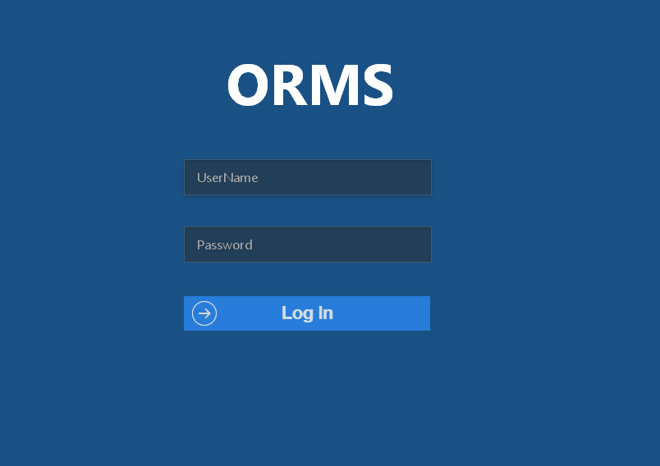

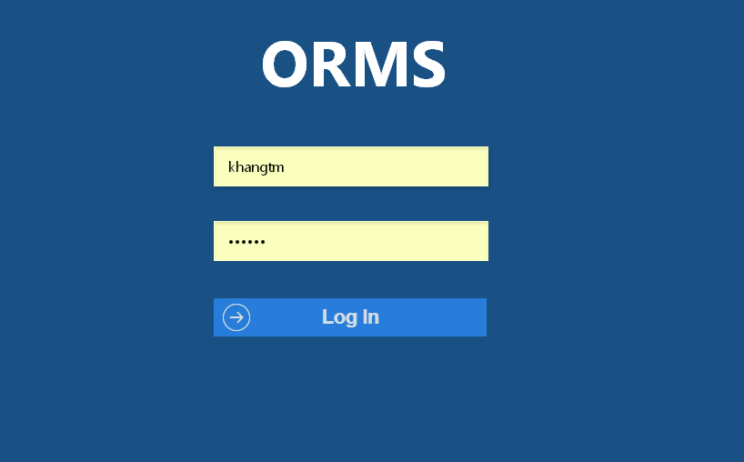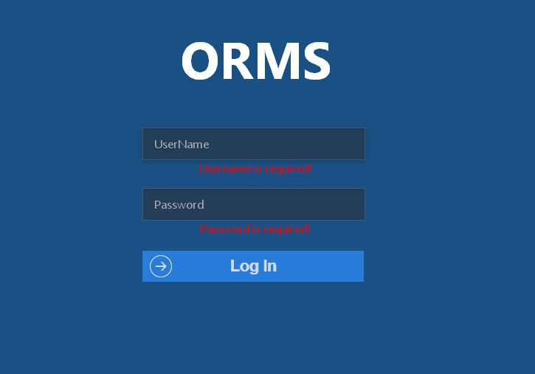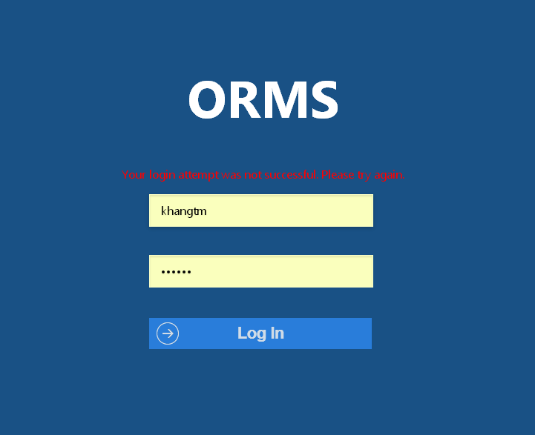

**Data field**

|  |  |  |  |
| --- | --- | --- | --- |
| No | Item | Type | Description |
|  |  |  |  |

## SC02: Logout

**Data field**

|  |  |  |  |
| --- | --- | --- | --- |
| No | Item | Type | Description |
|  |  |  |  |

## SC03: Admin home page

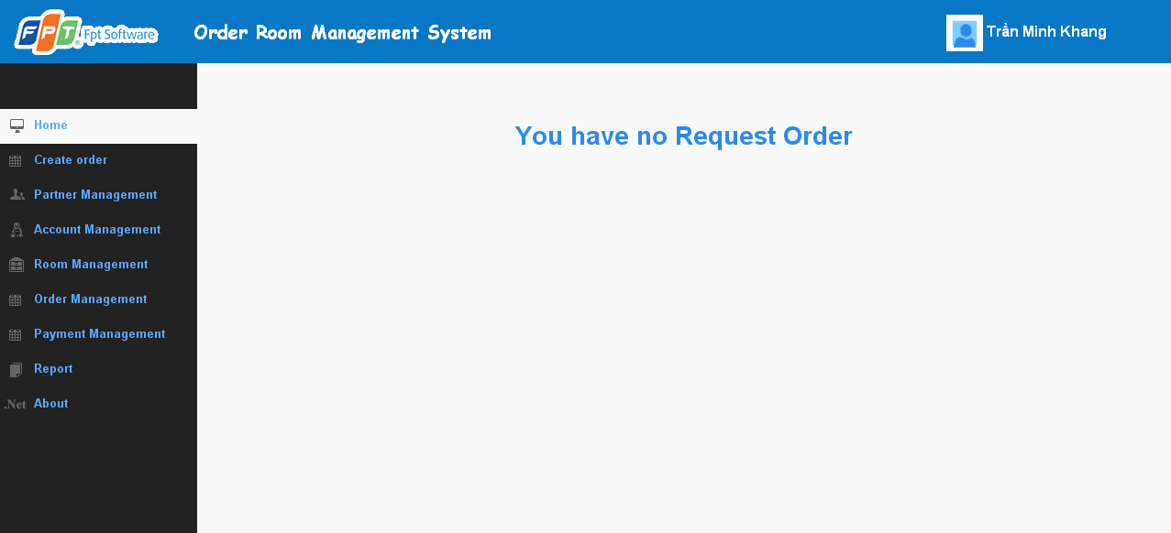

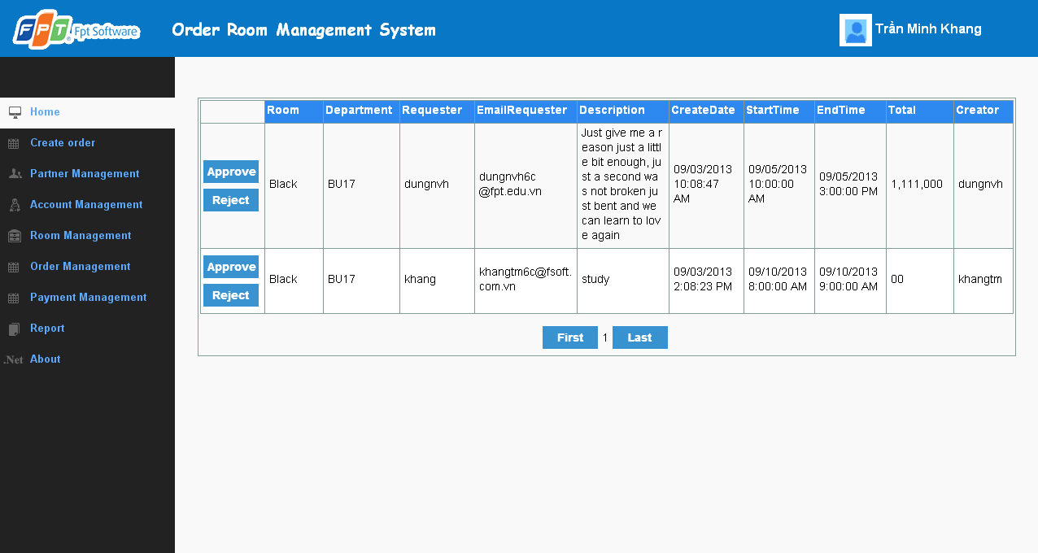

**Data field**

|  |  |  |  |
| --- | --- | --- | --- |
| No | Item | Type | Description |
|  |  |  |  |

## SC04: View image of all members

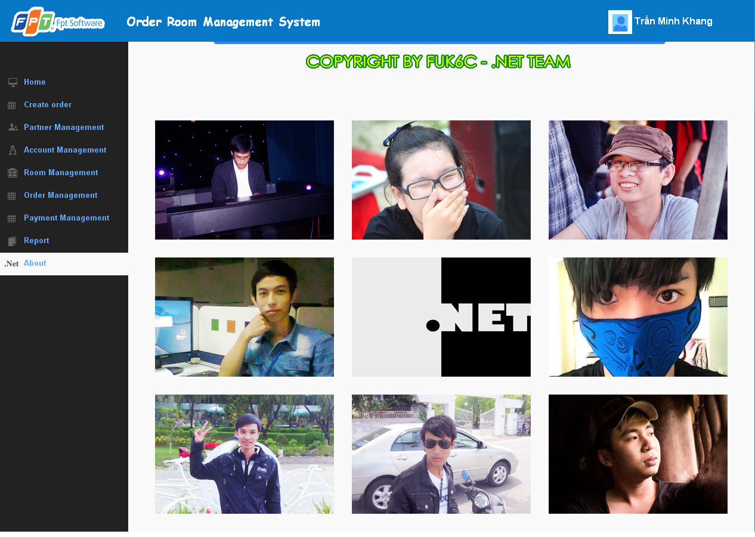

**Data field**

|  |  |  |  |
| --- | --- | --- | --- |
| No | Item | Type | Description |
|  |  |  |  |

## SC05: View information of each members

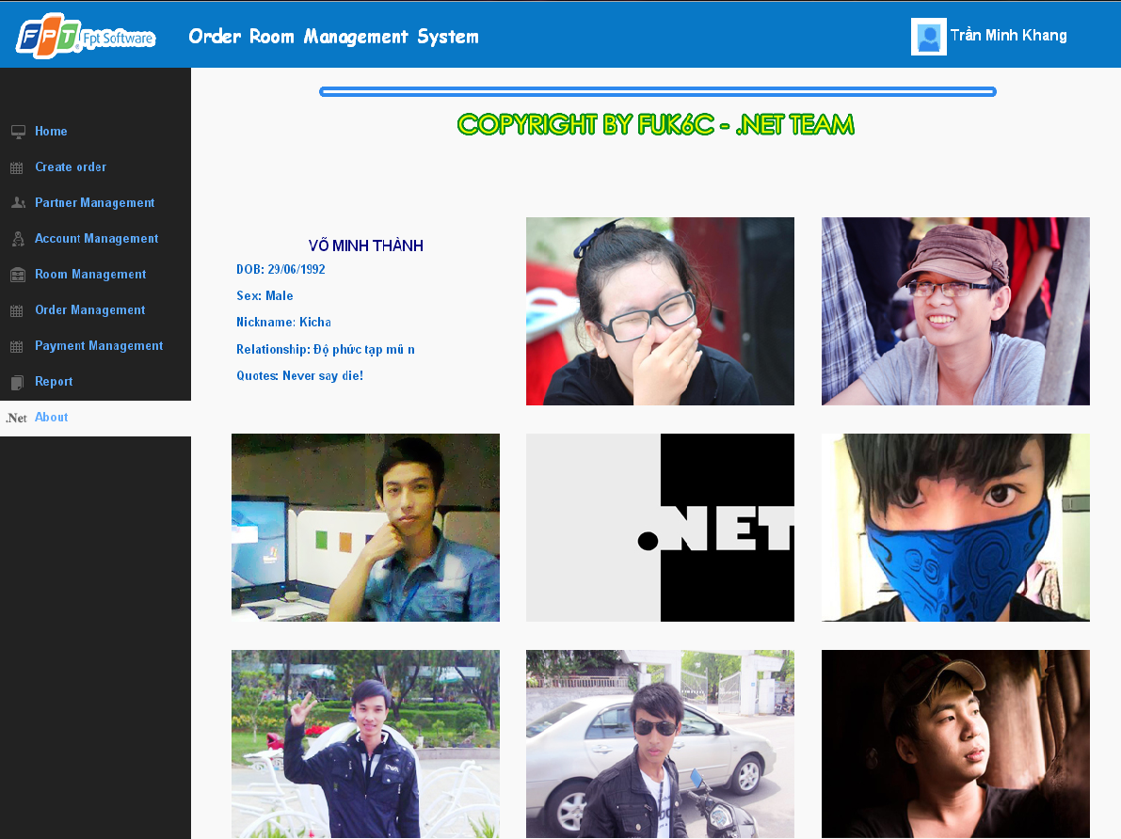

**Data field**

|  |  |  |  |
| --- | --- | --- | --- |
| No | Item | Type | Description |
|  |  |  |  |

## SC06: View all account

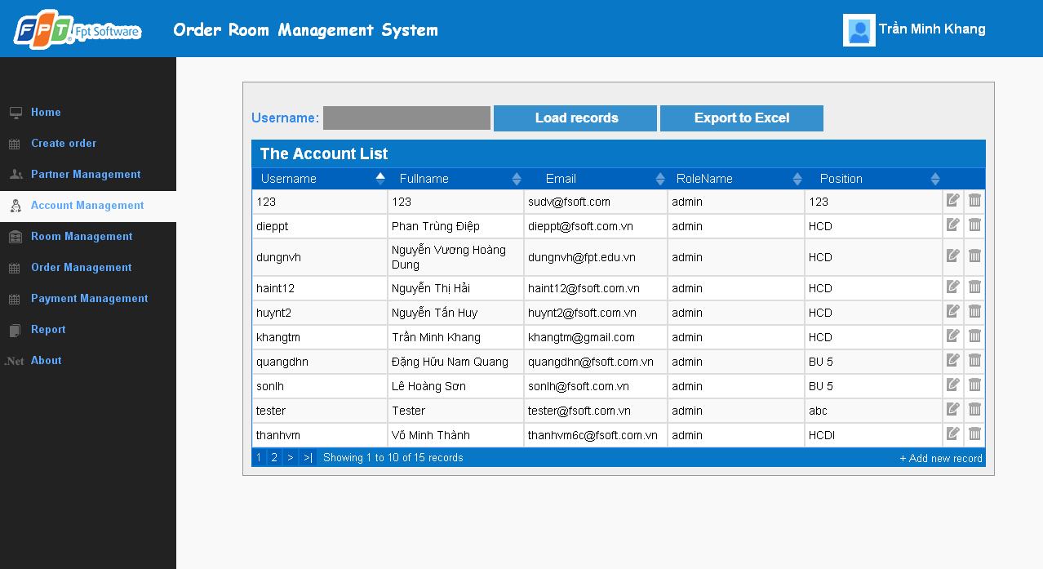

**Data field**

|  |  |  |  |
| --- | --- | --- | --- |
| No | Item | Type | Description |
|  |  |  |  |

## SC07: Create new account

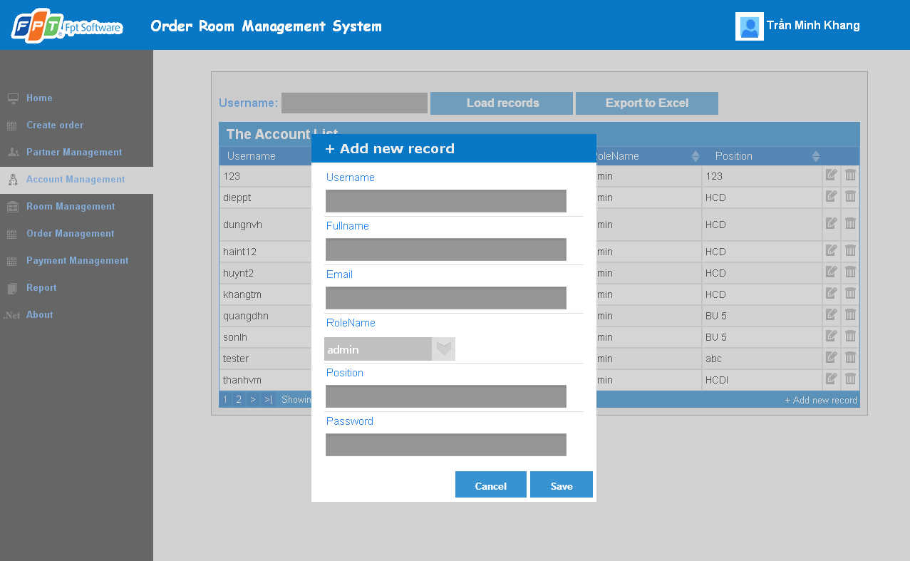

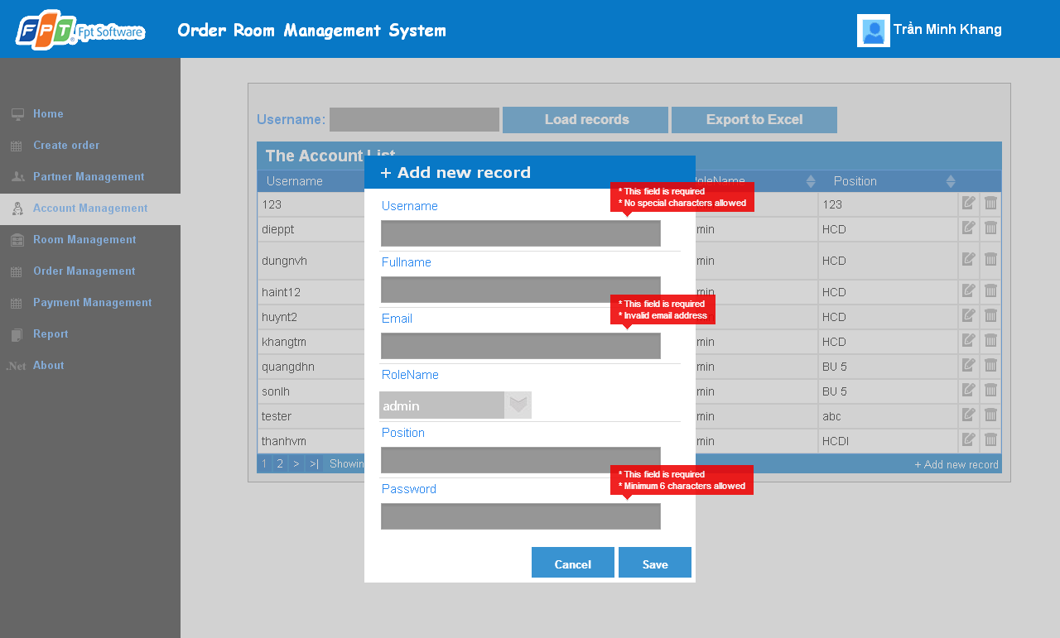

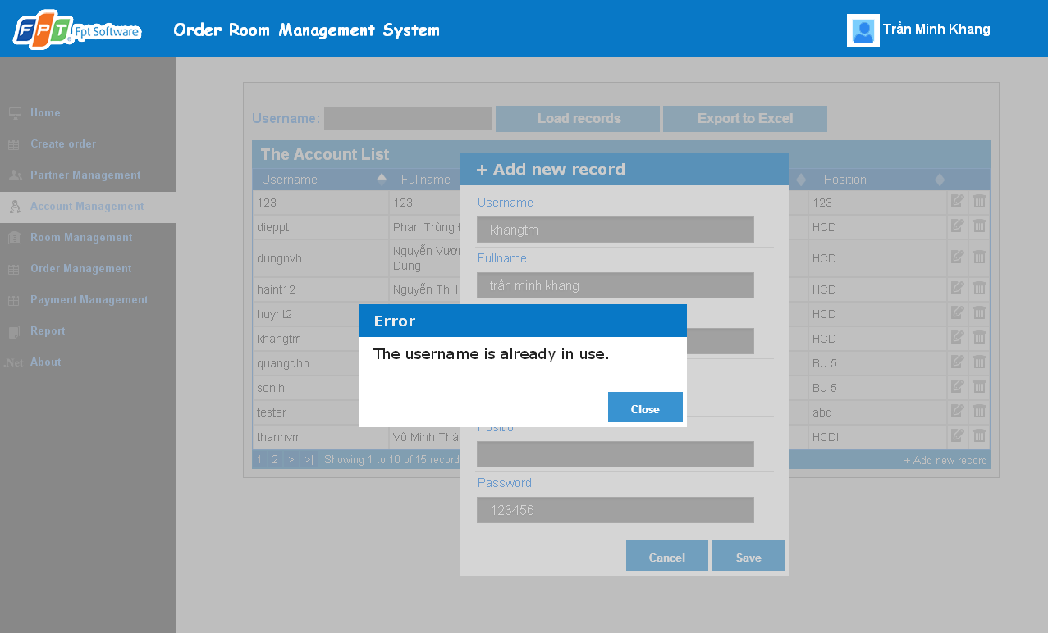

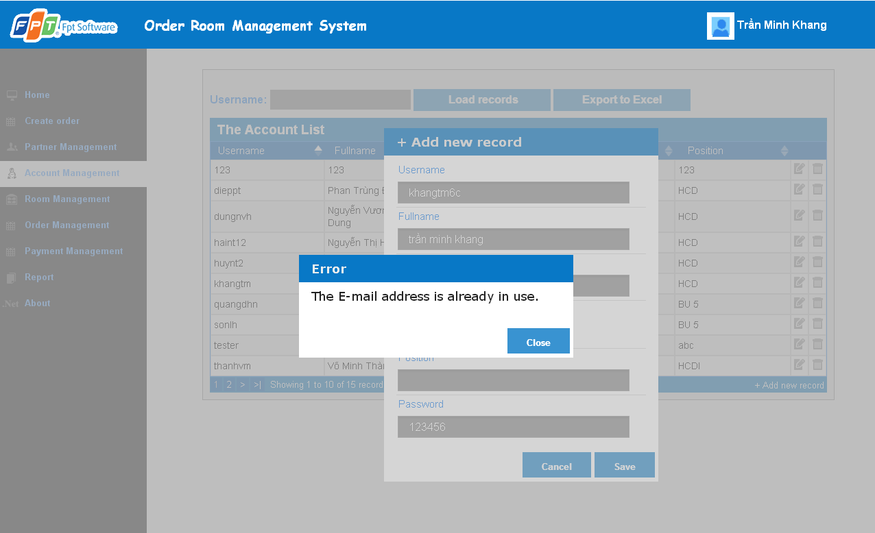

**Data field**

|  |  |  |  |
| --- | --- | --- | --- |
| No | Item | Type | Description |
|  |  |  |  |

## SC08: Update account

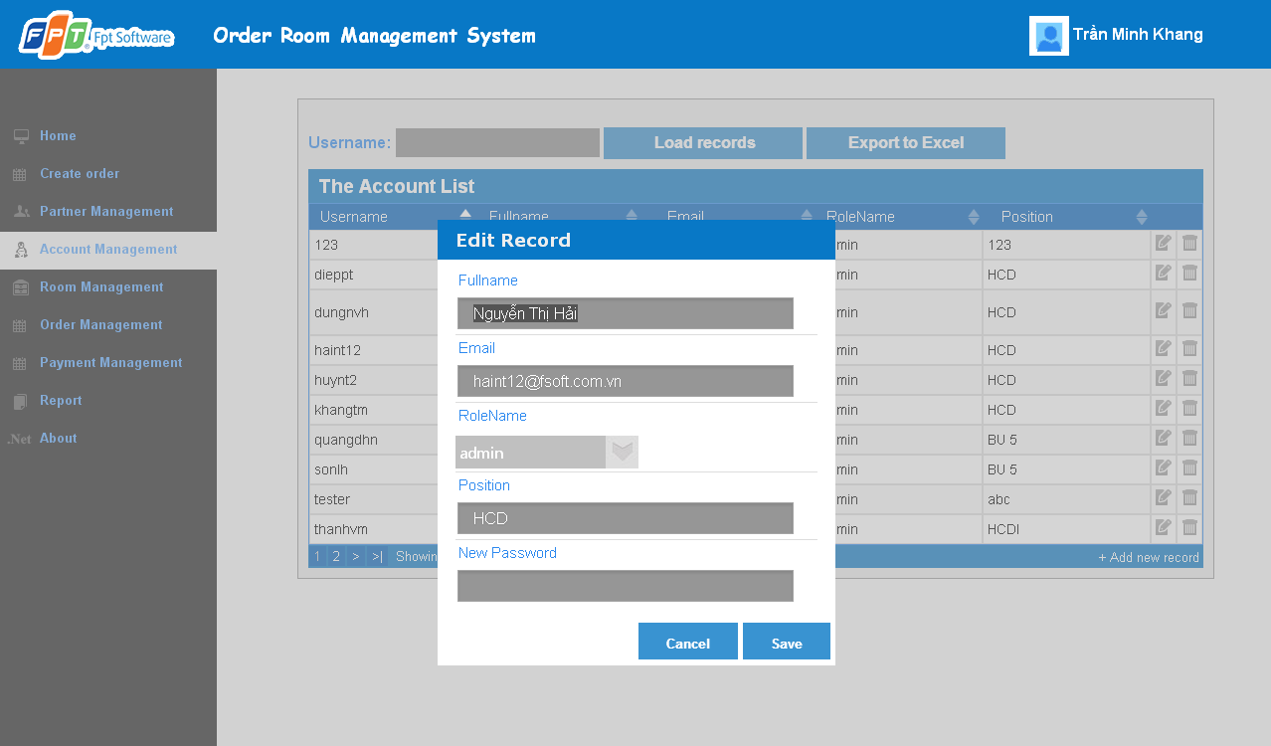

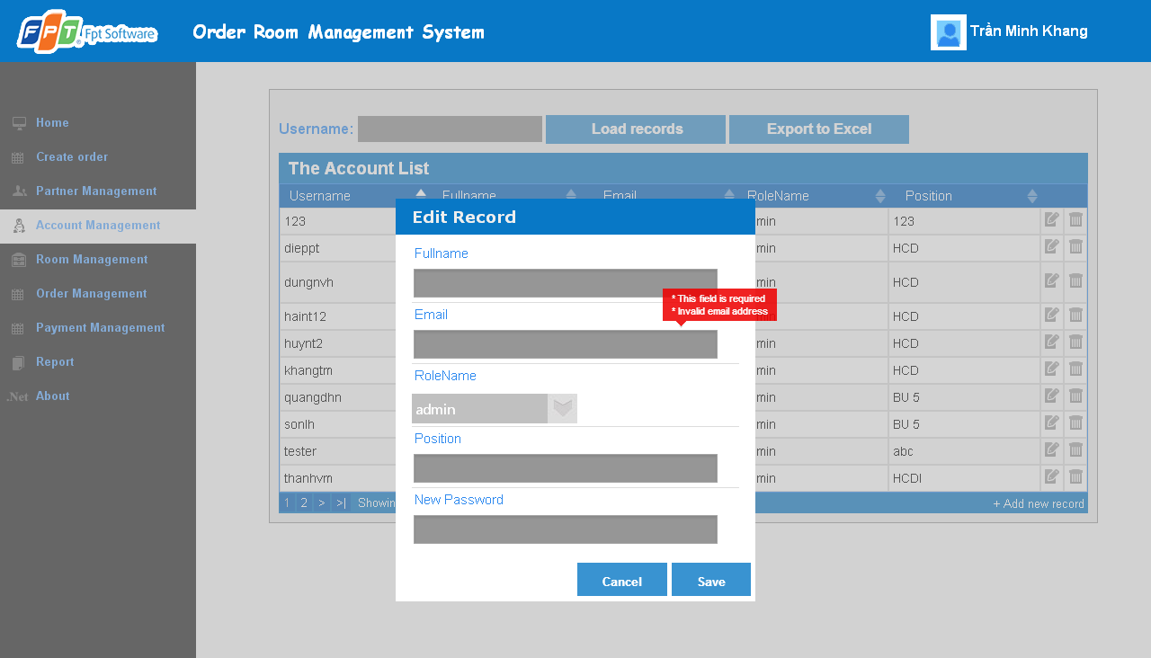

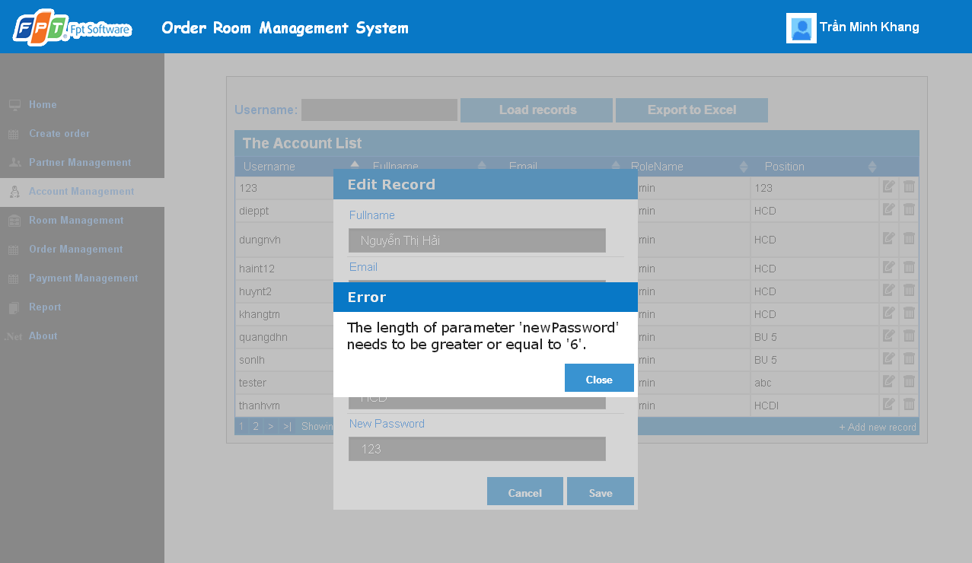

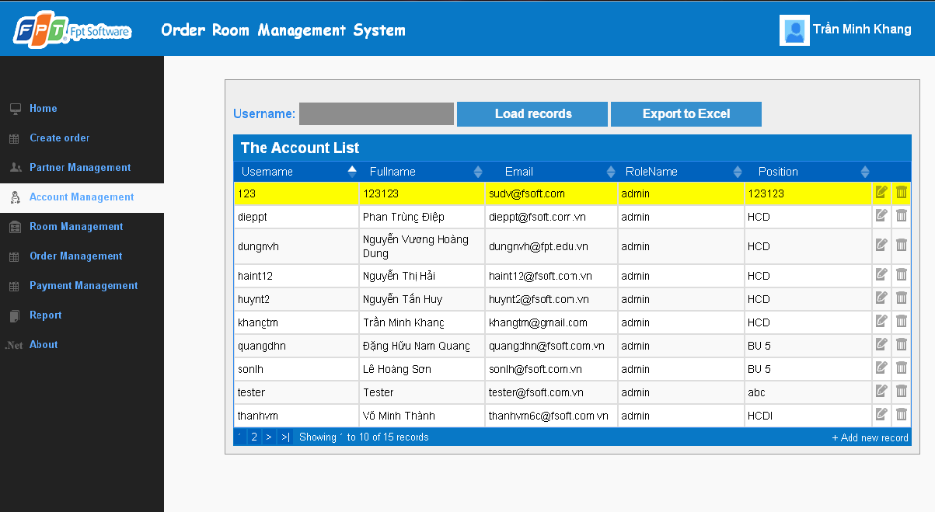

**Data field**

|  |  |  |  |
| --- | --- | --- | --- |
| No | Item | Type | Description |
|  |  |  |  |

## SC09: Delete account

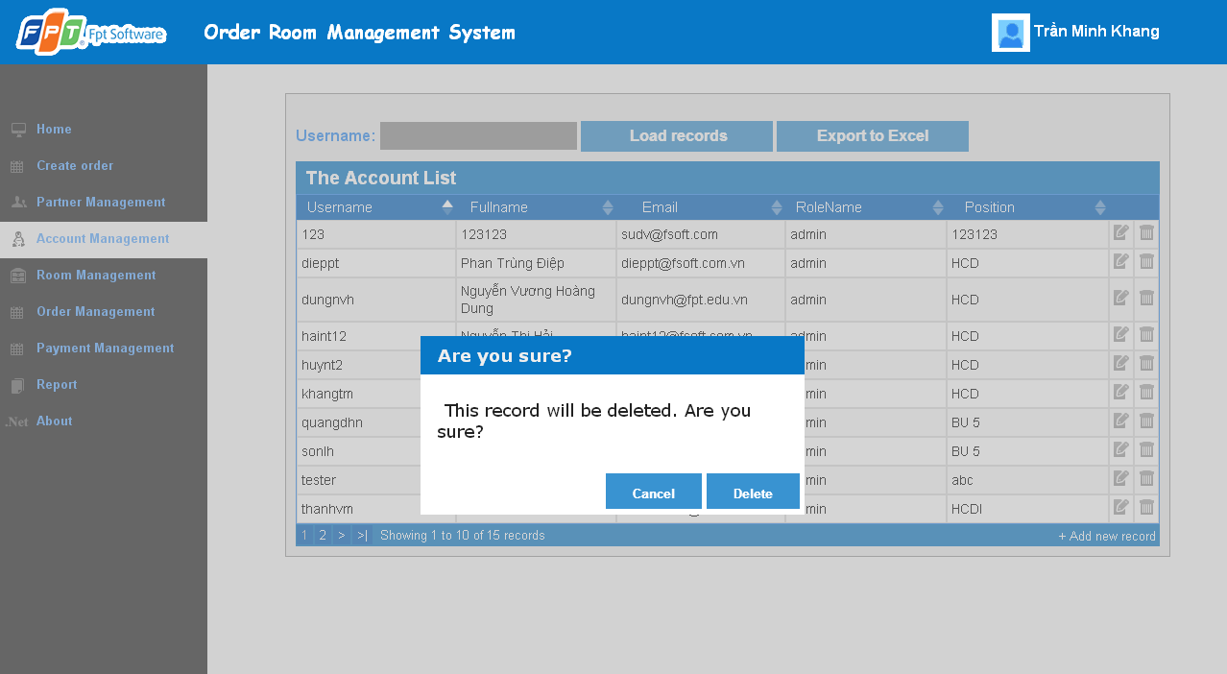

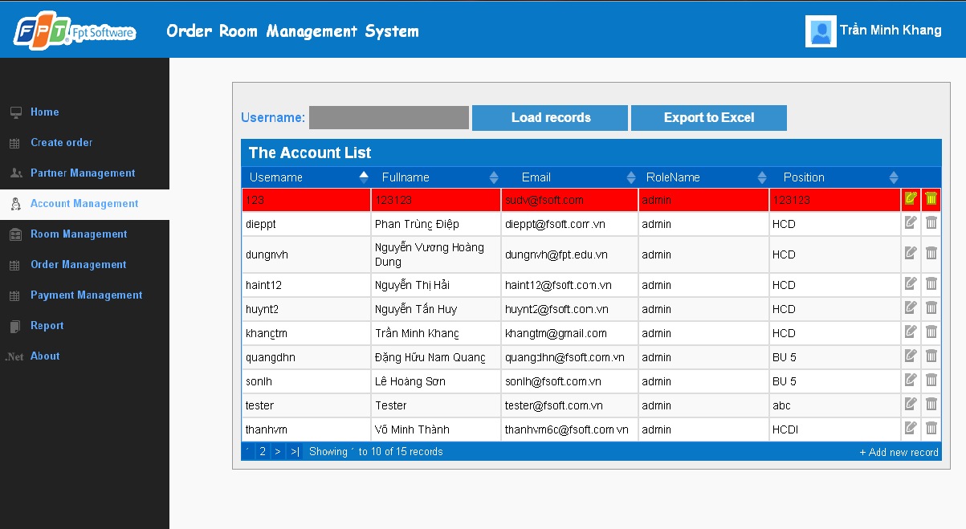

## SC10: View all partner

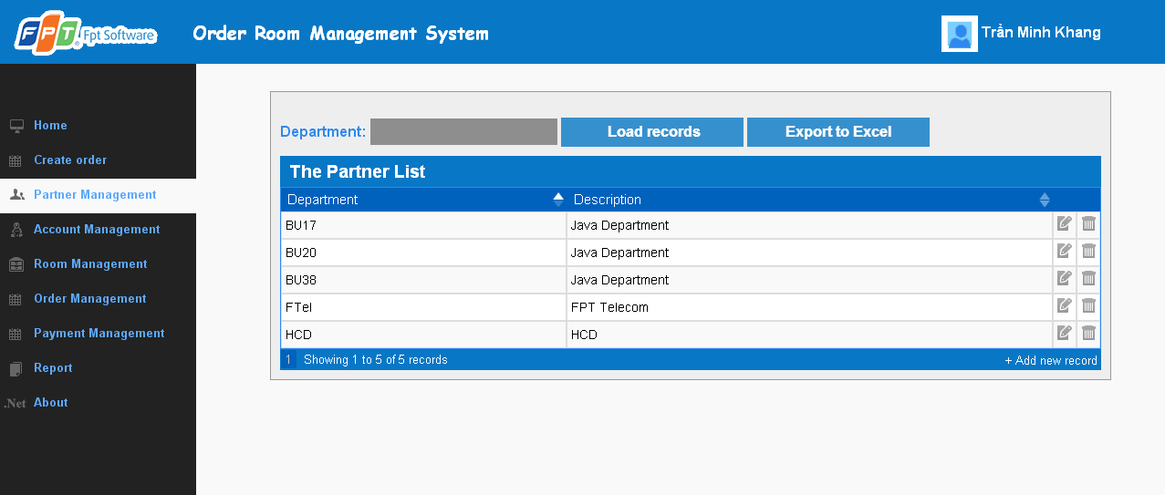

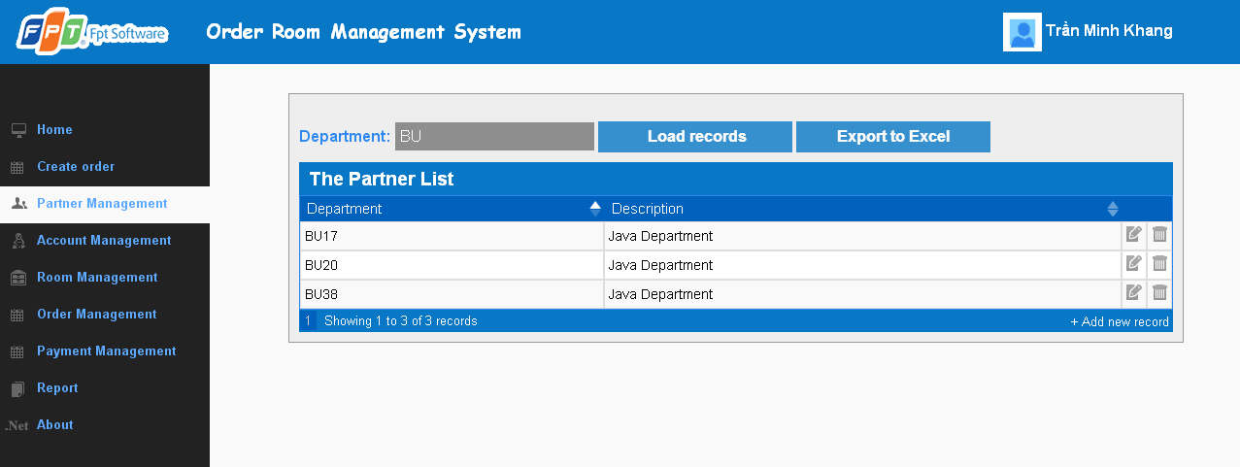

**Data field**

|  |  |  |  |
| --- | --- | --- | --- |
| No | Item | Type | Description |
|  |  |  |  |

## SC11: Create new partner

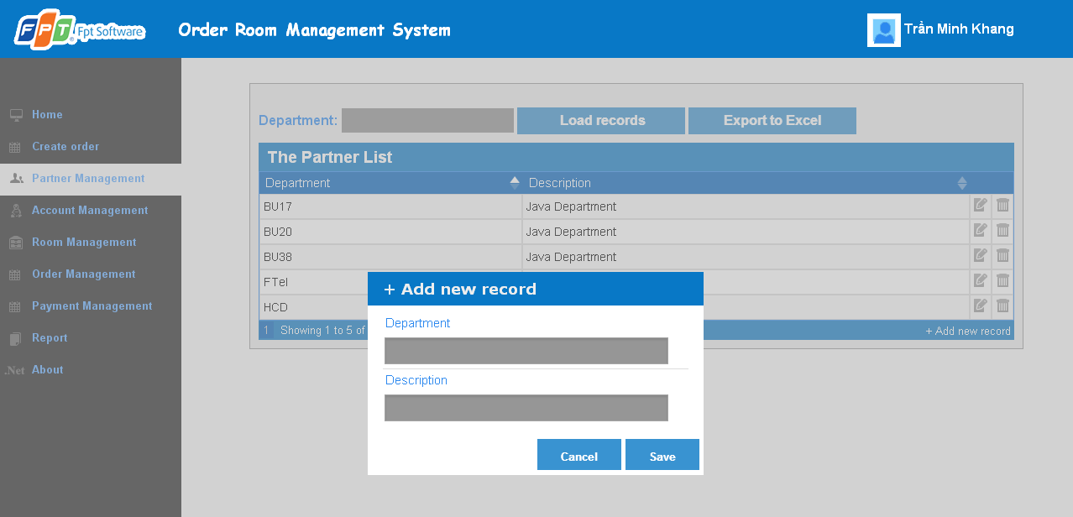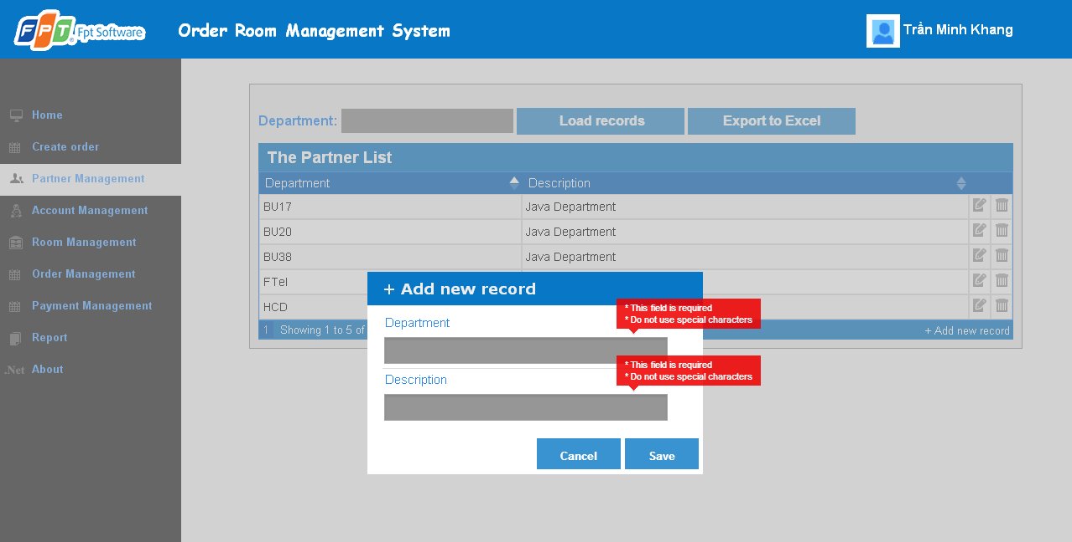

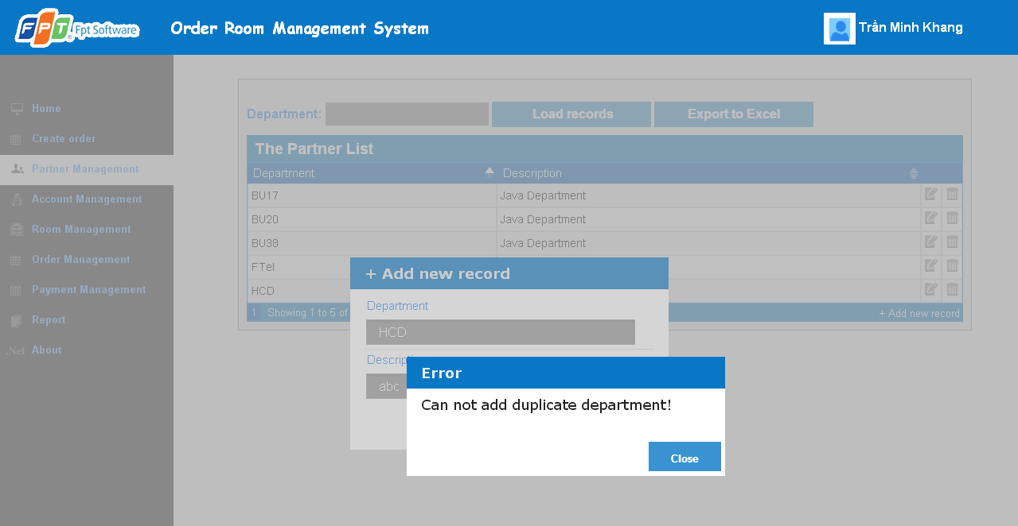

**Data field**

|  |  |  |  |
| --- | --- | --- | --- |
| No | Item | Type | Description |
|  |  |  |  |

## SC12: Update partner

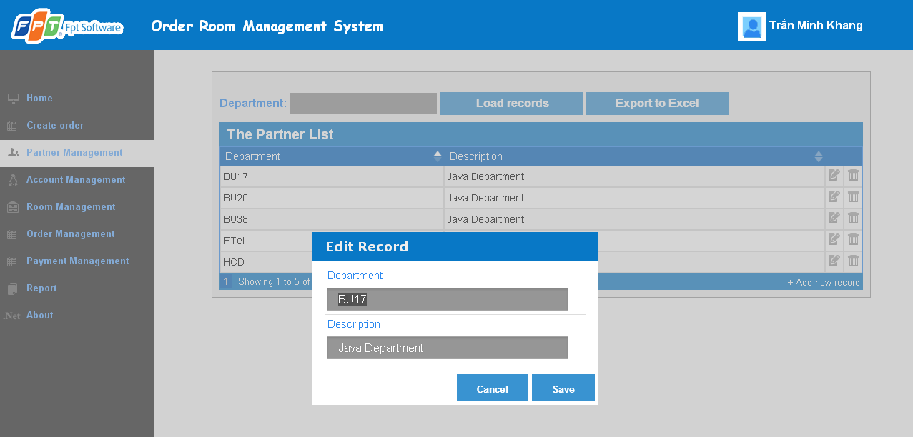

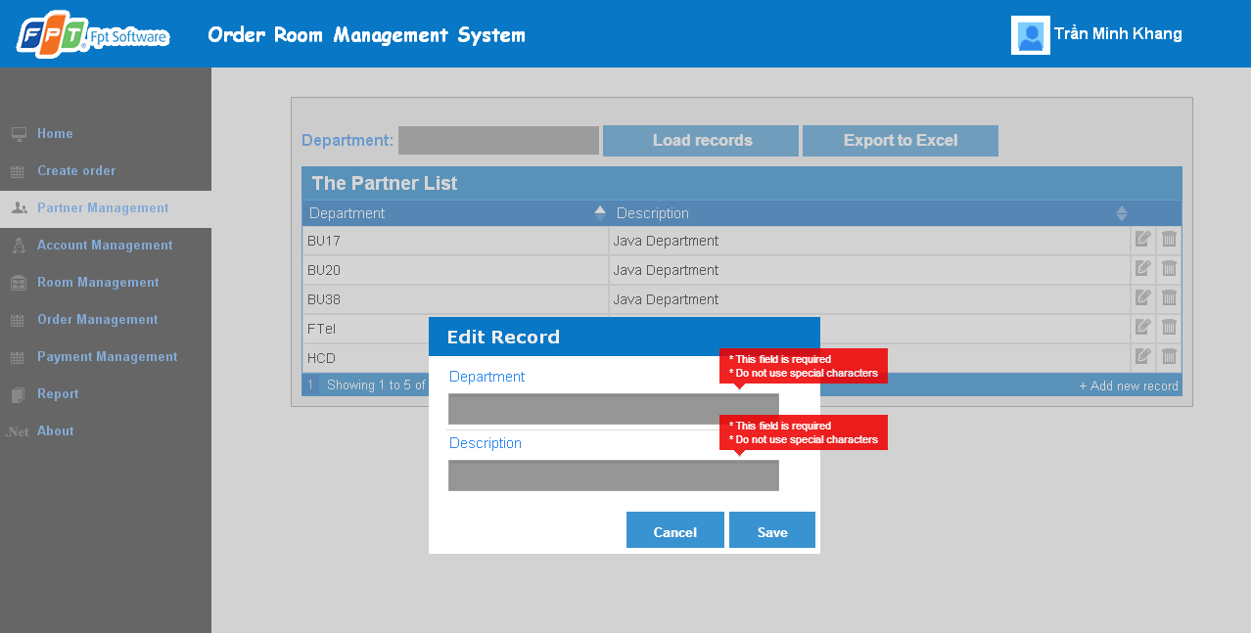

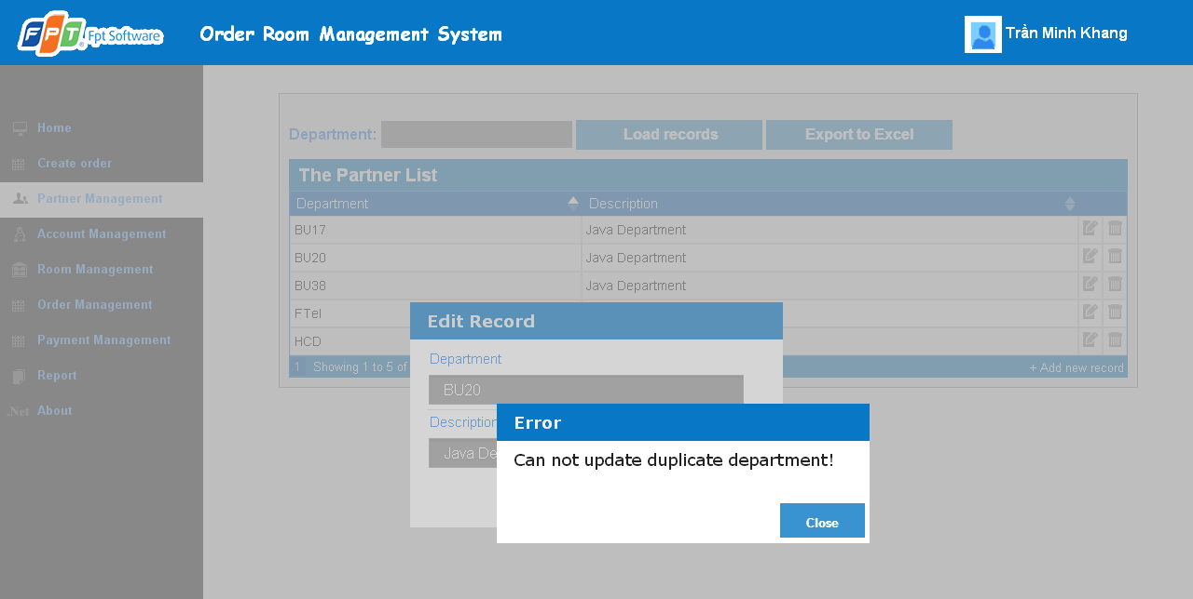

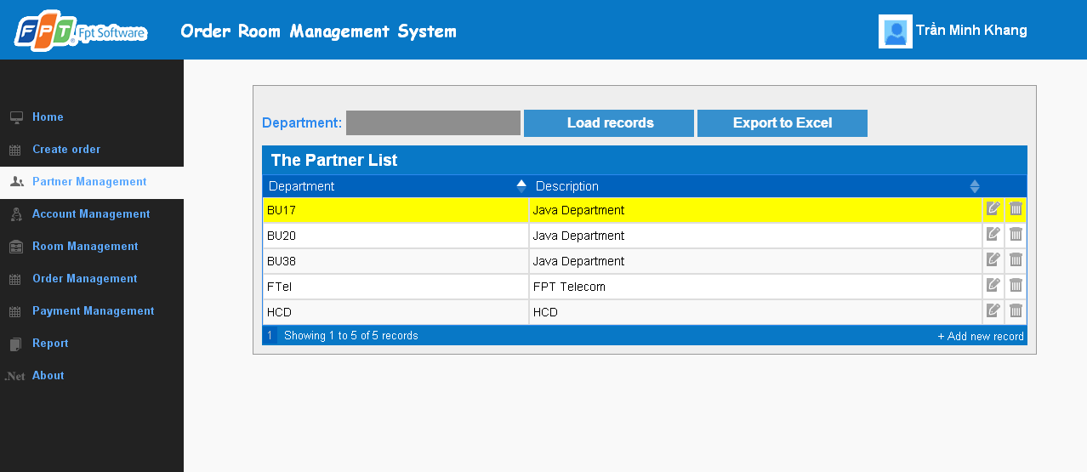

**Data field**

|  |  |  |  |
| --- | --- | --- | --- |
| No | Item | Type | Description |
|  |  |  |  |

## SC13:Delete partner

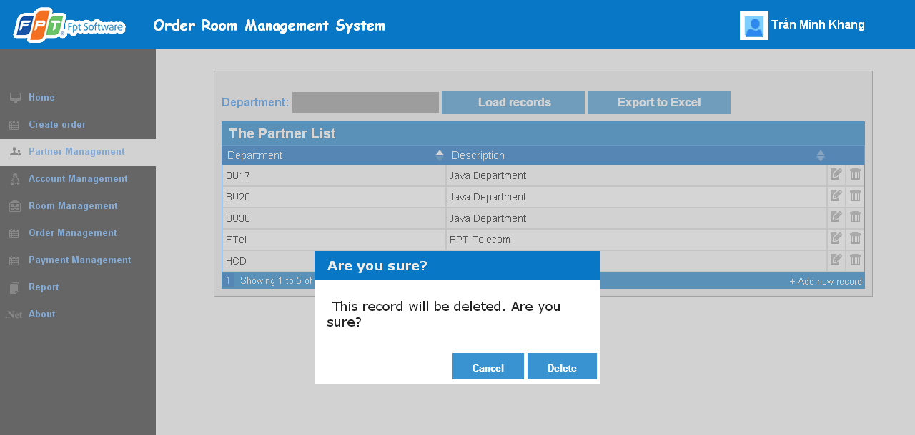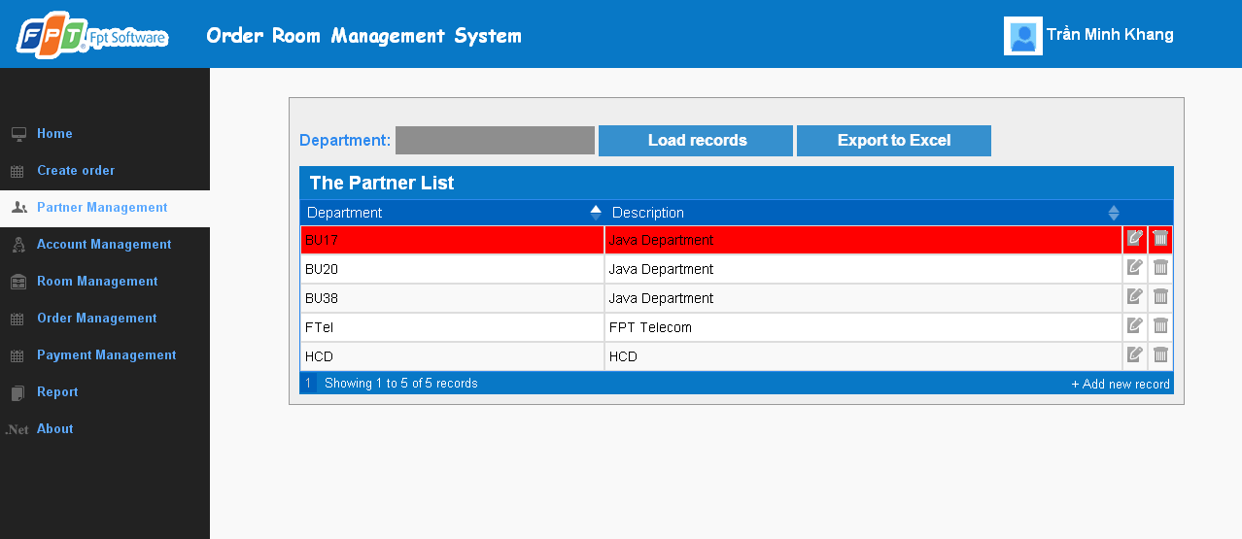

**Data field**

|  |  |  |  |
| --- | --- | --- | --- |
| No | Item | Type | Description |
|  |  |  |  |

## SC14:View all room

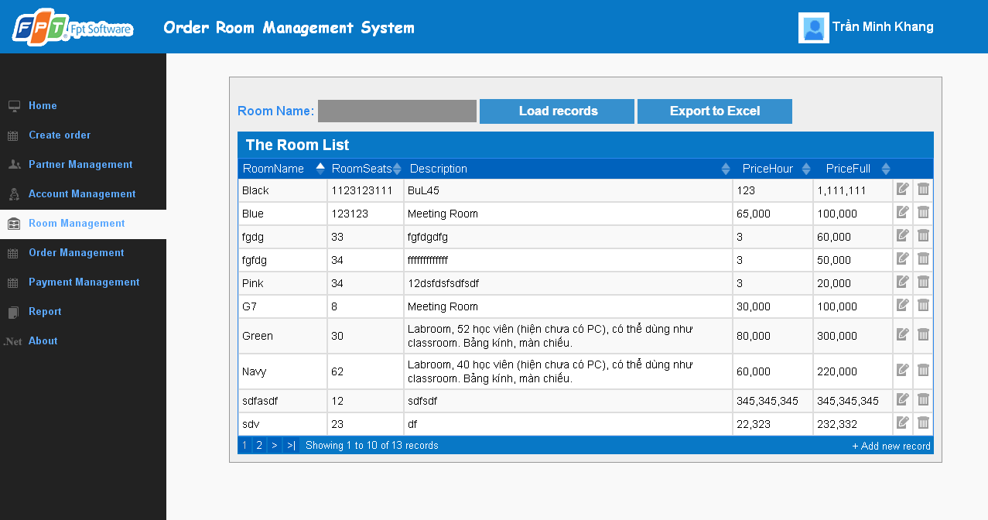

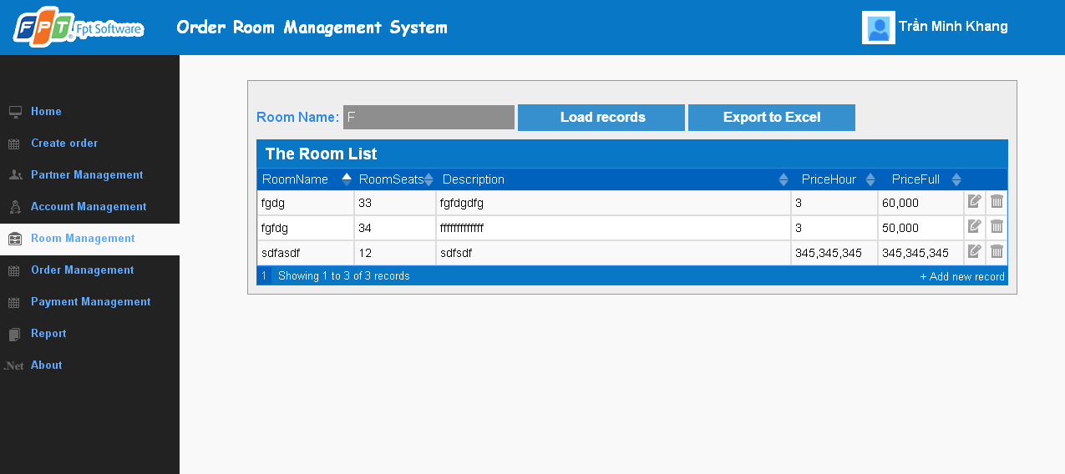

**Data field**

|  |  |  |  |
| --- | --- | --- | --- |
| No | Item | Type | Description |
|  |  |  |  |

## SC15:Create new room

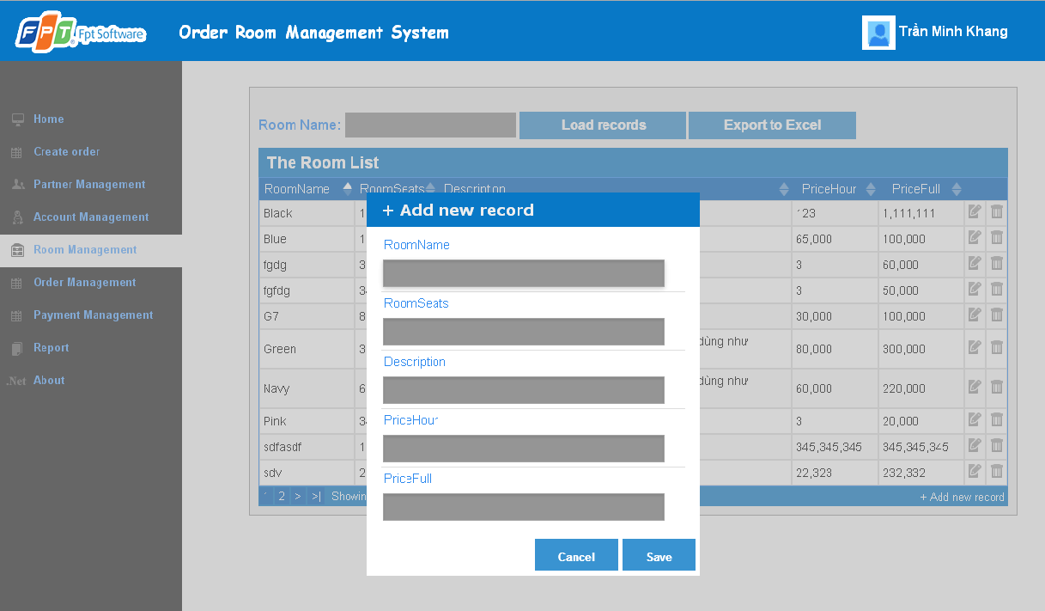

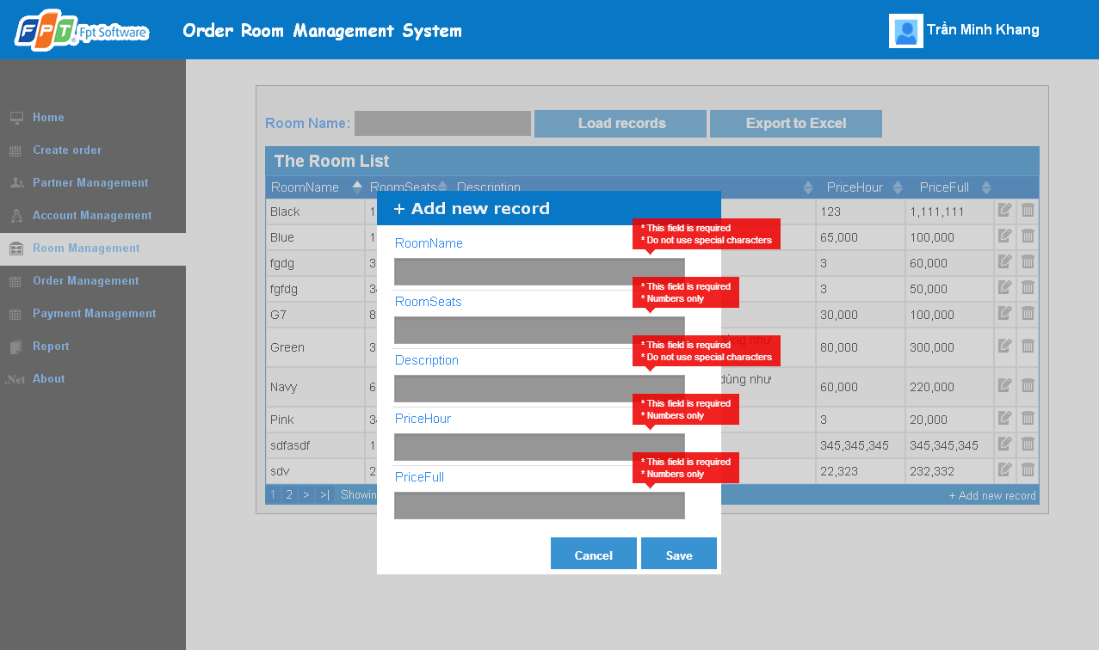

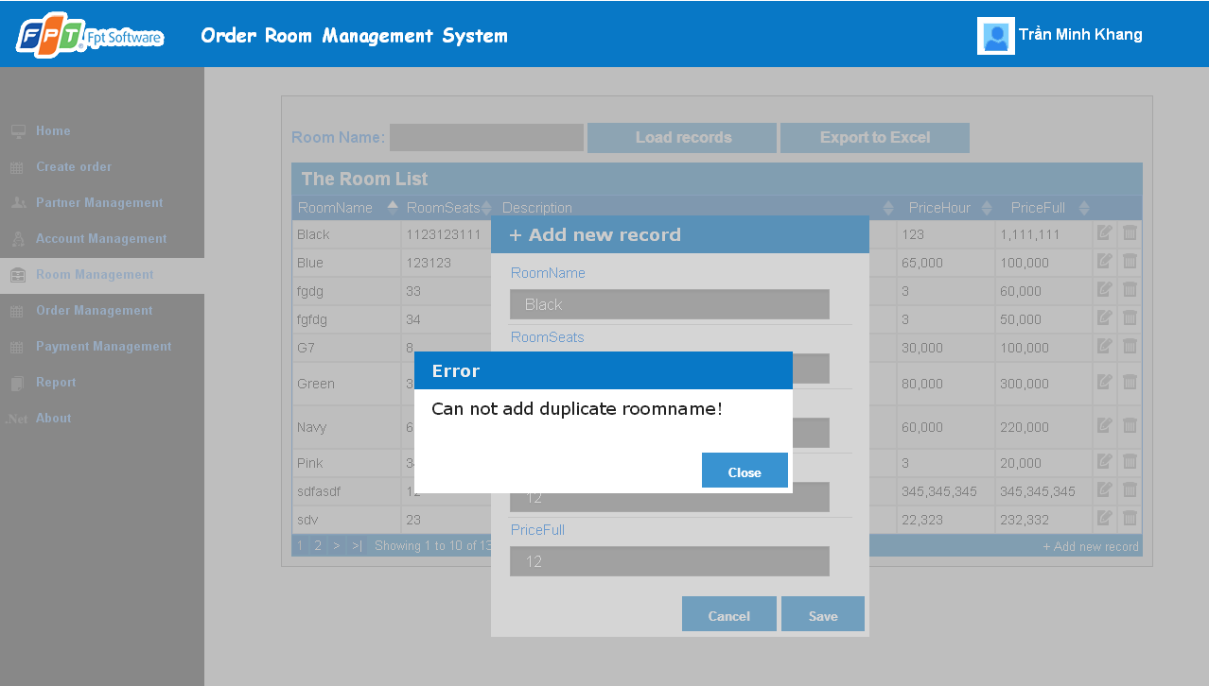

**Data field**

|  |  |  |  |
| --- | --- | --- | --- |
| No | Item | Type | Description |
|  |  |  |  |

## SC16: Update room

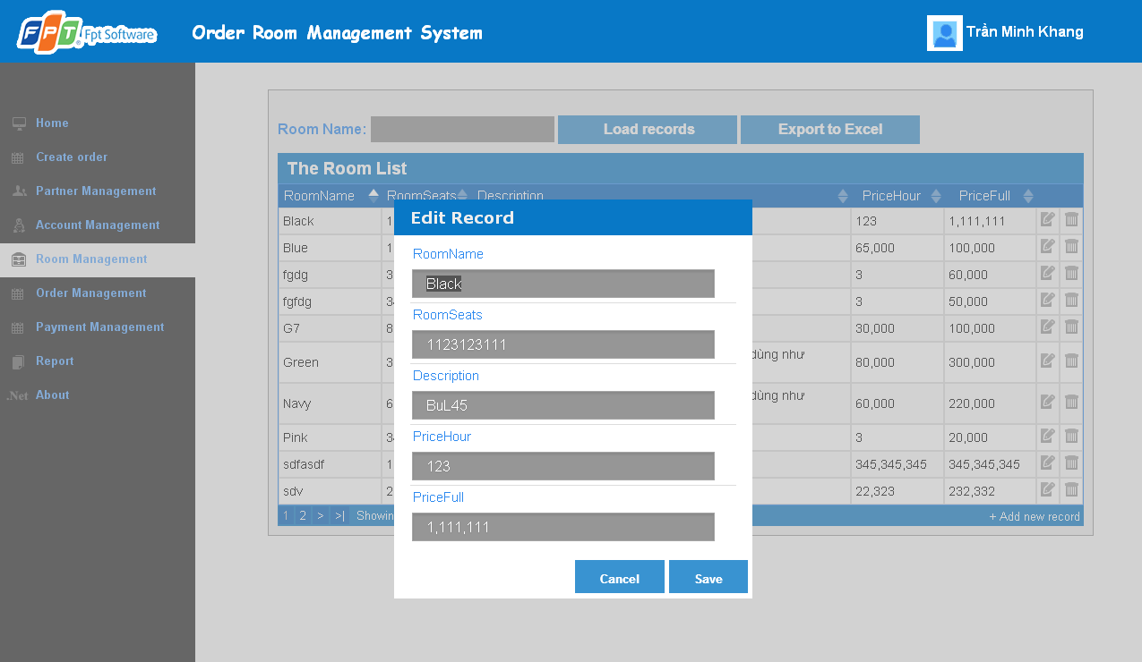

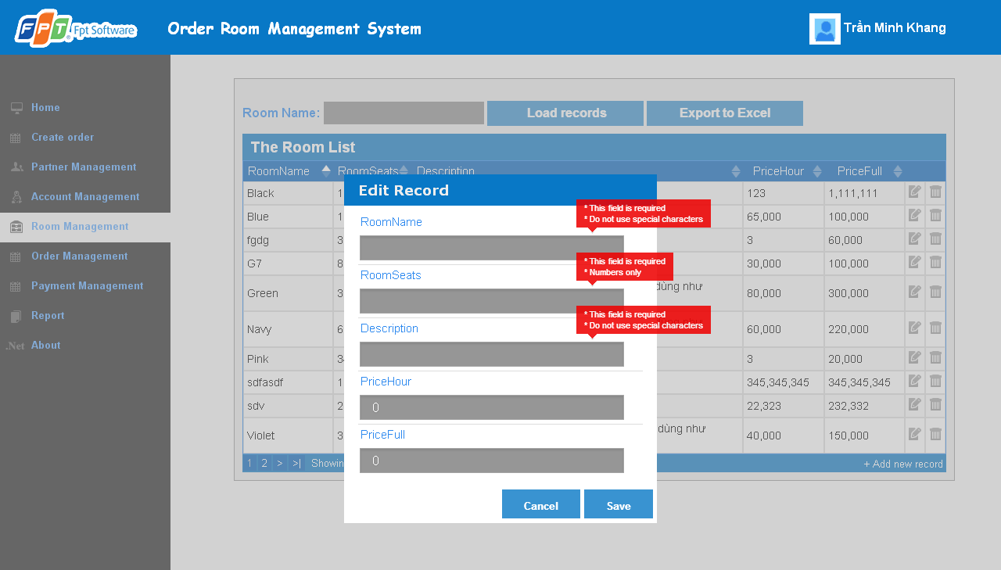

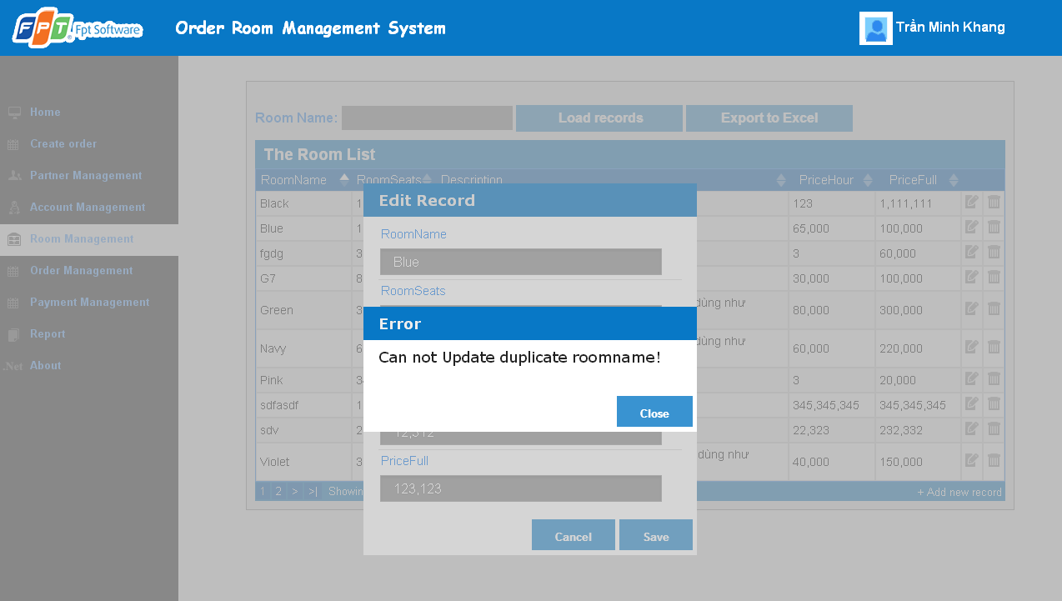

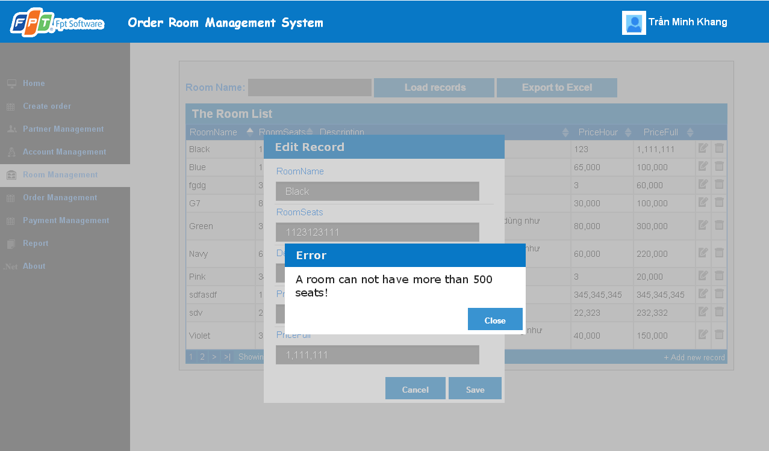

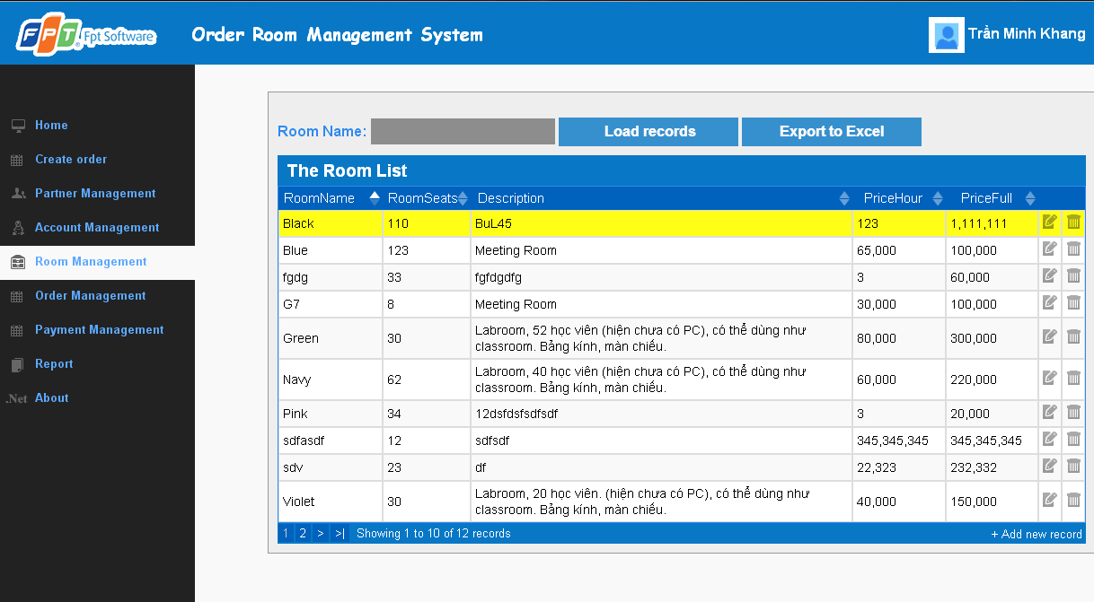

**Data field**

|  |  |  |  |
| --- | --- | --- | --- |
| No | Item | Type | Description |
|  |  |  |  |

## SC17: Delete room

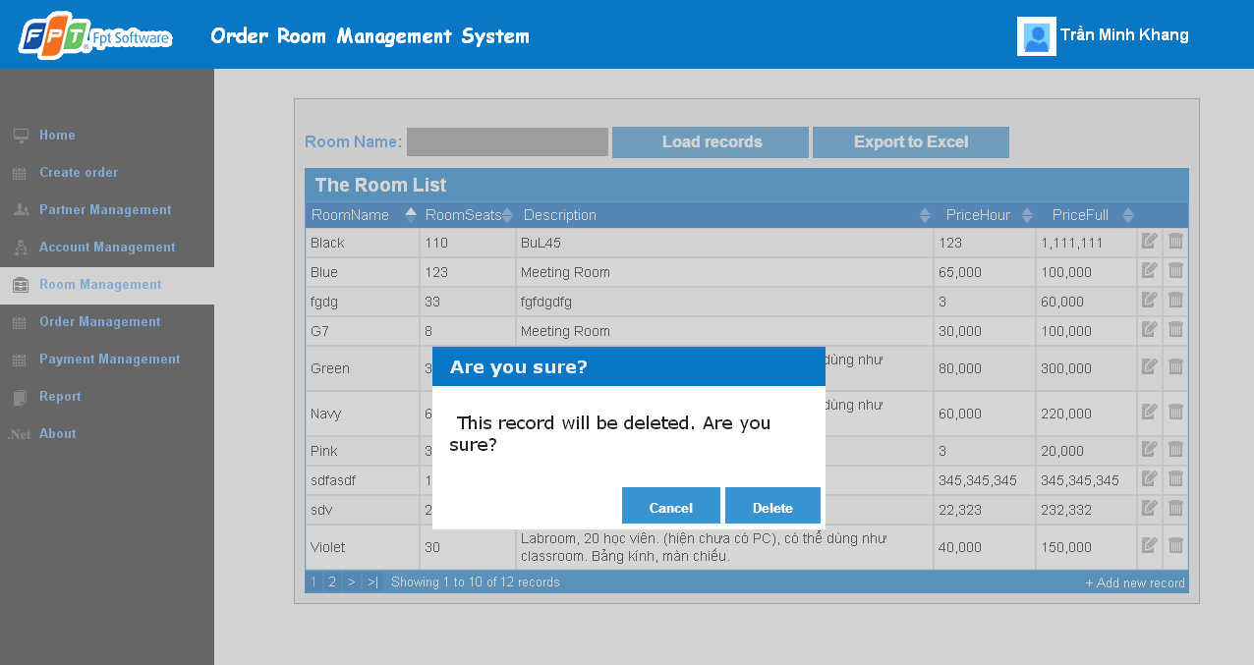

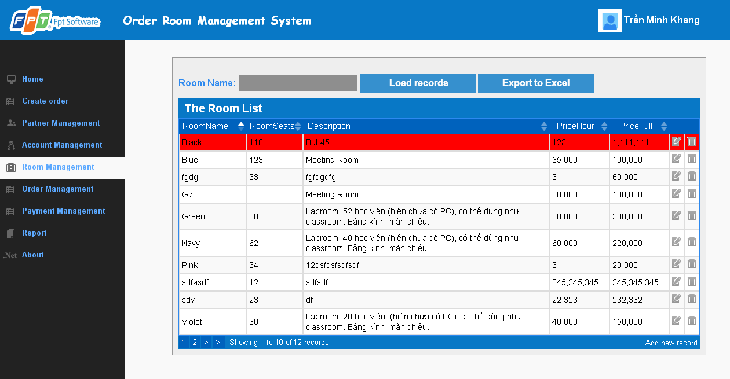

**Data field**

|  |  |  |  |
| --- | --- | --- | --- |
| No | Item | Type | Description |
|  |  |  |  |

## SC18: View all order

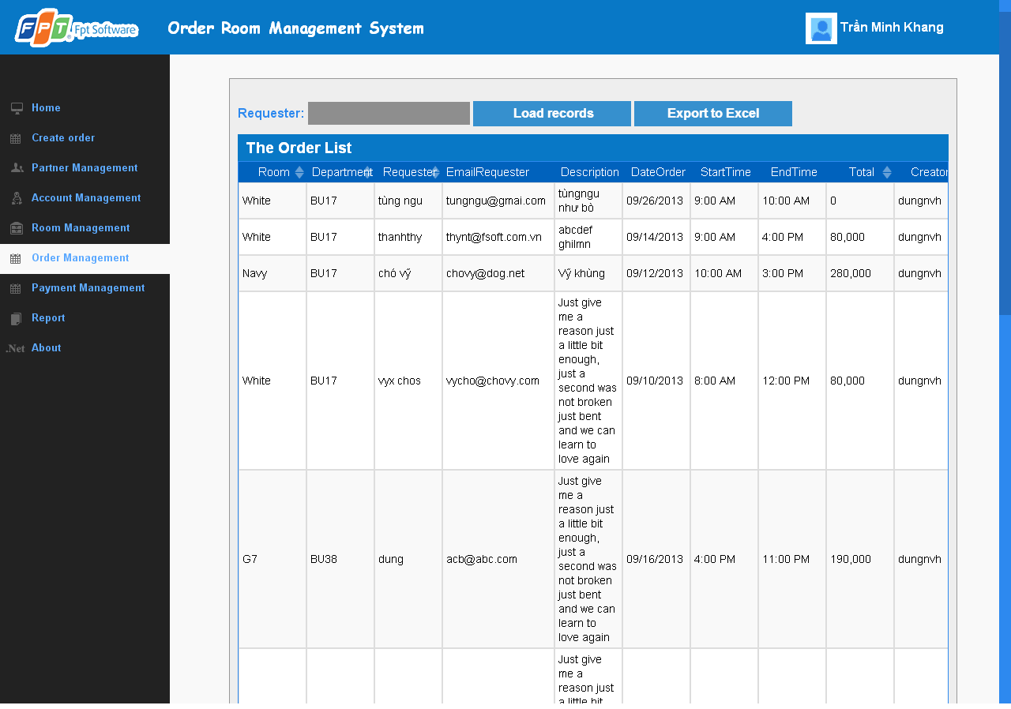

**Data field**

|  |  |  |  |
| --- | --- | --- | --- |
| No | Item | Type | Description |
|  |  |  |  |

## SC19: Create new order in Order Management Page

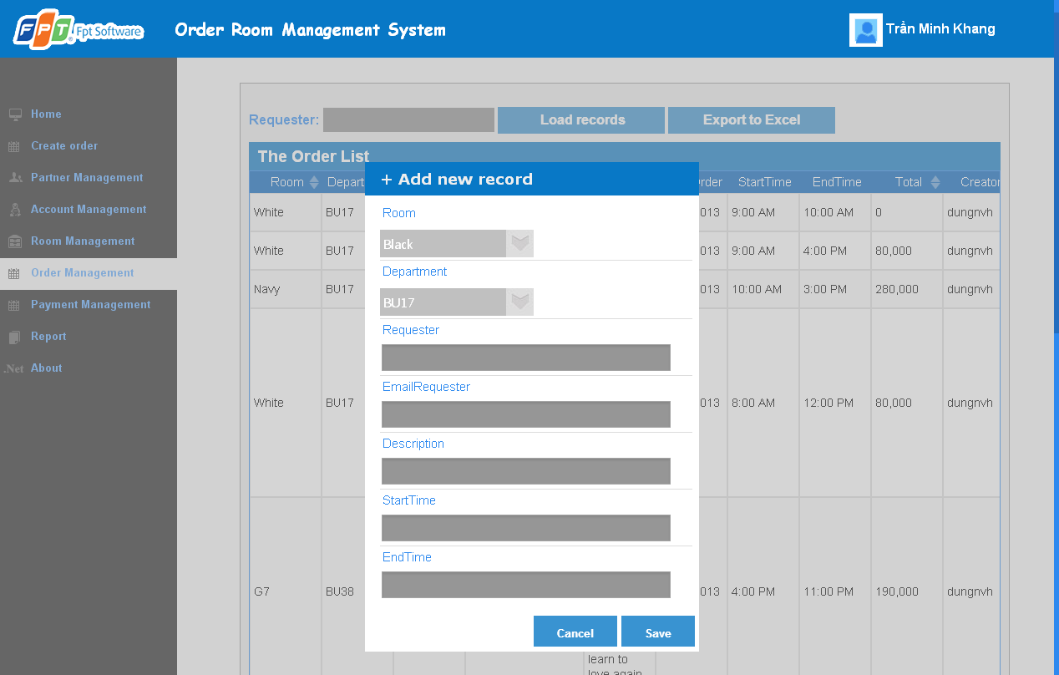

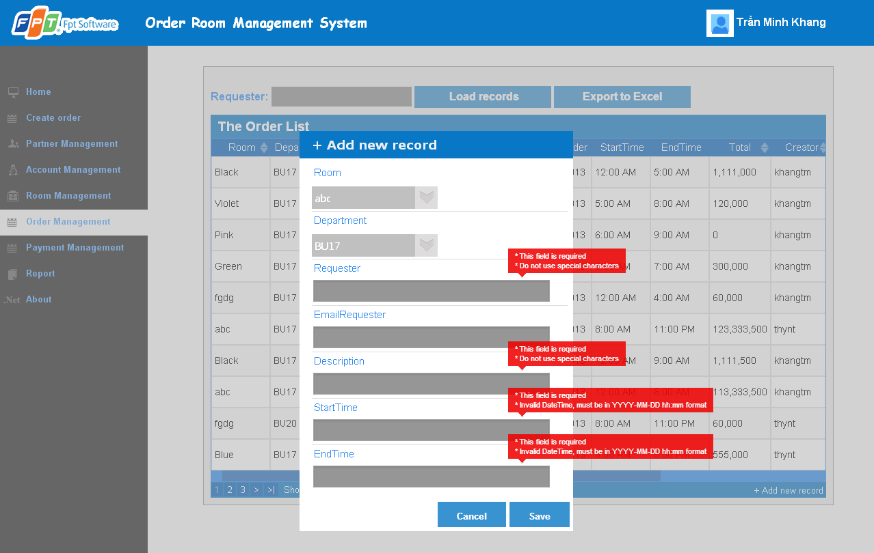 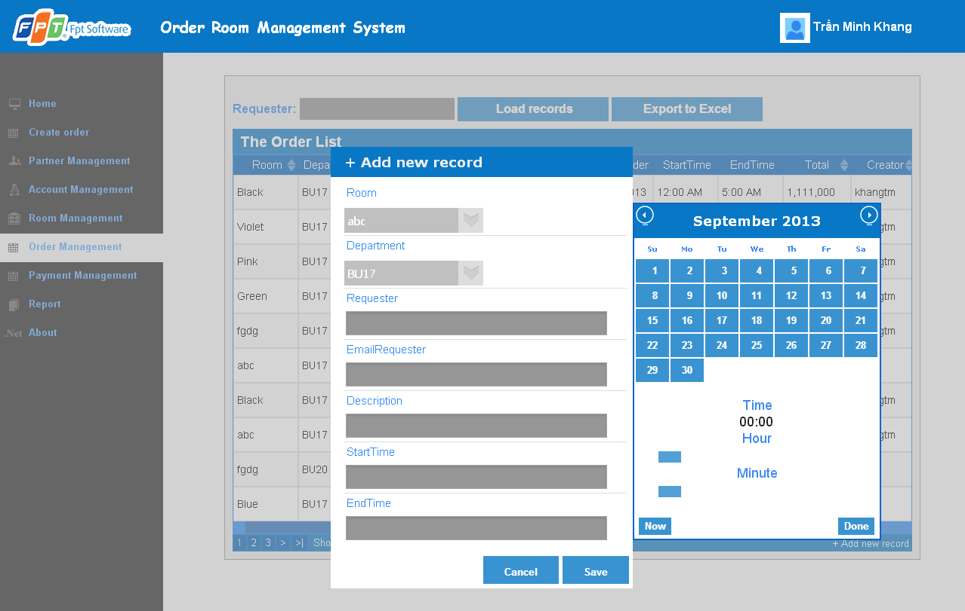

**Data field**

|  |  |  |  |
| --- | --- | --- | --- |
| No | Item | Type | Description |
|  |  |  |  |

## SC20: Update order

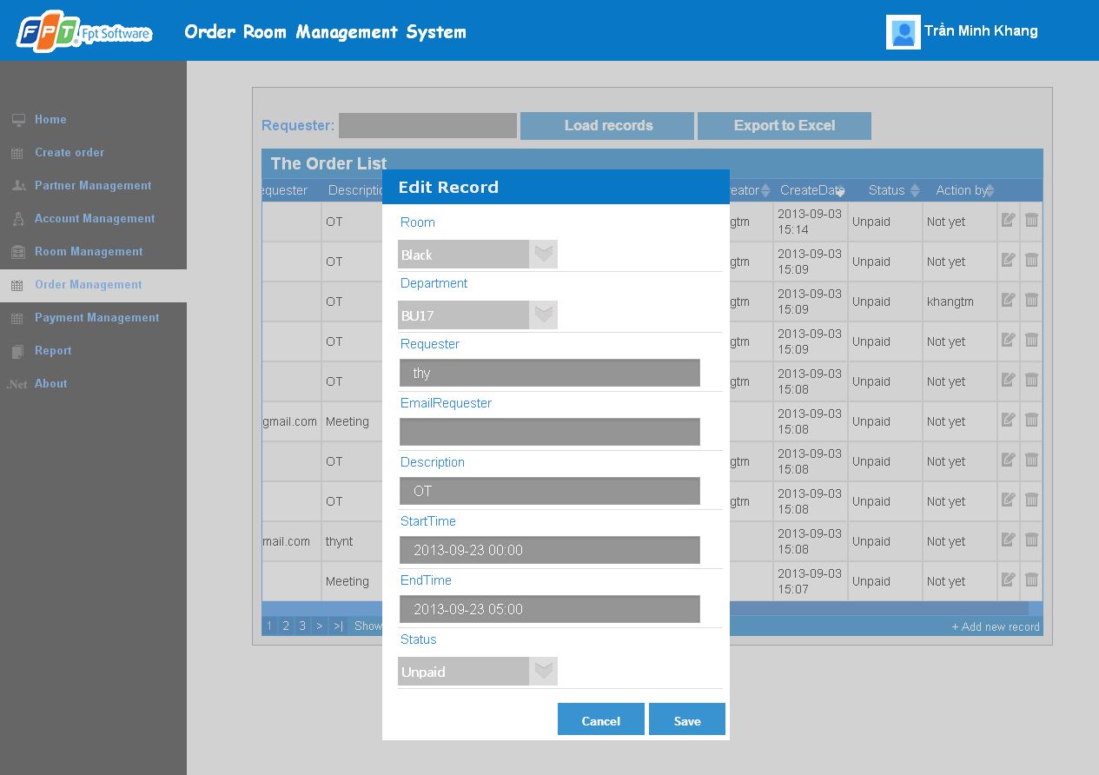

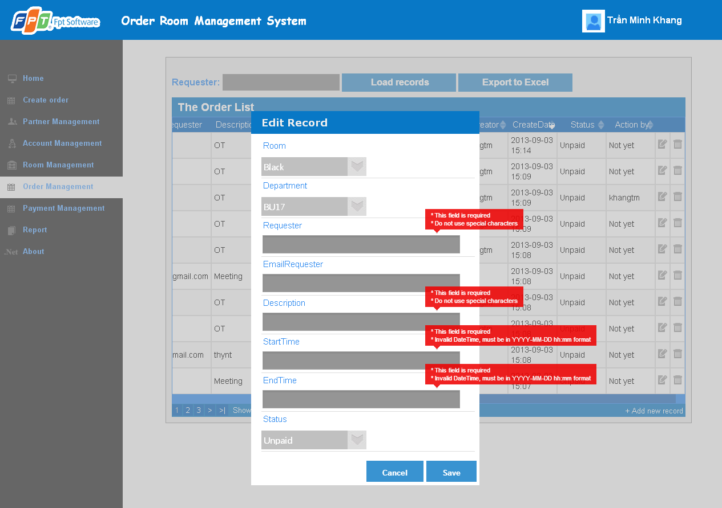

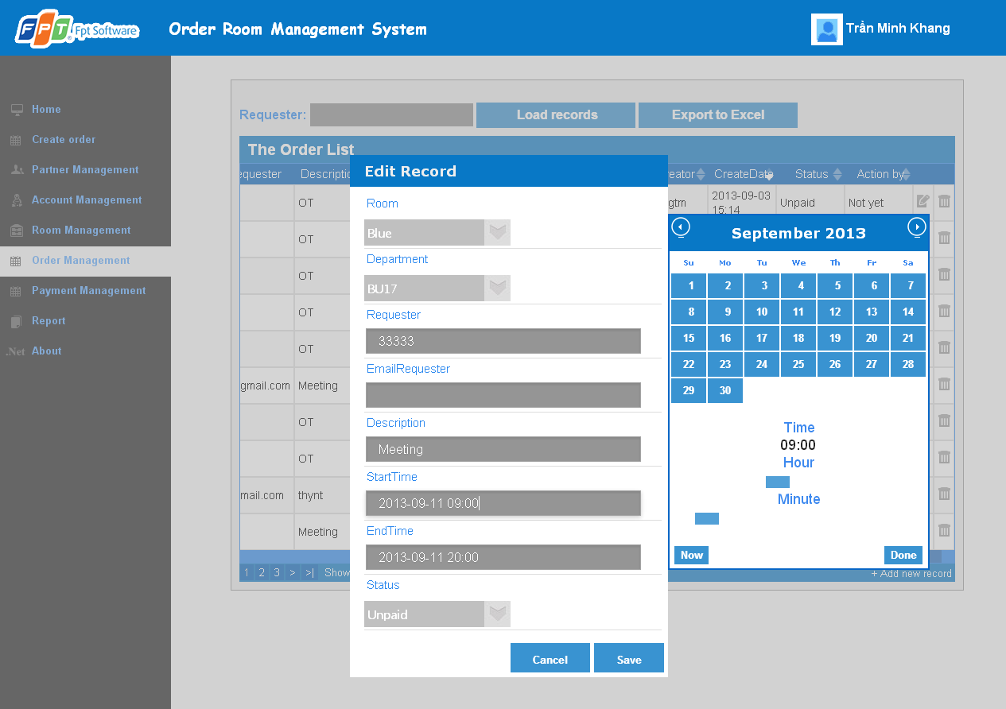

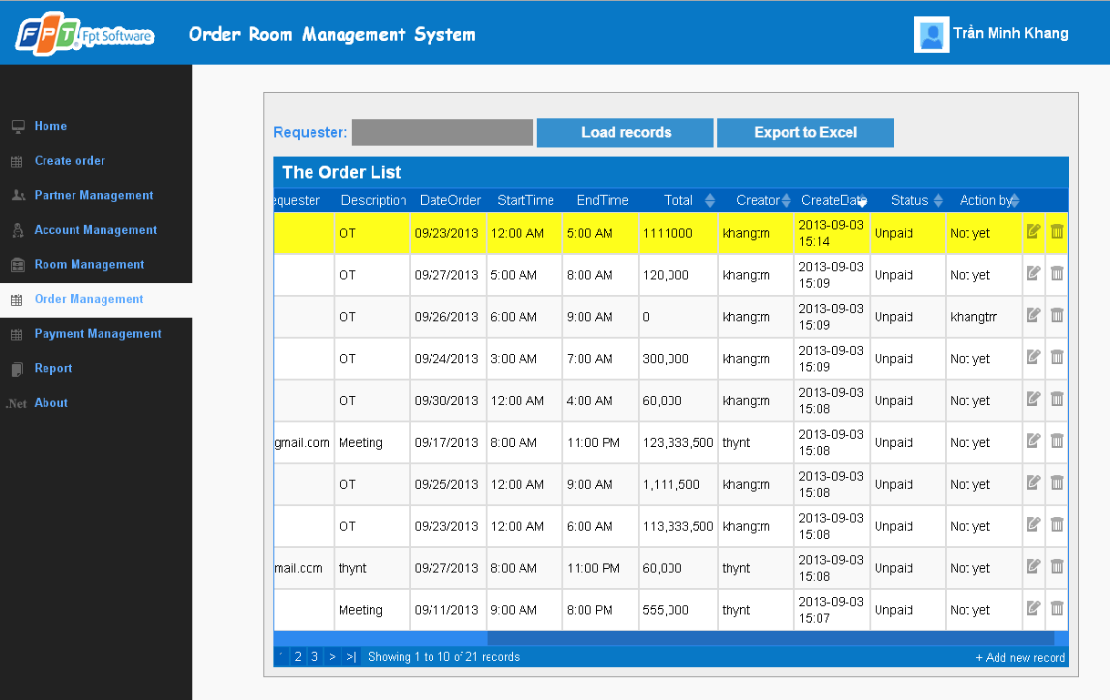

**Data field**

|  |  |  |  |
| --- | --- | --- | --- |
| No | Item | Type | Description |
|  |  |  |  |

## SC21: Delete order

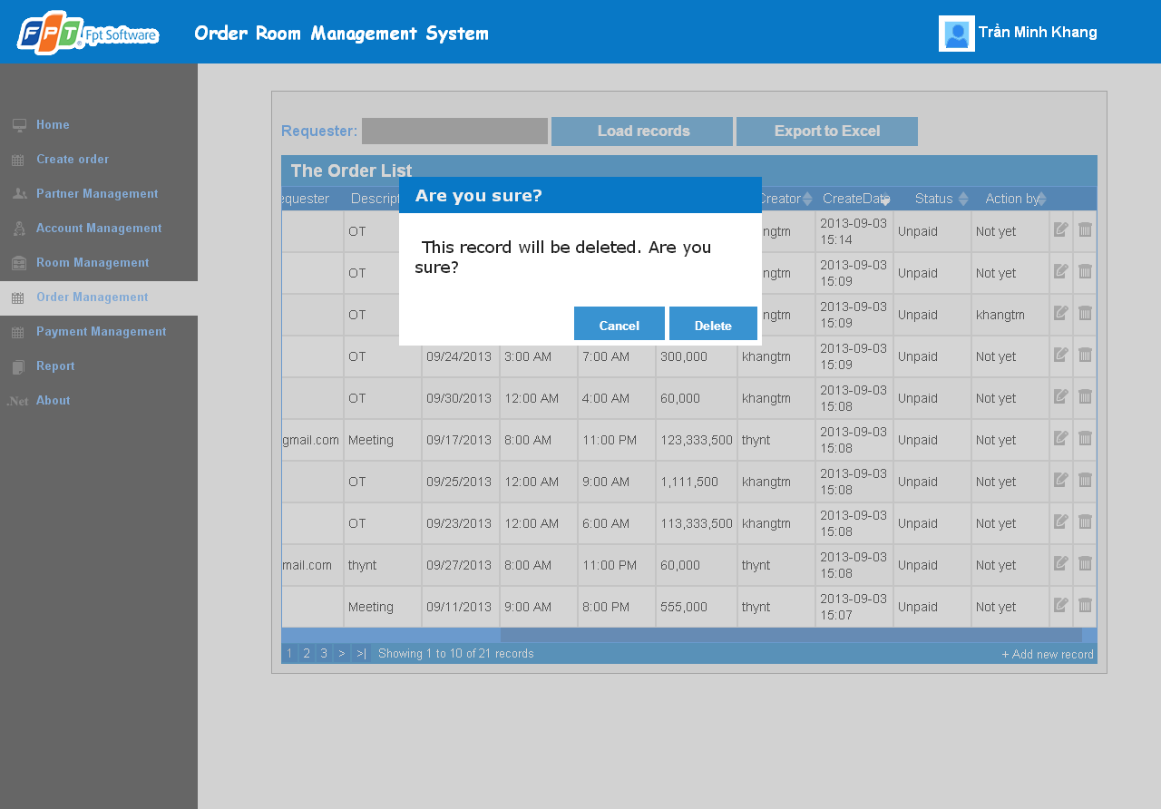

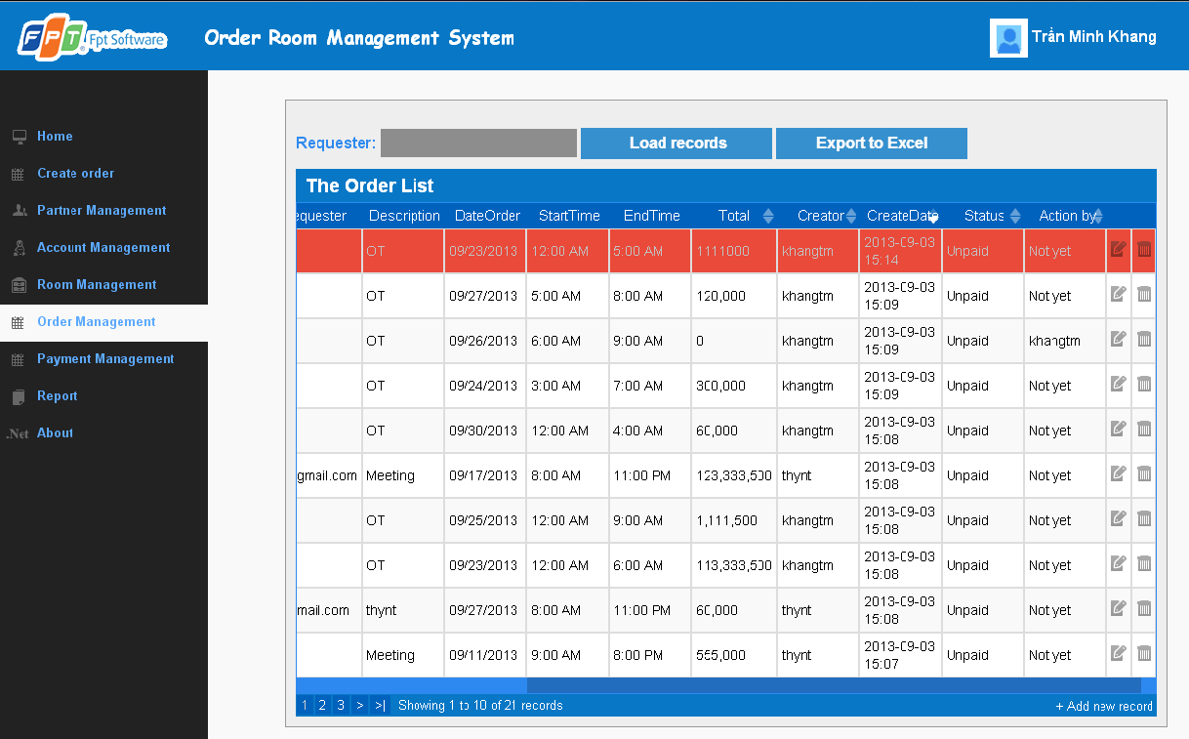

**Data field**

|  |  |  |  |
| --- | --- | --- | --- |
| No | Item | Type | Description |
|  |  |  |  |

## SC22: View profile account

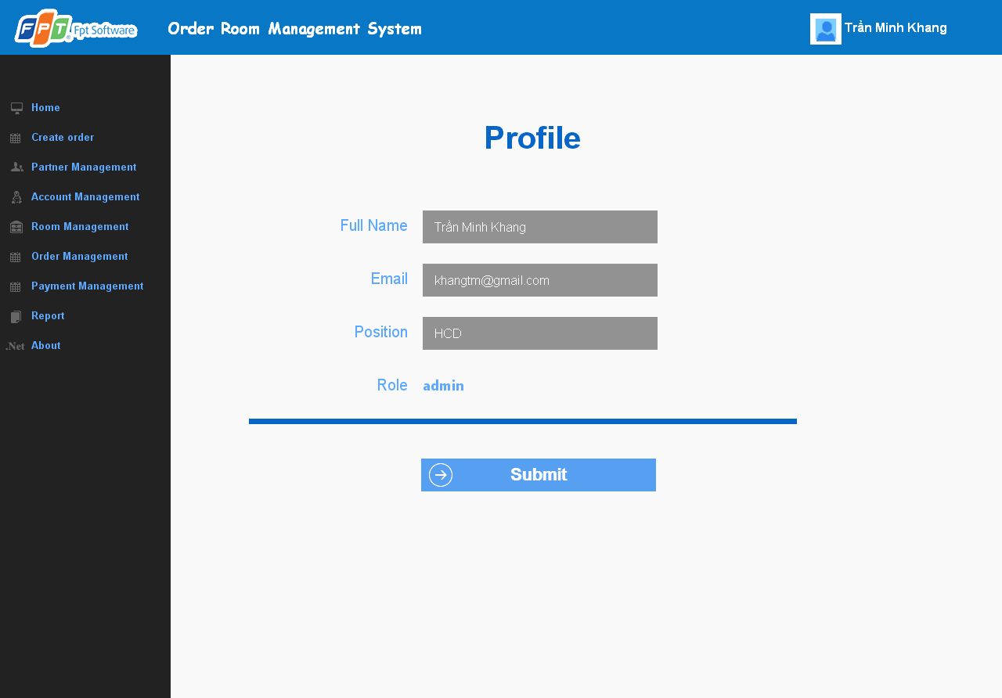

**Data field**

|  |  |  |  |
| --- | --- | --- | --- |
| No | Item | Type | Description |
|  |  |  |  |

## SC23: Update profile

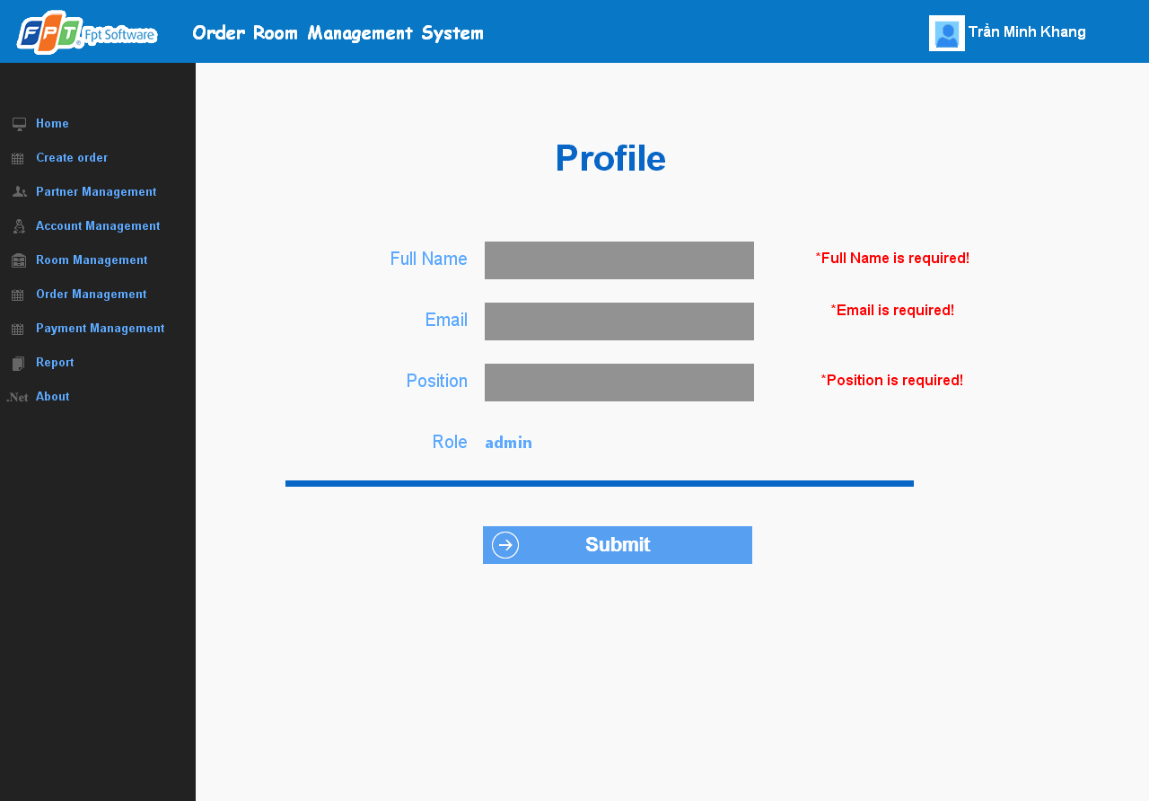

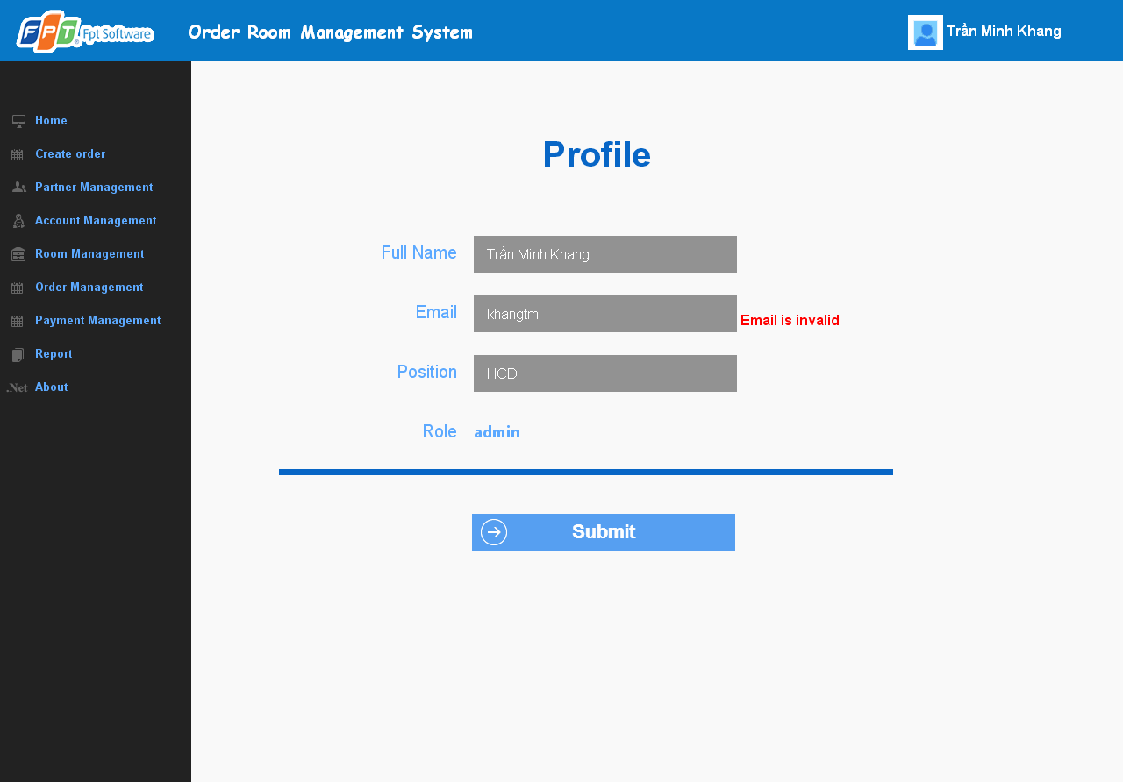

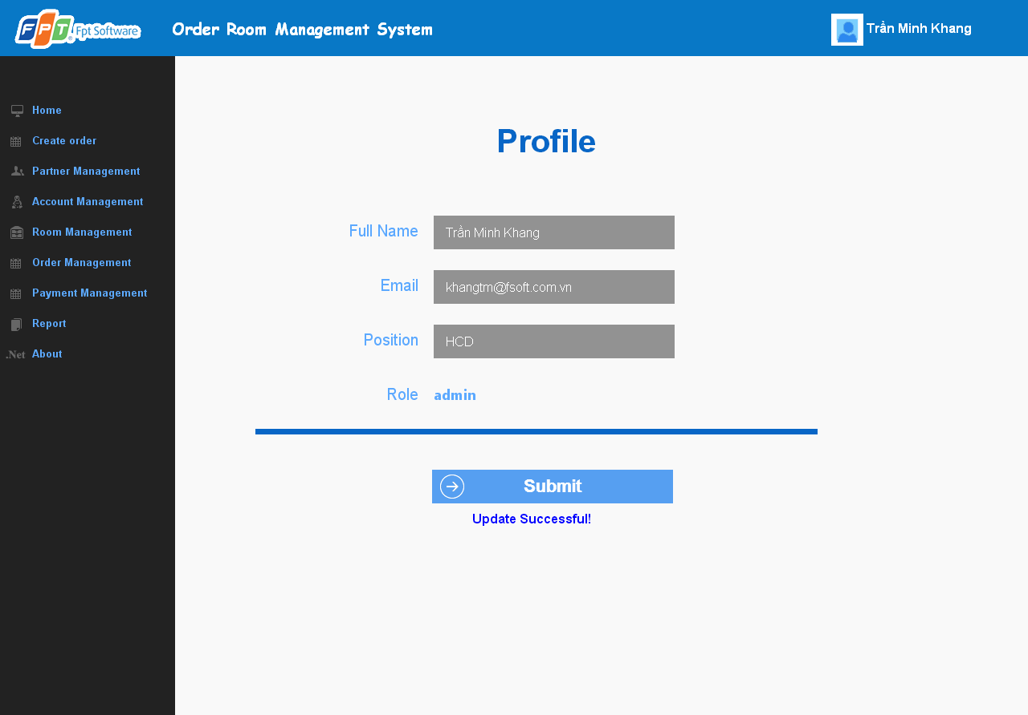

**Data field**

|  |  |  |  |
| --- | --- | --- | --- |
| No | Item | Type | Description |
|  |  |  |  |

## SC24: Change password

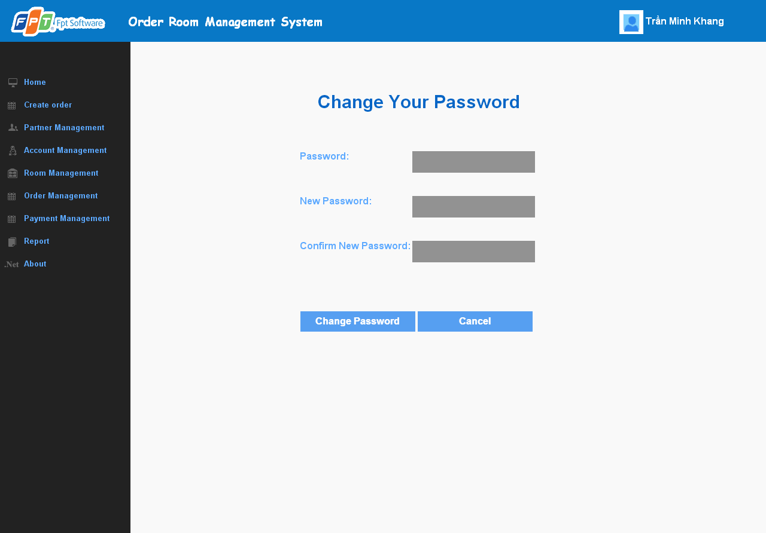

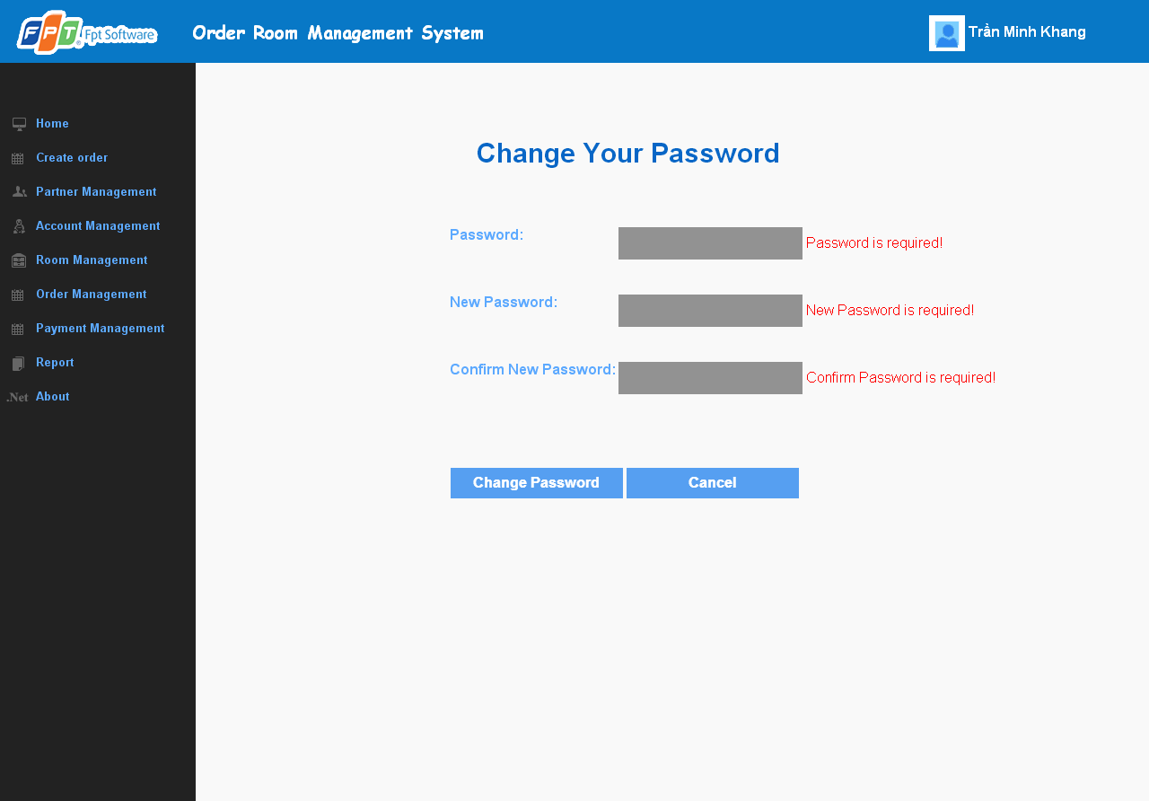

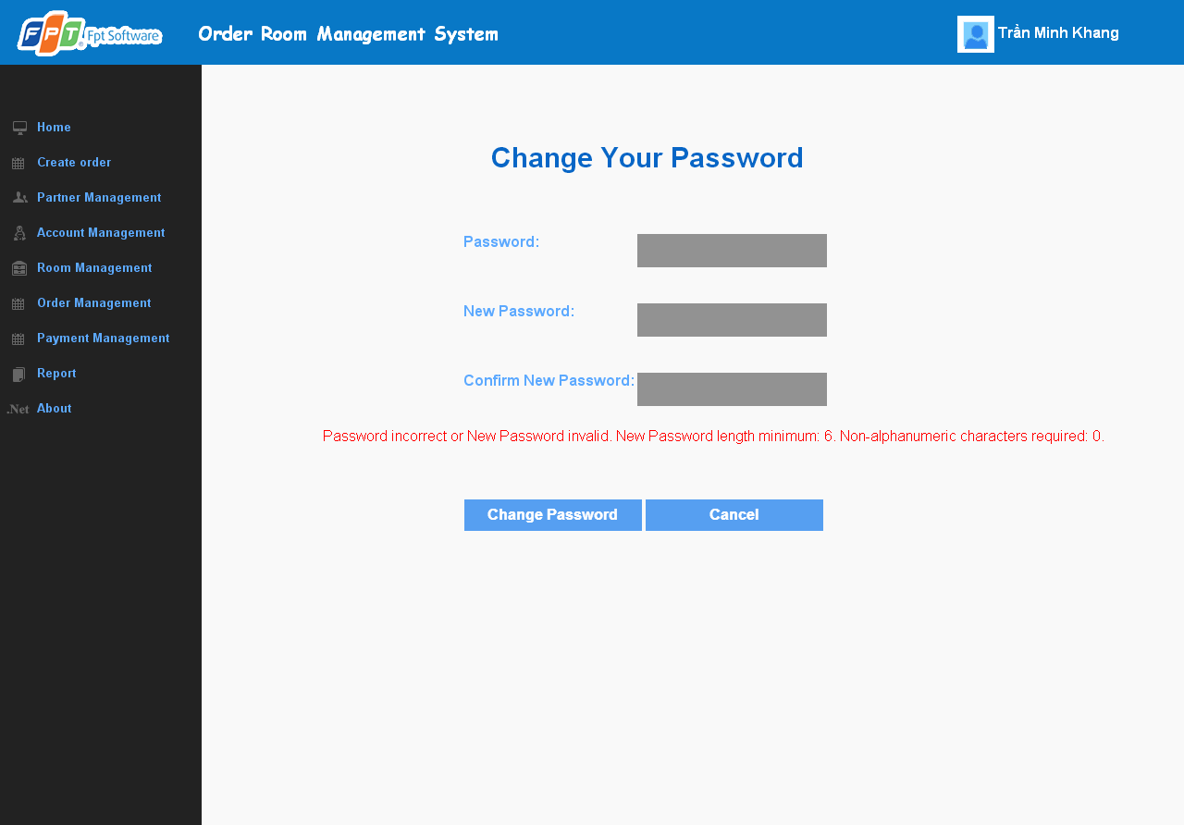

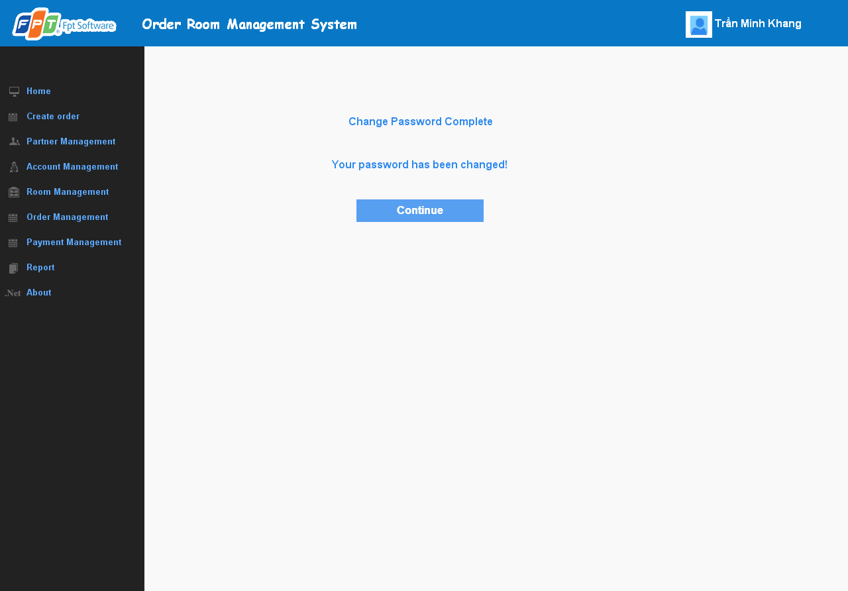

**Data field**

|  |  |  |  |
| --- | --- | --- | --- |
| No | Item | Type | Description |
|  |  |  |  |

## SC25: All report ordering by all room

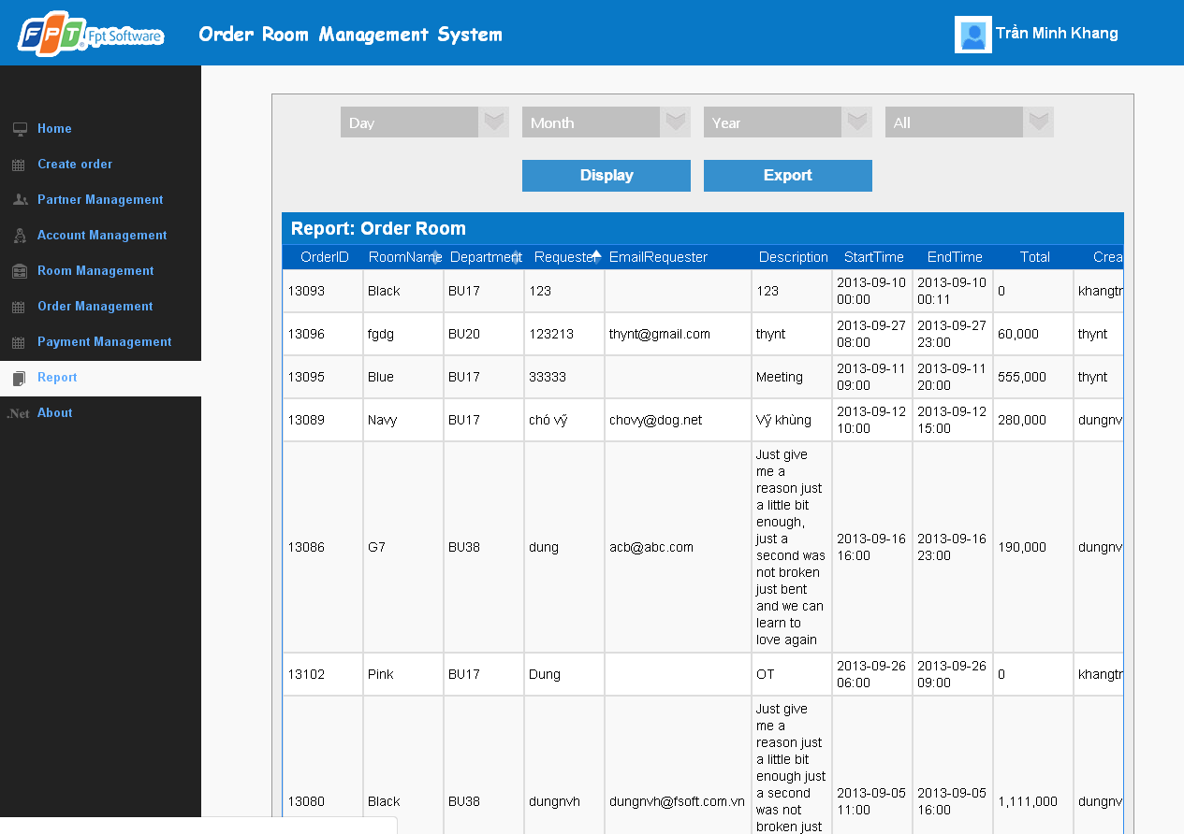

**Data field**

|  |  |  |  |
| --- | --- | --- | --- |
| No | Item | Type | Description |
|  |  |  |  |

## SC26: Report ordering order by room

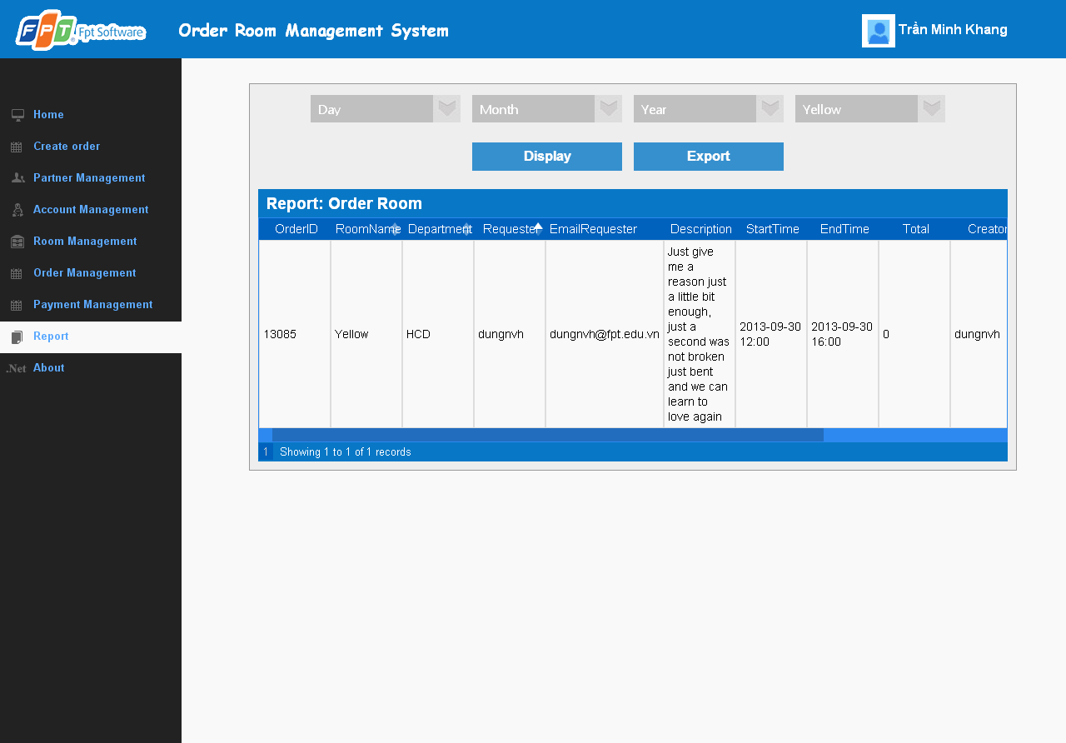

**Data field**

|  |  |  |  |
| --- | --- | --- | --- |
| No | Item | Type | Description |
|  |  |  |  |

## SC28: Report ordering order by room and date

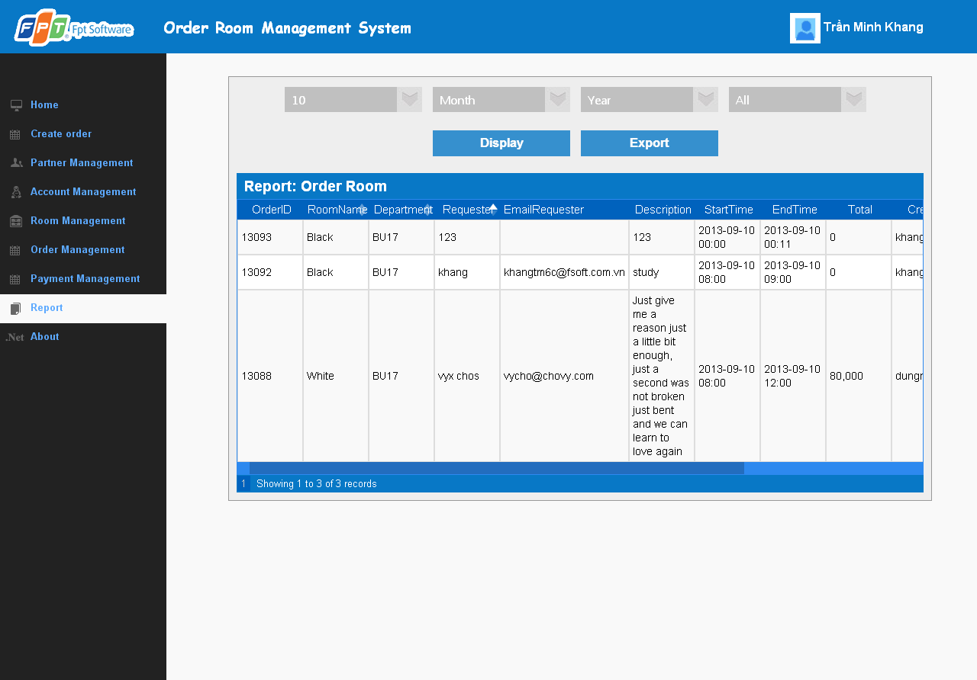

**Data field**

|  |  |  |  |
| --- | --- | --- | --- |
| No | Item | Type | Description |
|  |  |  |  |

## SC29: Report ordering order by room and month

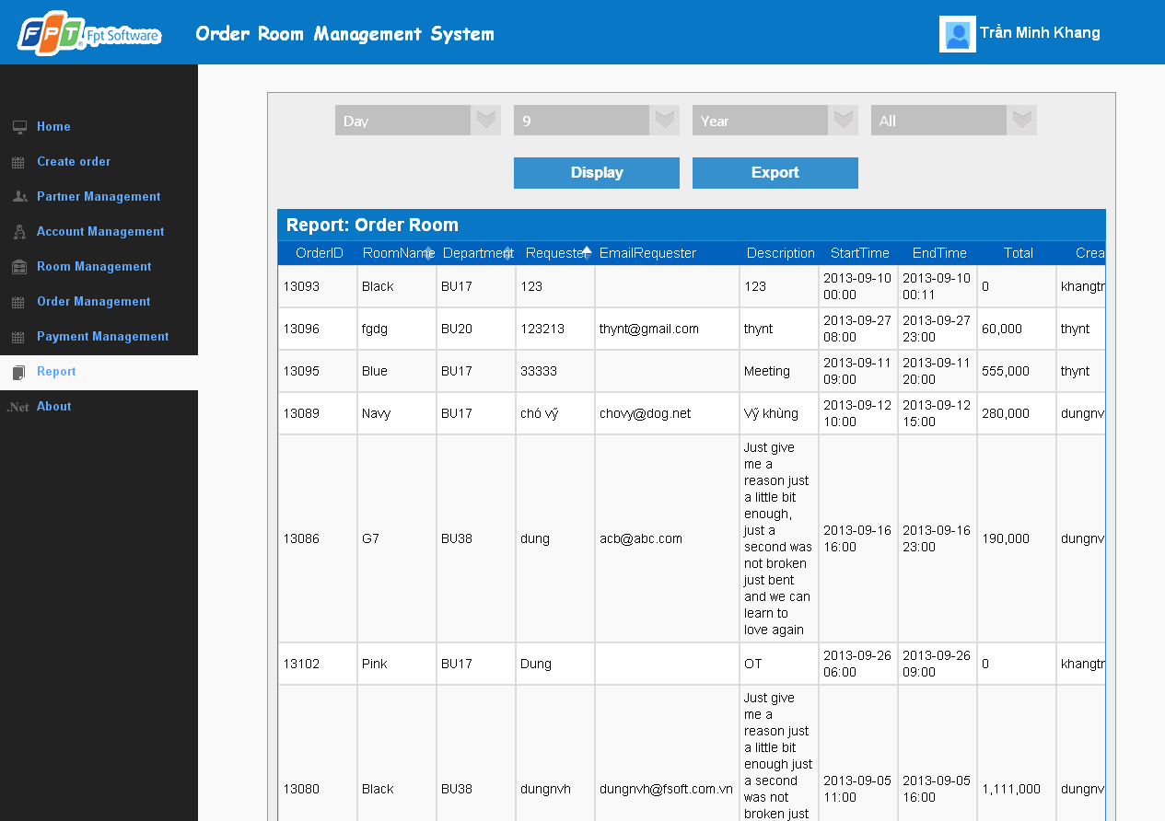

**Data field**

|  |  |  |  |
| --- | --- | --- | --- |
| No | Item | Type | Description |
|  |  |  |  |

## SC30: Report ordering order by room and year

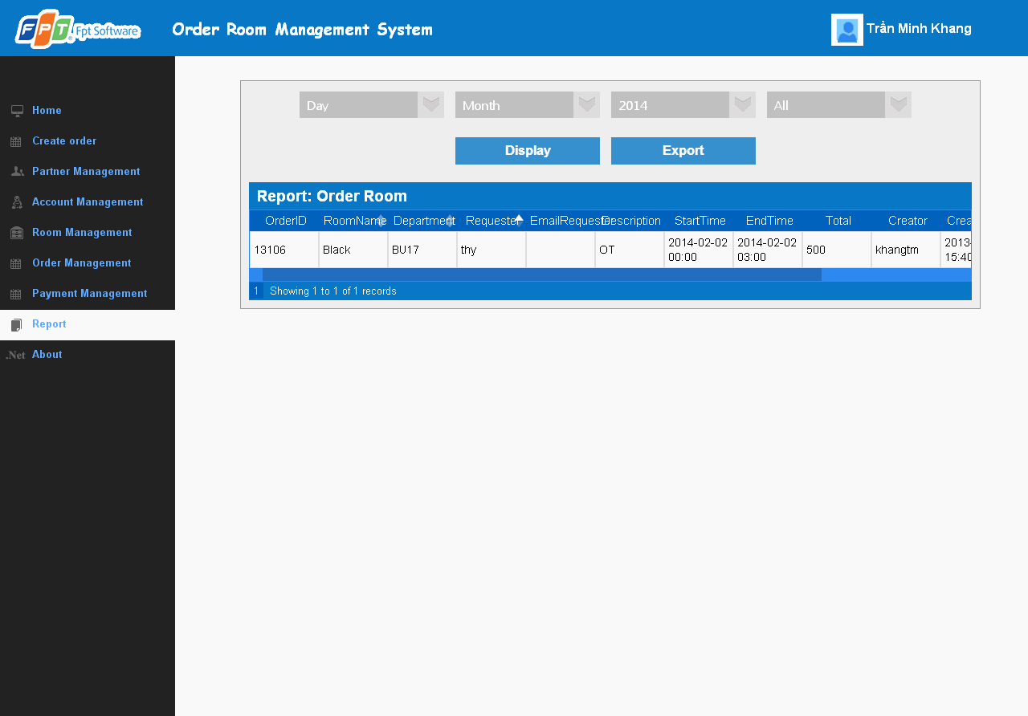

**Data field**

|  |  |  |  |
| --- | --- | --- | --- |
| No | Item | Type | Description |
|  |  |  |  |

## SC31: Report ordering order by room, date and month

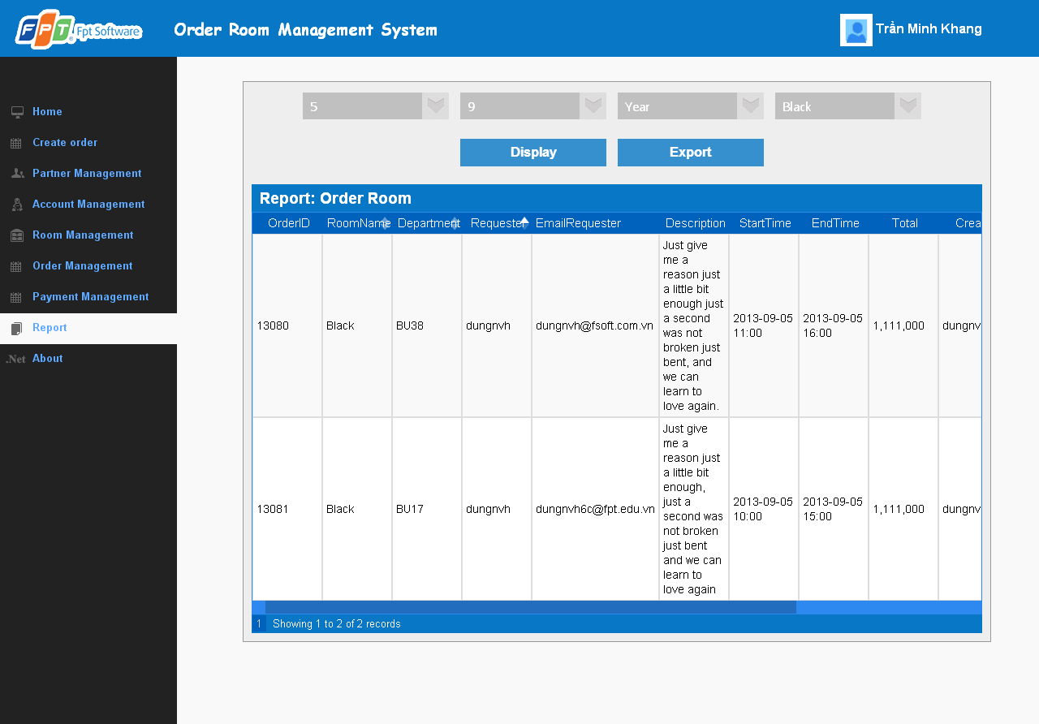

**Data field**

|  |  |  |  |
| --- | --- | --- | --- |
| No | Item | Type | Description |
|  |  |  |  |

## SC32: Report ordering order by room, date and year

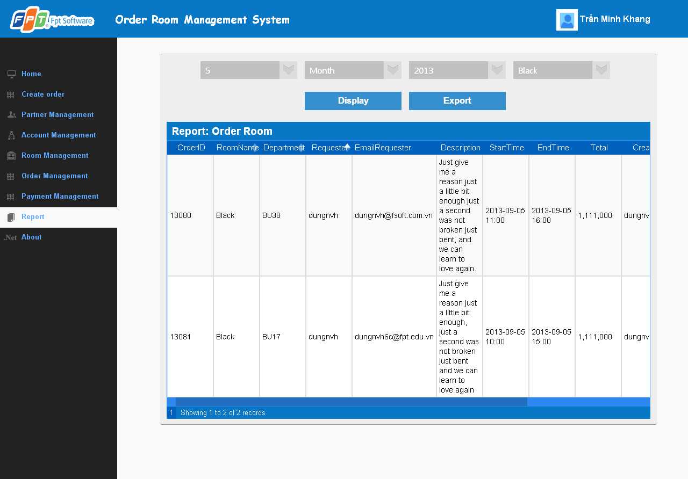

**Data field**

|  |  |  |  |
| --- | --- | --- | --- |
| No | Item | Type | Description |
|  |  |  |  |

## SC33: Report ordering order by room, month, year

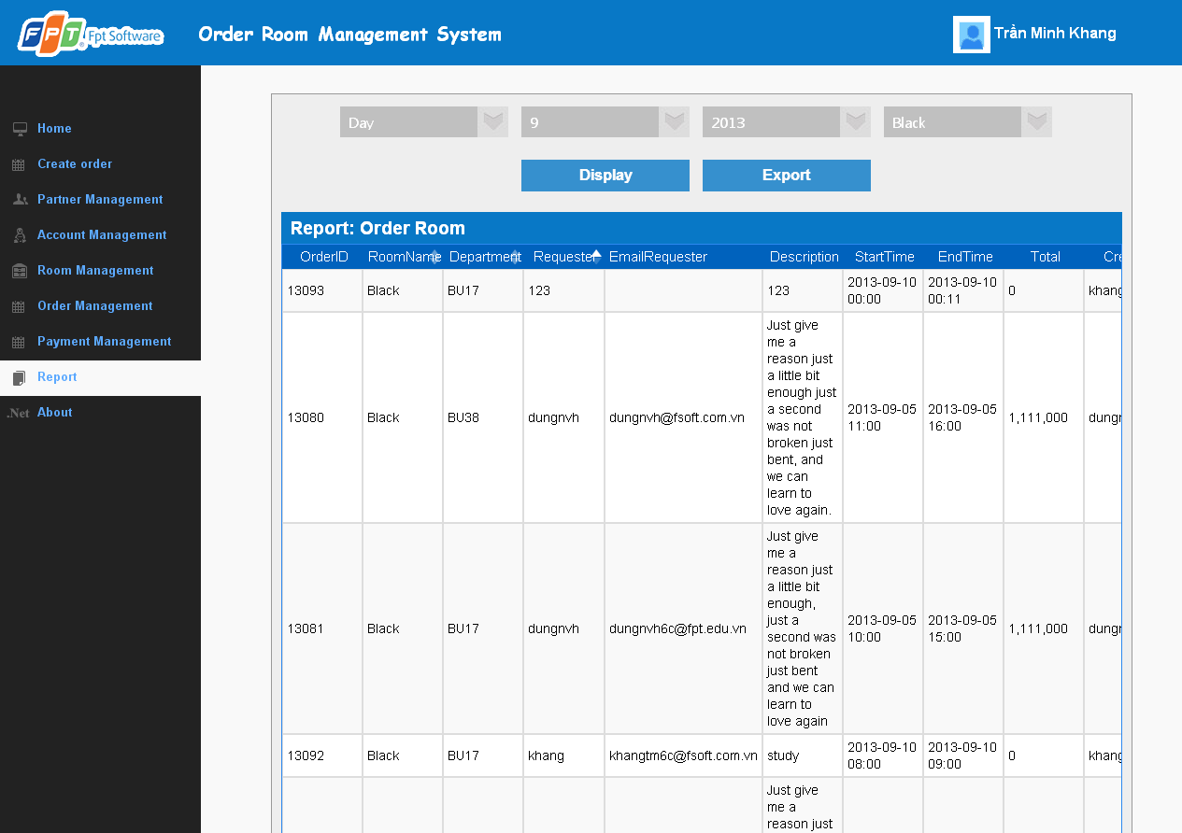

**Data field**

|  |  |  |  |
| --- | --- | --- | --- |
| No | Item | Type | Description |
|  |  |  |  |

## SC34: Report ording order by rom , date, month, year.

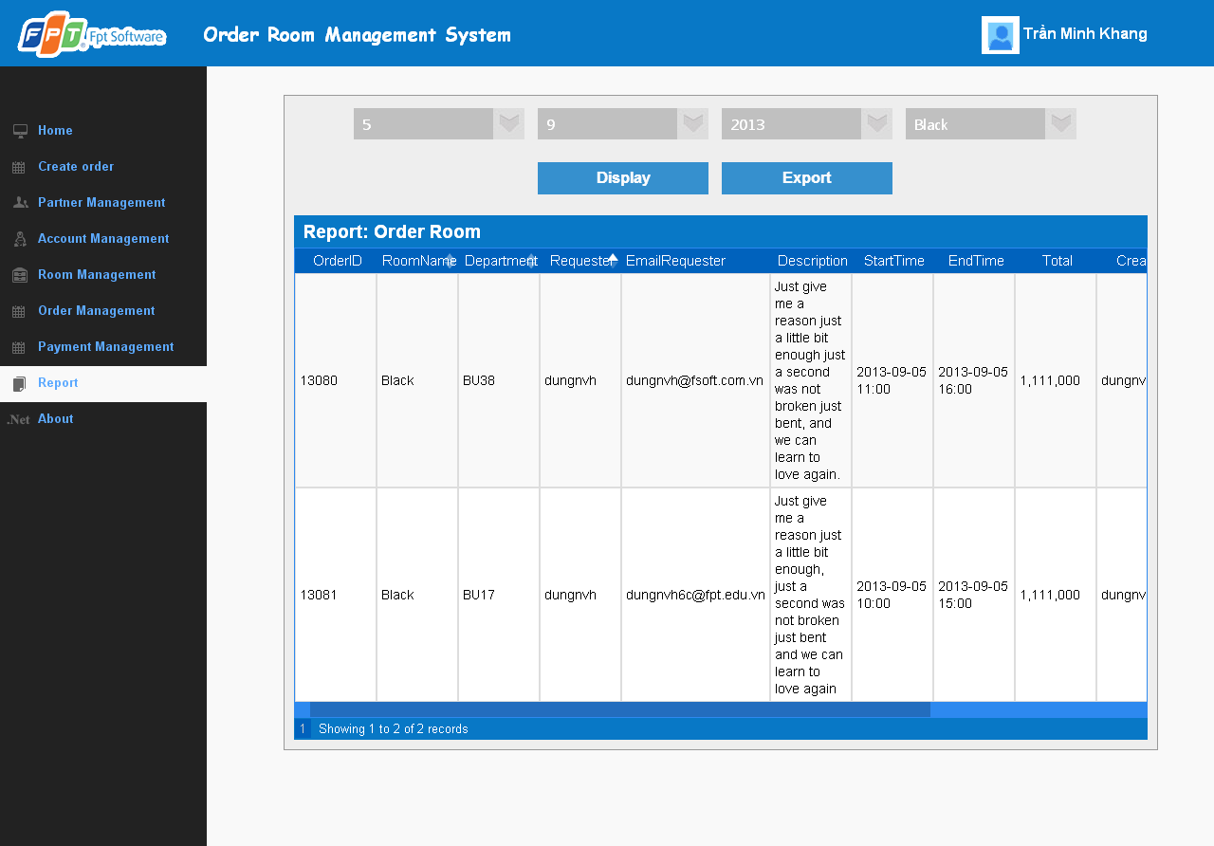

**Data field**

|  |  |  |  |
| --- | --- | --- | --- |
| No | Item | Type | Description |
|  |  |  |  |

## SC35: User home page

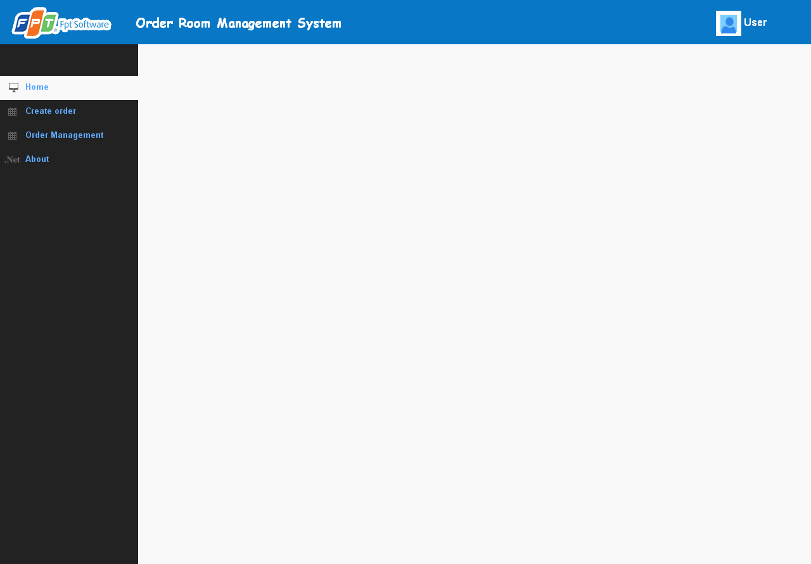

**Data field**

|  |  |  |  |
| --- | --- | --- | --- |
| No | Item | Type | Description |
|  |  |  |  |

## SC36: User Order management page

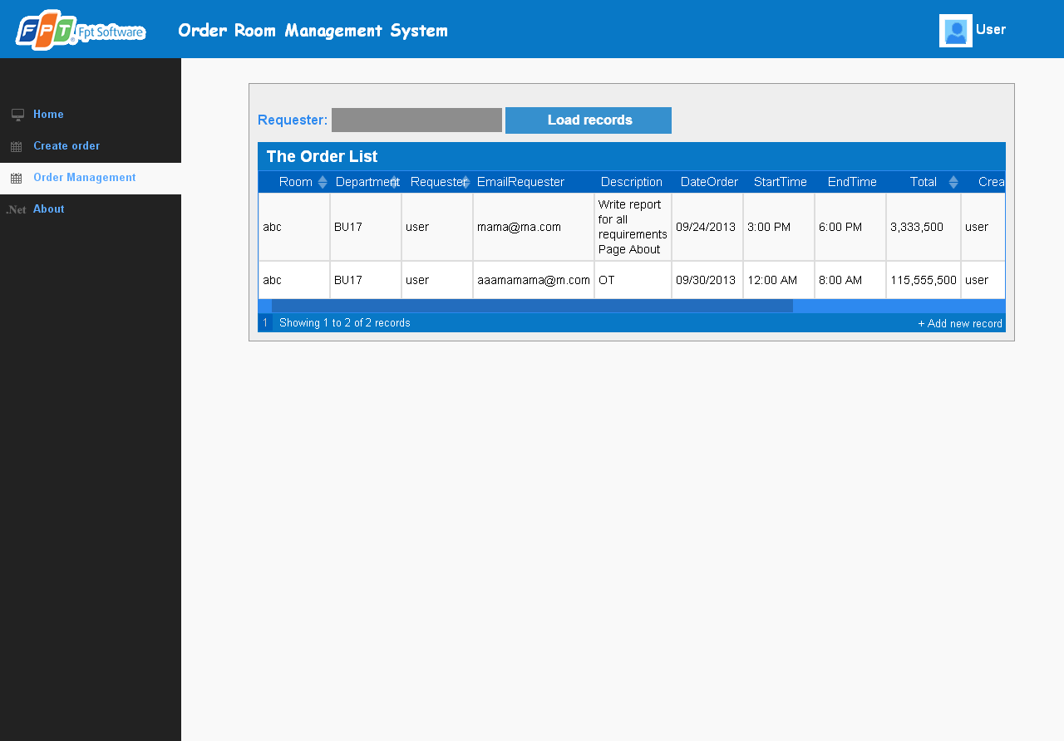

**Data field**

|  |  |  |  |
| --- | --- | --- | --- |
| No | Item | Type | Description |
|  |  |  |  |

## SC37: Create order Management

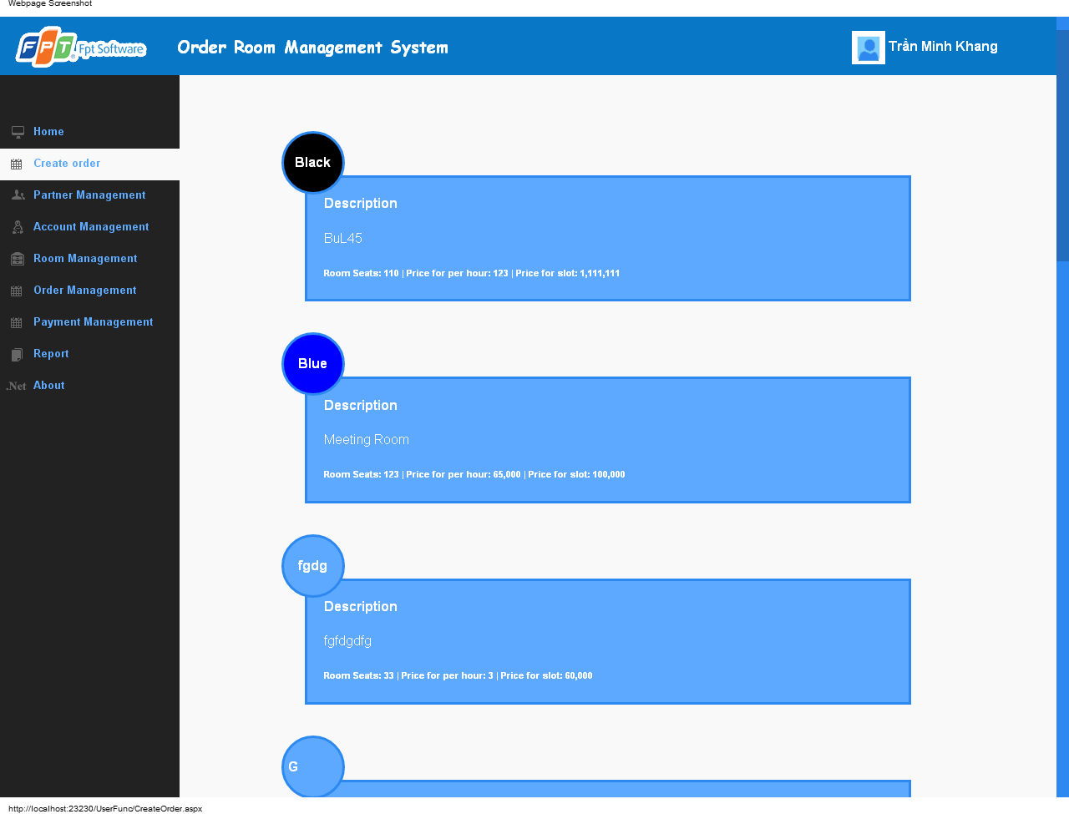

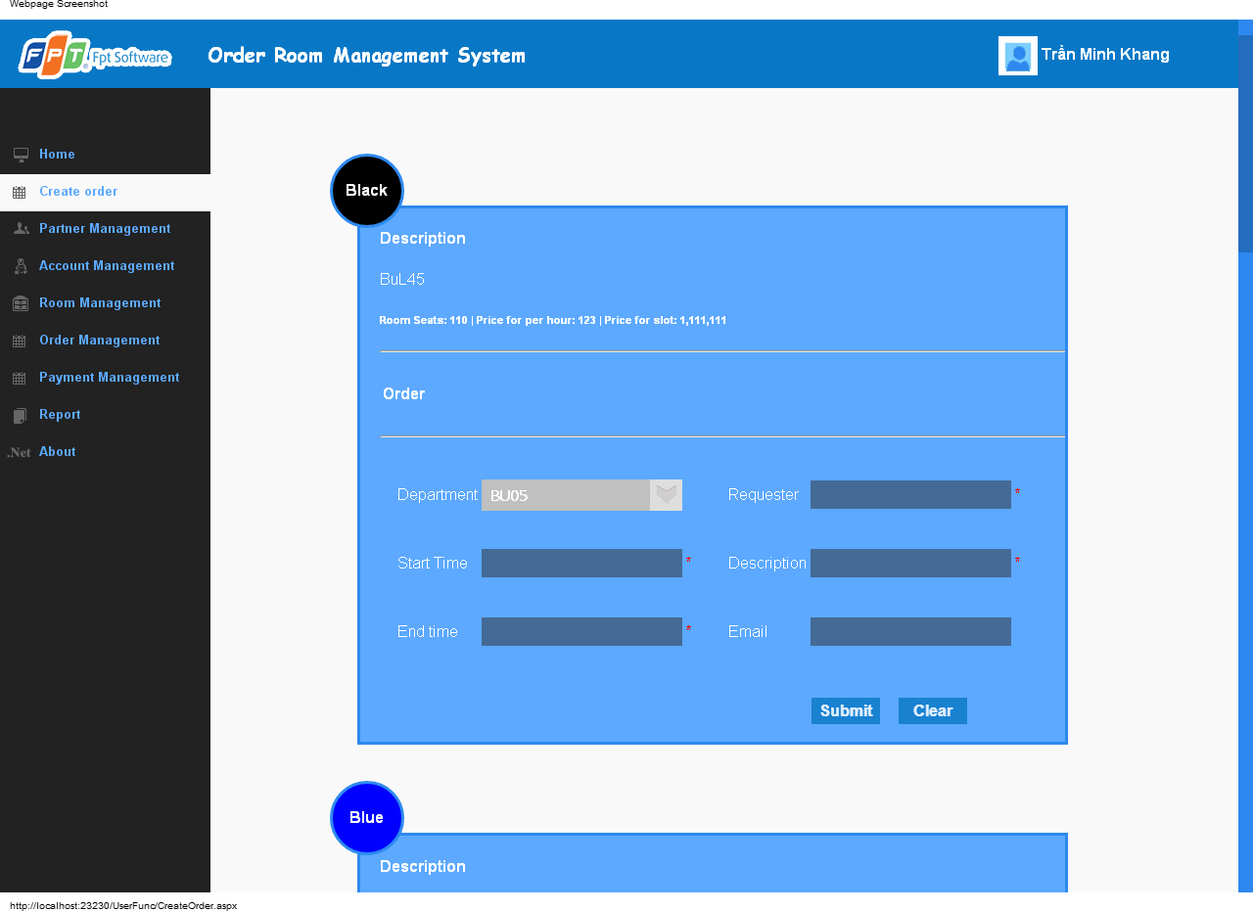

**Data field**

|  |  |  |  |
| --- | --- | --- | --- |
| No | Item | Type | Description |
|  |  |  |  |

## SC38: Payment Management

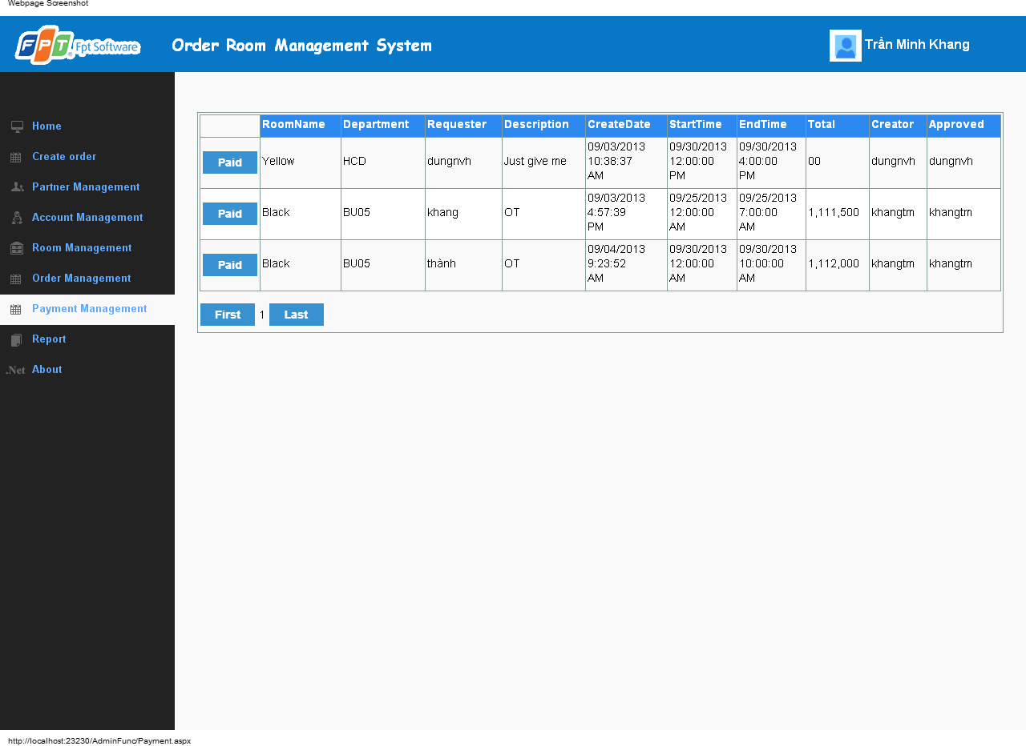

**Data field**

|  |  |  |  |
| --- | --- | --- | --- |
| No | Item | Type | Description |
|  |  |  |  |